Civil Litigation

Ms. Alice Mong’are

# Introduction /Taking Instructions

* Statute
  + Civil Procedure Rules
* In stay of execution
  + Can as for it
    - Informally – stand immediately after judgment is read and ask for the same for 30 days
    - Formally – notice of motion
  + Execution is what victorious party does to realise the reliefs given in the judgment
* Objector proceedings – when someone wants to include you in a case when you have nothing to do with it.
* 2 ways to challenge judgment’
  + Appeal - ask higher court to correct mistakes of lower court
  + Review – ask court to correct own mistakes (O45 r2)
    - Where there’s the existence of a clerical or arithmetical mistake or error apparent on the face of the decree,
    - shall be made only to the judge who passed the decree, or made the order sought to be reviewed
    - not done where the issue is new evidence

## Definitions

* Civil litigation - the process of making, defending or resisting a claim from the beginning up to its successful end by the enforcement of a judgment, if it is made.

## The overriding objectives are to ensure:

1. just determination of cases taken to Courts;

* documents & presentation before court should ensure this end.

1. efficient and proportionate determination of matters;

* efficient use of available judicial & administrative resources
  + magistrates & judges
  + judiciary staff

1. expedient determination of matters;

* in a timely manner
* at an affordable and reasonable costs to the parties;

1. proper application of technology at the right time.

## Client interviews and conferencing

* at the end of the lesson must be able to;
  + explain meaning & purpose of client interview
  + analyse how to conduct & obtain info
  + evaluate how to deal with a difficult client
  + analyse the duties of the advocate to the client

### Purpose & Scope of client interviews

1. forms advocate-client rlsp
2. advocate learns client’s intention
3. advocate is able to elicit the facts as perceived by the client
4. advocate is able to afford a legal opinion to the client
5. Advocate is able to formulate a course of action upon instruction by the client

### Objectives of Client interview:

1. form an advocate-client relationship;
2. learn the client’s goals;
3. learn as much as the client knows about the facts of the issue;
4. reduce the client’s anxiety without being unrealistic

### Advocate-Client Relationship

* interview heralds the fiduciary rlsp cemented by the retainer
  + fiduciary meaning relationship of trust
  + once client retains you and you accept to be retained, then rlsp created.
* knowledge acquired by the advocate should be treated as confidential
  + should not be disclosed to anyone else without the client’s consent
    - c/s King Woollen Mills LTD v Kaplan & Stratton advocates (1990-1994) EA 244.
  + Exceptions to client confidentiality:
    - was given and received to perpetuate a crime or fraud;
    - is needed to prevent certain death or serious bodily harm or to establish a claim; or
    - is for the defence of the advocate in a controversy between the advocate and the client;
    - has resulted in a client’s perjury as stated in the case of
      * c/s Hunt v. Blackburn, (1888).

### How to conduct a client interview

#### Preliminary Stage

* have some form of communication before the interview
  + may be a phone call or visit
  + to collect general info
* lay people have low esteem for lawyers
  + so endeavour to be forthright and approachable
  + prepare information like fees & costs that may be incidental to the case
  + be ready to discuss from the onset so that the client knows what they are getting into
  + may also be useful to examine any prejudices/biases that the advocate may have.
  + Would be prudent to reflect on what client expects from advocate
    - Think from client’s standpoint
    - Regardless of own attitude
  + Purpose to be positive in your attitude/approach to the client
    - Don’t be overly optimistic & mislead the client about the possible income
    - Just demonstrate that you are prepared to put the best spin, based on information received
* After forming an initial opinion of the case;
  + Decide the basic information you need from client
  + Ask the client to bring any documents that you deem to be relevant to the case
  + Set down time for interviews
    - Don’t schedule anything else
    - Ask them to bring relevant witnesses

#### Rules on commencing the interviews

* Take time to make client feel comfortable
  + Meet them at reception
  + Don’t intimidate them – keep away from office with achievements, pics with celebrities.
    - Once they trust you, can do that
  + Introduce yourself to the client
    - Can engage in informal talk to break the ice
  + Make sure room is comfortable and has a writing surface if you’re going to take notes.
  + Can offer refreshments
* Prepare to be uninterrupted by asking secretary to ensure that nobody comes in and by holding calls

#### Information gathering

* Most important aspect
* What counts is type of information
  + Let client tell the story
  + Ensure them that confidentiality extends to initial consultation even if they don’t engage your services
* Listen without interrupting
  + Employ active listening
    - Nodding
    - Eye-contact
    - Make notes on issues that need clarification
    - Don’t interrupt
* Let them tell you what they are hoping to get from you
* Once they’ve explained, summarize their story in light of the relevant facts to ascertain whether you understood them correctly
  + E.g., “We’ll go through what I’ve taken down, and you can correct me about what I got wrong”
  + Seek clarification
    - Avoid judgemental cross-examination
    - Confronting will come later when preparing the client trial
    - Don’t patronize
* Make room for vagueness, memory lapses & lies
  + This is natural because they want to seem like saints
  + But to get correct info, ensure that you engage openly with the client and encourage them to be as forthcoming as possible
  + Let them know consequences of not having correct info
* Go through list made in preparation for interview to ensure that you’ve gotten the basic info you need
* Address the client on your assessment of the case
  + Maintain eye contact to let them know that you were listening
  + Let the client know that the case is yours and there’s a rlsp
  + Don’t speak over them, avoid legal jargon
    - *Res judicata* – matter has already been determined involving the same subject matter & same parties
    - *Sub judice* – matter pending in court
  + Take time to explain what is happening to client
* Go over elements of case with your client & bring out the legal issues that arise
* If they haven’t brough any documents, ask the document that can support their case
* If client is charged with crime, try to bring possible defences by asking questions
  + Can ask about good character witnesses
* Information can also help determine whether there are
  + Possible conflicts
  + Client is asking for something illegal or unethical
* Let them know that privilege doesn’t cover criminal acts
* From information gathered, develop a case strategy
  + Be careful to identify the problem, fully investigate & strategize before giving firm dispositional advice
  + Don’t rush, schedule another date to allow you to clarify on the law & consult to allow you to advise more authoritatively
* Can also, at this point decide that you don’t want the case
  + Consider if you have doubts as to whether you can function effectively because of:
    - Conflict of interest
    - Lack of sufficient practice in particular area of law
      * Recommend someone else
      * c/s Oriental Commercial Bank Limited v Central Bank of Kenya (2012) eKLR.
    - could be that the client is walking trouble
  + can decline orally or by letter
* if decide to continue
  + tell them best & worst scenario
  + establish trust & treat them with respect
  + how you speak is an indication of how you’ll represent them
  + discuss fees
    - clients don’t like to be ambushed, let them know the gross figure
    - leet them know what you plan to do and how much it might cost them
    - explain to them how to calculate your fees
    - if possible, sign a fee agreement and secure a deposit on your legal fees

#### Closing

* explain what you plan to do
  + what steps they have to take in this regard
    - sign affidavits
    - Deposit money for court fees
* Arrange another meeting to explain progress
  + Clients are impressed by clients that put in extra efforts
* Be consistent & keep in touch
  + Provide extra information

### Questions in a client interview

#### Questions to ask the client

* Consider your information needs.

1. Personal information: Name, address, telephone numbers, family ties, work, age, nationality, income and health.
2. Other parties concerned: Basic personal details, advocate instructed (if any), connection with client (if any).
3. Witnesses (if relevant): Basic personal details of witnesses, connection with client.
4. The events that took place: Dates, time(s), place(s), people involved, the cause & course of events, people and property affected, incident which precipitated the visit to the advocate.
5. What the client wants: Identify the main problem, desired outcome, difficulties in achieving outcome, people to be affected by outcome, etc.
6. Previous advice and assistance offered to the client on the same subject matter: Anyone else consulted and details of consultant; the advice given, action taken, effects of the action.
7. Existing legal proceedings: Nature of proceedings, parties; stage of process; past or future hearing dates.

#### Based on the above info, explore:

1. The raw facts and the client’s source of knowledge.
2. All details relevant
3. All documentation relevant to the problem.
4. Questions required to prevent:
   * Accepting a client who creates a conflict of interest,
   * missing the deadlines espoused in the Statute of limitations,
   * not taking emergency actions to protect a client threatened by immediate harm.
5. Questions as to what the argument of opposing party would be in a court dispute
6. Evaluation of client’s value as a witness in court in court disputes
7. Status of transaction in transactional interviews – how far had you gone e.g., in the conveyancing process
8. Parties interested in transactional interview
9. Whether client has talked to another advocate about the problem in issue

### Special problems in client interviews

#### Ethics in client interviews

* When a client wants an advocate to assist in falsifying evidence and perpetrating illegalities so as to succeed in a case,
  + the advocate should refrain from such requests/orders.
  + The best approach is to interview the client and explain the law since falsifying testimony amounts to the offence of perjury.

#### Handling private or embarrassing material:

* give a client time to appreciate that you are a person who can be entrusted with the kind of information that a client might not be willing to tell his/her friends about.
  + an advocate should gain the confidence of the client by stressing to the client his duty of confidentiality to the client, and the privileges of the advocate-client communication.
  + In doing this, an advocate will obtain accurate and valuable information to any proceeding be it for litigation or alternative dispute resolution.

#### Handling possible client fabrication:

* The main cause of fabrication is by fundamental manipulation by the client.
  + an advocate should explain to the client that it is in the client’s best interest to tell him the truth.

#### Handling a client who wants instant prediction of a case:

* This problem arises out of the client’s need for assurance that the case has chances of success. The advocate should, therefore, explain to the client what work s/he will do, the issues s/he will research on, and the facts that s/he needs to investigate.

## Handling Clients

### ***The Difficult Client***:

* The fact that a client is difficult should not generally deter an advocate from representing the client.
* The cab-rank rule provides that advocates should make legal services available to the public in an efficient and convenient way that commands respect and confidence and is compatible with the integrity and independence of the profession without discrimination, including to difficult clients.
  + Cab-rank rule is the obligation of a barrister to accept any work in a field in which s/he profess him/herself competent to practise, at a Court at which they normally appear, and at their usual rates.
* Clients may be difficult for any number of reasons: they may have unique behavioural traits that are exacerbated by their legal matter; others may have mental health issues.

### Indicators Identifying A Difficult Client:

* Some that suggest the prospective client may pose challenges for the advocate are:

#### Previous advocates:

* There should be an interrogation on
  + the number advocates the client has had in the past on the same matter,
  + outstanding accounts or unpaid accounts,
  + any unjustifiable criticism of the advocate,
  + description of the previous advocate as demanding; wanting calls or letters returned promptly and client not willing to oblige, etc.

#### Litigation history:

* An advocate should inquire
  + whether the matter has been litigated for years,
  + whether the client is presently representing himself or herself,
  + whether the client will not tell you the reason why his or her previous advocate got off the record,
    - and he is also not keen on an advocate getting in touch with the previous advocate on record regarding his case,
  + and the level of the client’s knowledge of the case and Court process.

#### Personality traits and behaviour:

* This is done to find out
  + personality type of the client,
  + the client’s feeling about the importance of the case,
  + the client’s use of a lot of the advocate’s time and that of his/her staff.
  + the client’s low expectations about the outcome of the matter,
  + time it takes
  + unrealistic costs
  + his continuous failure to provide instructions.
  + On behaviour, it includes
    - whether the client is verbally abusive to the advocate and his/her staff, or
    - whether the client writes abusive letters to the advocate.

#### Communication in the case:

* A difficult client fails to respond to correspondence.
* Besides, the documentation/orders that the client provides in an interview are different from the information provided over the telephone and the client fails to explain the difference.
* In addition, the client may not be clear or coherent in his instructions.

#### Client’s ability to pay for services rendered by advocate:

* A difficult client might ask for concessions even when they have the ability to pay.
* The client might also indicate directly or indirectly to the advocate that s/he will not testify at the trial.

### Managing the difficult client

* An advocate should:

1. Be alert to indicators & take steps to ensure that the rlsp is effectively managed.
2. Explain his/her role and set the boundaries early on in the retainer
   * Advocate’s role is to analyse a given situation to the problem presented/means of achieving the goal the client presented
3. Document everything s/he possibly can, including telephone calls, voice mail messages and e-mail messages
4. Have the client’s instructions in writing as confirmed by the client (also in writing);
   * Necessary to include, in writing, the possible consequences of various courses of action the client may be contemplating.
5. Recommend counselling for the client if possible to place a client in a state of mind to discuss the matter soberly, realistically & reasonably
6. Set realistic expectations early on in the case
7. Manage need & expectations f the client about service, timing, results & cost.
8. Discuss the client’s difficulties with staff to come up with action plan for the client
   * Train staff on the risk of acting for a difficult client
   * Make sure staff dealing with client same way as advocate especially in terms of documenting
9. Ensure client understands importance of openness & honesty
10. Be calm, patient & clear.

### Client Counselling

#### Purpose & scope

* There’s always a real temptation & tendency in client counselling to make judgments & give orders & tendency in clients to depend on their legal counsellors for judgment & direction

#### Purpose

* Ask what the client wants to avoid unethical practice of choosing for client,
  + counsel with the goal of coming up with options/alternatives.

#### Ethical guidelines to keep in mind

1. Don’t lecture client
2. Put client’s best interest first
3. Maintain confidentiality
4. Recall that counselling is client-centred
5. Remember purpose is to open up options
6. Don’t decide for client

#### Scope of counselling

* Experienced counsellors
  + use different counselling styles as appropriate
  + Set up relaxing & trusting environments early on
  + Are honest & respectful
  + Need to put some distance btn self & client

#### What if the real problem is not legal?

* Stereotypical situation is where a client has a minor legal problem e.g., traffic ticket, or a dispute with a neighbour, landlord-tenant, debt problem
  + Could be apparent to advocate that client needs professional counselling & therapy
  + The advocate would be wise to address any legal problem in the usual manner and then address underlying problem.

#### Can an advocate decide for the client in counselling?

* One of the most commonly encountered problems for advocates in the counselling process is that a client wants an advocate to make the decision for him/her as s/he is paying legal fees.
  + In such a case an advocate can get him/herself into a professional trap.
* The core of client counselling is that the client must make the decisions.
  + If an advocate makes a decision and the client acts based on it, s/he is entirely responsible for the outcome of the action.
  + The role of the advocate is to chart out the alternatives and then make sure the client makes a fully informed and volitional decision.

#### Duties to a client when counselling:

In the process of counselling, an advocate owes a client duty to avoid professional malpractice.

1. Duty of care: Where there are underlying issues that are not legal, an advocate has to be very careful not to mislead the client.
2. Duty of confidentiality: A client should be at ease when giving information knowing that it will not leak to a third party. Exceptions to client confidentiality are, for instance, where the information:
   * was given and received to perpetuate a crime or fraud;
   * is needed to prevent certain death or serious bodily harm or to establish a claim; or
   * is for the defence of the advocate in a controversy between the advocate and the client;
   * has resulted in a client’s perjury as stated in the case of Hunt v. Blackburn, (1888).
   * This duty however applies only where legal advice is sought from a professional legal adviser in his capacity as such, when the communications relating to that purpose made in confidence by the client, from disclosure by himself or by the legal adviser, except the protection be waived.
3. Duty to act in a client’s best interest: An advocate should always put the best interest of his client first. There should be no conflict of interest and where there is a conflict, an advocate should disqualify himself from acting or advising the client.
4. Duty to listen: An advocate should be a good listener. Good listening will encourage a client to give the important information that is needed by the advocate.
5. Duty not to decide for the client: Even where a client insists that the advocate should decide for him/her, the advocate should not do so. An advocate should open up options and let the client decide.

#### h. Forms of client counselling:

1. Transactional counselling: This form of counselling relates to how to structure deals/transactions (especially commercial) with other organizations and how to conduct their affairs so as to minimize the taxes and legal liability of the organizational and individual clients.
2. Dispute resolution counselling: This includes pre-litigation where an advocate advises the client on whether a law suit or alternative dispute resolution mechanisms is necessary. Also includes strategy in litigation or ADR (whichever is adopted by the client)

## Legal opinion

## To litigate or not to litigate

# Pre-litigation preliminary considerations

## Cause of action

### Determining the existence

* Not all issues determined during client interviews are resolved through litigation process
* A legal right must exist
* The legally recognized right to a relief is known as cause of action

### Cause of Action

* Contains:
* Facts sufficient to support a valid suit
* The legal theory upon which a lawsuit (action) is based
  + Also legally recognised right to a relief
    - c/s Ashby v White
* In pleading this will include
  + The relevant facts distinct in each situation
    - * Fact in issue – matters for court to determine
      * Relevant facts – prove or disprove a fact in issue]
  + Particulars (if any) which relate to the actions of the defendant
  + The reaction of the plaintiff in relation to the act of the defendant that caused the plaintiff to incur a loss/damage

### Considerations before concluding existence of the cause of action

* Examine both law & facts in the case
  + - * Determine what general area of substantive law applies to the case
      * Narrow general substantive law to specific topic identified
      * Examine specific area & determine the factors/elements that must be present b4 cause of action is created
* Issues to note
  + The defendant must have a duty of due care toward the victim.
  + That duty must have been breached (by a careless act).
  + The defendant’s careless act must be the actual cause of the damages.
  + The defendant’s careless act must be the actual cause of the damages i.e., damage must be foreseeable
  + Damages must have been sustained

### Importance of Identifying Elements of Cause of Action

* Each of the elements must be proven at a trial for the plaintiff to prevail
  + Helps in understanding what you must prove at trial
* To win a case, the advocate must present evidence to support each element
  + Enables you to gather appropriate evidence & conduct relevant discovery
* Initial pleadings must allege facts supporting each element
  + Equips you to prepare pleadings that comply with legal requirements & review opposing pleadings for legal deficiencies
* Knowledge of cause is essential in undertaking pre-trial preparation

## Time Limitation of actions

* Unless file within appropriate statute of limitation, case will be dismissed despite merits
  + Need to seek courts discretion to revive case
    - Need to show sufficient cause to explain delay
  + Time limitations can be easily calculated.
    - e.g., a plaintiff may have three years from the date of the accident in which to file an action for personal injuries. The date of the accident can be easily determined from Police Reports and Witnesses
    - in professional malpractice cases, or in fraud cases, the limitations might start to run not from the date of the malpractice or fraudulent act, but from the date the plaintiff discovers the malpractice or fraud.
  + So facts matter in trial process and need to be careful.

## Various time limitations

* + Tort -3yrs – Section 4 of Limitation of Actions Act (Cap 22 LoK)
    - If tortfeasor wants to claim from tortfeasor under Sec 5 LOAA, have to do it within 2 yrs
  + Libel/slander – 1 year from date of occurrence
  + Fraud/mistake – Sec 26 – time can be extended and doesn’t start to count until aware
  + Contract – 6 years
  + Claims against gov’t – 30 days
    - If contract – 3 years
    - Tort – 1 year
  + Adverse possession – 12 yrs
  + Land – 12yrs Section 7 of LoAA
  + Employment – Section 90– 3yrs
  + Enforce decree – 2 yrs
    - It only accrues interest for yrs
* c/s Abdullahi Ibrahim Ahmed (Suing as the personal representative of the estate of Anisa Sheikh Hasan (Deceased)) v Lem Teklue Muzolo (2013) eKLR.
  + issue of limitation must be specifically pleaded by a party to the suit before a court can make a decision on it.

## Calculating of limitation of time

* The first day is not counted, but the last day is counted.
  + Thus, filing a lawsuit for injuries from an automobile accident for an accident that happened on Friday, 28th January 2009, the counting begins on 29th January 2009. Since there is a 3-year statute of limitation for torts, a complaint must be filed on or before 28th January 2012.
* However, if that date is a Court holiday, filing can be undertaken in the next Court-day.

## Tolling the statute of limitations:

* Some events may toll or extend the statute of limitations. When a statute is tolled, time stops running. The common reason a statute of limitations can be tolled is when the plaintiff is a minor. Limitation begins to run once the minor reaches the age of majority.

## Claim Statute:

* Some cases are governed by specific Statutes which require that a prospective defendant be notified, in writing that a claim is pending, who is making the claim, what the claim is for and the amount of the claim before a lawsuit can be filed.
* Civil suits are mostly guided by the Civil procedure Rules, 2010, amended 2020
* Government Proceedings Act Sec 13A(1) Cap 40 requires that a 30-day notice be given to the gov’t
  + Kenya Bus Services LTD & another v Minister for Transport & 2 others (2012) eKLR.
* The party then has the opportunity to pay the claim before any lawsuit is filed.
  + This is especially common when a governmental entity is being sued.
  + There are time limits for presenting the claim.

## Laches:

* Equitable cases (cases in which the plaintiff is asking for something else other than money damages) are governed by another limitation referred to as ‘laches.’
* May ask for
  + Injunctions
  + Restitution
  + Specific performance
* Laches only touches on equitable remedies
* Laches is an equitable principle that prevents lawsuits from being filed when, in fairness to the defendant, too much time has elapsed, even though the statute of limitations has not expired.
  + *e.g.,* suppose Njoki and Okello sign a written contract in which Okello agrees to sell his house to Njoki for Ksh.3.5 million. For various reasons, Okello changes his mind and refuses to complete the sale. Rather than sue on the contract, Njoki finds another house for the same price and takes no immediate legal action against Okello. Three years later, however, after a surge in the real estate market, Njoki decides to do something. Okello’s house is now worth KSh.15 million, and Njoki assumes she can purchase the house for the contract price of Ksh.3.5 million, and can immediately sell it and make a large profit. She therefore sues Okello for specific performance of the agreement. Assuming the statute of limitation is 6 years. Njoki waited too long to file a suit thus, laches will prevent her from prevailing in her action.
  + Njoki’s claim for damages could have been the difference between the contract price and the fair market value of the house at the time the contract was to be performed and not the date that the action was filed.
    - She could sue for breach of contract at the time the performance was expected.

## Tickler/Reminder Systems:

* Most litigation firms have calendar or tracking systems to remind them of important dates. The calendar system is referred to as ‘tickler systems.’

## Feasibility of the lawsuit:

* Even though an advocate may determine that a case has merits, s/he may nevertheless decide that engaging in litigation is not practical as it
  + takes time and
  + is costly,
    - not only in advocate fees, but in other costs.
* Advocate should always review a case to see if its practical before accepting it.

## Turning down a case

* If an advocate decides not to accept a brief, s/he must clearly communicate the same to the party concerned. This should be done in writing so that there is a record of the fact.
* exercise due care in stating an opinion regarding the merits of the case to the individual.
* It is also advisable to warn the person about any possible statute of limitations.

ILLUSTRATION:

MPOLE & SAMU COMPANY ADVOCATES

MUTULA HALL, SECOND FLOOR,

P.O. BOX, 100356-00100,

NAIROBI, KENYA

Tel: 0723321654 / 020-2586987

Email: mpole75@gmail.com

………………………………………………………………………………………………………

Our Ref: DL/10/2017 20th July 2017

TO

MR. CLAIMANT,

P.O. BOX 21 CITY SQUARE, “BY REGISTERED POST”

NAIROBI.

Dear Sir,

Thank you for considering us regarding your dispute with ABC Corporation. As I explained to you on telephone, our Law Firm is presently unable to represent you in this matter. Please note that our inability to accept your case is not a reflection or comment on the merits of your case.

If you wish to pursue the matter, please consult any other legal firm as soon as possible.

As we have previously explained to you, the statute of limitations in such kind of cases is three years from the date you suffered the injury. If you have not filed a lawsuit within the specified time, you will be prevented from doing so.

Yours faithfully,

MPOLE KAVITA

FOR: MPOLE & SAMU COMPANY ADVOCATES

## Ethical considerations before accepting a case

* based on the rules of professional conduct which, *inter alia*, include:

### Competency to handle the case:

An advocate should not accept a case if s/he does not possess the ability, knowledge, or time to handle it. S/he should also not ignore a case once s/he has accepted it.

### Frivolous claims:

An advocate should not pursue lawsuits that have no merit. Handling such cases puts on high risk an advocate for being sued by the defendant in the action and, in addition, subjecting oneself to disciplinary proceedings by the Advocates Disciplinary Committee.

### Conflict of interest:

It arises when a firm is asked to sue a party whom it currently represents or previously represented in another case. A conflict is determined by whom the firm represents, rather than by whom any particular advocate in the firm represents.

## Ethical considerations after accepting a case

### Communication with the client:

Lawyers owe a duty to their clients to keep them advised about the status of their cases. Failure of lawyers to do so is the basis of one of most common complaints against advocates.

### Communication with the opposing party:

It is unethical for an advocate to personally contact an opposing party who is represented by an advocate. However, if the opposing party is not represented by a counsel, communication is allowed.

### Confidentiality:

* Communication between a client and an advocate should always be made confidential.
* This is a right of a client which is even enshrined under Article 31(d) which provides that every person has a right to privacy, which includes the right not to have the privacy of their communications infringed.

### Honesty:

* An advocate should never knowingly make a false representation about a case to a Court or Tribunal.
* advocates should always be honest in their dealings with other advocates.

### Advocate fees:

* The fees charged by an advocate should not be unreasonable or unconscionable.
* Besides, fee payment arrangement, including any additional expenses should be clearly explained to the client.
  + i.e., filing fees to process documents, process servers’ fees for serving papers
* Litigation fees can be charged at a flat rate, or fixed sum, or on hourly billing basis as agreed.
* The fee agreement between the client and an advocate should always be in writing and signed by the client. An advocate should not share a fee in a case with a non-lawyer.
* Contingent fee – common arrangement in personal injury cases
  + Agreement btn advocate & client to take a percentage of whatever recovery is obtained
  + No recovery, no fee
  + Allowed on the theory ta permit people to pursue cases they could not afford otherwise

#### Fees

* compensation that an advocate receives for his time & efforts in a case
  + Not just expenses Also, court fees

##### Out-of -pocket expenses -disbursement costs

* + Advocate can advance the requisite fees and expect reimbursement in addition to his fee when the case is settled & this should be made clear to the client.
* Most advocates require clients to pay court fees

##### Written Fee agreement

* + Should always be written & signed by the client
  + Usually included in a document referred as a retainer agreement
  + So that if refuse to pay, go for assessment to deputy registrar and then file a suit.

##### Fee sharing

* + Generally, an advocate cannot share a fee in a case with a non-lawyer
    - Sec 37 Cap 16

##### Property of client – trust accounts

* + c/s Kamau John Kinyanjui v R (2010) eKLR
    - an advocate cannot comingle his own assets with property belonging to client
    - have trust account for client
  + used for 2 main purposes
    - advances by the client
    - settlement/satisfaction of judgments
      * advocate has lien against settlement, even though settlement cheque is primarily the property of the client
      * have to put this money in trust account

## Demand letter

* It is a formal notice demanding that the addressee perform a legal obligation, on specific terms and within a specified time.
* Letter from advocate on behalf of client telling the other party about claim to be made against them if no action is then about the same.
* Have to let your client know when doing this and copy them

### Scope

* Sent to person against whom grievance is raised
* Sent before commencement of suit
* Intended to elicit payment/compliance from the part of the prospective defendants
* Serves to inform adversary of pending suit
* Adversary given time-frame within which to respond.
* May be written by person seeking redress or their lawyer
* A copy is made & the original must be sent in a way to provide proof of delivery
  + Registered mail
  + Registered legal clerk
  + Email, WhatsApp etc

### Purpose

* Afford both parties opportunity to avoid embarking on unnecessary litigation
  + Avoid incurring additional costs
  + Avoid causing case backlog
  + Notice reality of constricted economy
* Serves as notice to other party that there’s issue against them

### Mandatory

* Is mandatory – Civil Procedure Rules, 2010
  + If you want to plead, you must demand (Order 3 Rule 2 (d))
  + If excluded, a party may not be able to claim for costs of the suit
    - Has been declared unconstitutional.

### Reasons for making formal demand

* 1. To avoid incurring additional costs of suit should the claim be admitted by the other party.

1. To avoid suits that may be vexatious or brought out of malice.
2. To give notice of intention to right a wrong against a legal right.

### Contents of a demand letter

* 1. Date.
  2. Authority giving the advocate to act for the claimant i.e., “I HAVE BEEN INSTRUCTED BY …”
  3. Summary of the matter in issue.

1. Demand for a specific relief or payment sought.
2. Deadline by which the matter must be settled.
3. It should be addressed to the person against whom the complaint is made,
   * or the recipient’s lawyer,
   * or if the person has an advocate to whom s/he has donated power, to such person holding the power of attorney.
4. The term “DEMAND LETTER” stated in the body of the letter to direct the recipient to act accordingly
5. Clear intimation that payment is required. It must be of a peremptory character and unconditional.3
6. Reasonable duration to respond
   * i.e., 7 days, where debtor resides in the same town as advocate,
   * 10 days, where he resides in a different town in Kenya and
   * 15 days, where he resides outside East Africa.
7. Consequences of default or non-adherence to the demand of claim.
8. It should contain sufficient facts that would enable the other party to understand what the case is all about. In other words, it should be long enough to convey the material facts.
9. In a defamation case, it should set out the specific words complained of and the language used in the words.

### What should be included

* Clear intimation that payment is required
* It must be of peremptory character & unconditional
  + Re colonial Finance, Mortgage & Investment & Guarantee Corporation Limited (1905) 6 SRNSW 6
* Reasonable duration to respond – Paragraph 19 LSK Digest of Professional Conduct & Etiquette (1982 revised 2000)
  + Minimum 7 days, where debtor resides in the same town as advocate,
  + Minimum 10 days, where he resides in a different town in Kenya and
  + Minimum 15 days, where he resides outside East Africa.
* Name and signature of the advocate.
  + It is a document that is chargeable under the Advocates (Remuneration) Order, 2009 and it therefore attracts the prohibition under Sections 34 and 35 of the Advocates Act, Cap 16,
    - i.e., it should not to be drawn by an unqualified person, or remuneration thereof accepted by an unqualified person.
  + c/s Singh v. Munshi Ram (1937) 4 EACA 9.
    - it was held that “signing in the name of the Firm is not sufficient and not safe. It may lay the demand letter open to challenge as not being given either by the party or by an advocate as his representative on his behalf.”

### DO NOT include

* A threat that criminal proceedings would be initiated against the debtor in event of non-payment:
  + A demand letter should not demand from the debtor the costs of the advocate giving notice (Khanbhai v O’Swald (1933) 15 KLR 53).
  + There is both a statutory and professional bar to making such a demand.
* Rule 11/13 of the Advocates (Practice) Rules, 1966 & Paragraph 19 LSK Digest of Professional Conduct & Etiquette (1982 revised 2000)
  + provides that no advocate may request in a letter of demand before action payment from any person other than his client of any costs chargeable by him to his client in respect of such demand before action, or in respect of professional services connected with the demand.
  + But, if subsequent to the original letter of demand, the debtor requests to be allowed to make payment of demand sum by instalments, and the terms are accepted, then it is permissible to add the advocate’s costs to the principal sum owing.
  + This must be done at the time of accepting the proposal of payment by instalments.
  + This is permissible because fresh consideration is being given by the creditor, for adding those costs to the principal amount.

### Other considerations

* It is important to note that the demand letter will later become highly relevant in subsequent applications and hearings in the suit, as well as to an assessment of the conduct of parties.
  + c/s Mbogo v. Shah, (1968) EA 94.
    - Express provisions is made in the Civil Procedure Rules, 2010 for a Court to order that particulars of any notice earlier pleaded to be supplied to the opposite party.
* The demand letter should be in consonance not variance with the plaint.
  + c/s Abdulla v. Esmail (1969) EA 111 & Jared Benson Kangwana v. Attorney-General HC Misc. Civil Application No. 446 of 1995 (unreported).
    - it was held that where the plaint is at variance with the demand letter, particulars in explanation must be given by the plaintiff.

### When Demand Letter Would Not Be Advisable.

* 1. Anton Pillar Order
  + It is an order requiring the respondent to allow the applicant to enter and conduct a search on the premises of the defendant. The main purpose is to enable the obtaining and retaining of evidence.
  + Move the court with certificate of urgency & notice of motion
  1. Mareva Injunction.
  + This is an injunction to restrain the defendant from removing property from a certain jurisdiction. The key basis to enable the Court to exercise jurisdiction over the property should the applicant be successful in the suit. The injunction can also be sought to prevent dissipation of the property i.e., parting with the property.
* Initial application for the above is usually made *ex parte*
  + without notice to the defendant.
* Knowledge by defendant that the application is pending may defeat the very object which the plaintiff is trying to achieve, through
  + dissipation of the subject matter of the suit, or
  + removal of assets of the debtor from the Court’s jurisdiction, etc.
* A demand letter would thus adversely affect the element of surprise and the efficacy of the Court orders.

### ‘WITHOUT PREJUDICE’ COMMUNICATION’

* Upon reply, the person who is being claimed against will quote the legal phrase “Without Prejudice”
* c/s Millicent Wambui v. Nairobi Botanica Gardening Limited (2013) eKLR: Cause No. 2512 of 2012.
  + it was held that once the person who is being claimed against responds, an advocate should quote the legal phrase “Without Prejudice” to protect the sender with regard to the contents of the letter.

#### Scope of protection:

* The protection goes only in so far as protecting the communication between parties that genuinely attempts to resolve the disputes between the parties.
* Thus, the doctrine protects admissions, concessions or offers made by parties in communication.
* The words ‘without prejudice’ impose upon the communication an exclusion of use against the party making the statement in subsequent Court proceedings.
* A party making a ‘without prejudice’ offer does so on the basis that they reserve the right to assert their original position, if the offer is rejected and litigation ensues.
* However, the ‘without prejudice’ communication could be admissible if:
  1. the issue was whether or not the negotiation resulted in an agreed settlement or whether the communication was made at all;
     + defence of tender
     + c/s Kawamambanjo Limited v. Chase Bank (Kenya) Limited & Another, (2014) eKLR;
     + c/s Guardian Bank Limited v. Jambo Biscuits Kenya Limited, (2014) eKLR;
     + c/s Al Yusra Restaurant Limited v. Kenya Conference of Catholic Bishops & Another, (2014) eKLR.
  2. waiver by the parties;
  3. there is need to prove that there was fraud or perjury;
  4. there is need to explain some delay in proceedings, especially where one of the parties seeks to have the suit dismissed.
* How to show that communication is without prejudice:
  + The words should be inserted at the top of the correspondence.
  + However, there is no rule that requires the words to be at the top. It can also be inferred by the conduct and can be oral.

### Illustration

PAMBA & COMPANY ADVOCATES

--- HALL, SECOND FLOOR,

P.O. BOX, ----00100,

NAIROBI, KENYA

Tel: 07--- / 020----

Email: ---@gmail.com

………………………………………………………………………………………………………

**Our Ref**: DL/10/2017 **Your Ref**: TBA

9th June 2021

TO

MADAM LETO,

P.O. BOX ----00100, “BY REGISTERED POST”

NAIROBI.

Dear Madam,

**DEMAND LETTER**

We have been instructed by our client Mr. Edward to address you as follows:

On 9th May 2021, our client bought your home for a contract price of Ksh.1,500,000. While you received the payment and made an intimation that the roof was in perfect condition, our client found out otherwise the day he moved in.

Our client has made repeated attempts to contact you but you have not come forward.

Our instructions are to DEMAND from you, which we HEREBY DO, the immediate arrangements to make full repairs to the roof or refund the payment made to you of Ksh.1,500,000 to my client.

TAKE NOTICE that unless you comply within the next 30 days from the date hereof, we shall commence proceedings without further reference to you whatsoever and at your risk as costs and other attendant consequences.

Yours faithfully,

J. P. Pamba,

FOR: PAMBA & COMPANY ADVOCATES

Cc: Client

### Assignment

* Write a demand letter for the illustrations given so far
  + Edward & Letu on the house roofing thing.

### After receiving the response to a demand letter, an advocate should:

a) seek the client’s opinion on the next course of action;

b) advise the client on settling the matter out of Court;

c) advise the client on the economics of going to Court.

# – Jurisdiction and function of Overriding objectives

## OVERRIDING OBJECTIVE “Double O Principles”

* Overriding objective
  + Expeditious disposal of cases
  + Time-effective
  + Cost-effective
* Is the foundational principle of the act & all other provisions of the CPA are to be read in light of it
* Act seeks to build culture in which litigants are encouraged to resolve disputes as early as reasonably possible.
  + If this isn’t possible, parties will be expected to narrow issues in dispute down to the real issues

### The Place Of Litigants/Advocates In Relation To The Overriding Objective To Civil Courts

* Foundational guide which courts must follow when exercising their civil jurisdiction
* Is meant to give effect to primary goal in any exercise under legislation.
* It means to facilitate justice in disputed in a way that’s
  + s/s Section 1 (A) CPA & Art 159 (2) CoK; Sections 3A and 3B of the Appellate Jurisdiction Act, Cap 9 that lay down the Overriding Objective (Oxygen Principle/Rule double Os) of civil litigation in Kenya.
    - Just (proportionate) 159 2 (a)
    - Efficient 159
    - Timely
    - Cost effective

### Specific overriding objectives.

* 1. An obligation to act honestly.
  2. An obligation to not make or respond to a case or claim without a proper basis.
  3. An obligation to take only necessary steps in a proceeding to facilitate quick resolution of the disputes.
  4. An obligation to cooperate with other parties and the Court: Lawyers and parties will be required to exchange sufficient information and documents at an early stage in order to create the basis for meaningful settlement discussions. In circumstances where proceedings have commenced, Order 11 of the Civil Procedure Rules, 2010, requires persons to whom the overriding obligations apply to disclose to each party the existence of all documents that are, or have been, in that person’s possession, custody or control of which:
     1. the person is aware;
     2. the person considers, or ought to reasonably consider, are critical to the resolution of the dispute.
  5. An obligation not to mislead or deceive the Court.
  6. An obligation to use reasonable endeavours to resolve the dispute.
  7. An obligation to narrow the issues in dispute.
  8. An obligation to ensure costs are reasonable and proportionate.
  9. An obligation to minimise delay.
  10. An obligation to disclose the existence of critical documents.

### POLICY DISCUSSION:

* Section 1A and 1B of the Civil Procedure Act, Cap 21 and Section 3A and 3B of the Appellate Jurisdiction Act, Cap 9 were incorporated into the Acts after considering:
  1. Adversarial conduct which may have exacerbated disputes and contributed to the partisan attitudes and practices of lawyers, parties and witnesses, particularly expert witnesses.
  + Mitigation of this
    - ADR
    - Out of court agreements – courts mandated
    - Pre-trial conference
    - Court-annexed mediation
    - Victim-impact statements.
  1. Lack of cooperation and disclosure, particularly at an early stage of proceedings.
  2. The use of procedural tactics, including delaying proceedings, where it is perceived to be in a litigant’s interest.
  3. Incurring unnecessary or disproportionate legal and other costs.

_ The to cure the absurdity, the paramount duty and the overriding obligations are intended to:

* 1. promote less adversarial approach to litigation: By
  + invoking the processes of the courts,
  + litigants subject each other to a compulsory process and expenses,
  + use publicly-funded Court and judicial facilities and resources, and
  + have an impact on the capacity of the legal system to deal with other cases.
  1. discourage the abuse of legal processes for strategic purposes and engender quick justice:
  + Litigants with more resources and legal expertise have a greater capacity to adopt tactics to delay or frustrate the resolution of a dispute where the outcome is not likely to be in their favour.

### Proportionality.

* Means
  + Litigants appropriately uses the court system & prevent waste of court resources through inefficient processes
  + Tactical litigation that has effect of reducing access to the courts for other litigants with meritorious claims
  + Justice shall be done to all irrespective of status (Art 159 (2)(a))
  + Promoting principle that justice shall be administered without undue regard to procedural technicalities (Art 159 (2)(d))
* c/s Uhuru Highway Development Ltd & others v Central Bank of Kenya Deposit Fund Protection Board & 3 others [2003] eKLR– Kamlesh Patni case where evidence was overwhelming

### frreesFairness

* Section 1A (3)
* Lawyers & parties will be required to exchange sufficient information & documents at an early stage in order to create the basis for meaningful settlement discussions.
* In circumstances where proceeding s have commenced, Order 11 CPR, 2010 (amended 2020) requires
  + Disclosure of all documents that are or have been in that person’s possession, custody/control of which the person is aware & considers/ought to reasonable consider are critical to the resolution of the dispute.
  + Except where they interfere with your privilege/confidentiality.

### Court’s obligations

* Section 1B CPA
* Give effect to overriding objective

### Fundamental goals of Civil justice system

Overriding objective principles are meant to focus attention on the following goals

* 1. Fairness
  2. Openness
  3. Transparency
  4. Application of substantive law
  5. Independence
  6. Impartiality
  7. Accountability
* Section 1A
  + Objective of acts & rules of court in rltn to civil proceedings is to facilitate just, efficient, timely & cost-effective resolution of real issues in dispute
  + This purpose is achieved by
    - Determination of the proceedings in court
    - Agreement between the parties
    - Any appropriate dispute resolution process agreed to by the parties/ordered by the courts.

### Courts power to further overriding objectives

* Section 1B CPA – in making an order or giving directions, objectives are;
  + Just determination of disputes
  + Efficient use of resources
  + Dealing with the proceeding in a manner proportionate to the
    - complexity,
    - importance of the matter
    - amount in dispute.

### The discretionary powers of the court:

* The discretionary powers of the Court, in relation to the overriding objective, can be exercised to the:
  1. extent to which the parties have complied with any mandatory or voluntary pre-litigation processes;
  2. degree of promptness in which the parties have conducted the proceeding;
  3. extent to which the parties have used reasonable endeavours to resolve the dispute by agreement or to limit the issues in dispute;
  4. extent of public importance of the issues in dispute and the desirability of judicial determination of the issues thereof;
  5. extent to which the parties have had the benefit of legal advice and representation.

### Key themes

* Just determination
* Efficiency
* Minimising delay
* Proportionality

### Subjects of OO

* Lawyers
* Litigants
* Legal practitioners
* Section extends to cover directors, officers & employees of corps who are directing the litigation
  + May not be personally held liable for breaching OO, but corporations are liable for the acts of their directors
* Self-representing litigants
  + Court won’t lower standards but will consider legal advice received.

### Exceptions

* Use reasonable endeavours a to resolve the dispute
* Attempt to resolve or narrow the issues in dispute
* Where it isn’t in the interest of justice to narrow issues
* Where the nature of the dispute is such that only judicial intervention is appropriate.

### Court considerations in furthering ‘OO’

1. extent to which the parties have complied with any mandatory or voluntary pre-litigation processes;
2. extent to which the parties have used reasonable endeavours to resolve the dispute by agreement or to limit the issues in dispute;

### obligations of legal practitioners

* OO doesn’t override existing duties & obligations to a client
  + Under common law & statute arrangements for the regulation of the legal profession
  + Legal practitioners’ primary duty is to court.
    - c/s D’orta-Ekenaike v Victoria Legal Aid (2005) 223 CLR 1
      * don’t deceive court
      * don’t withhold info or docs required to be disclosed
      * don’t abuse court processes
      * don’t waste court’s time
      * don’t coach witnesses/clients about their evidence
      * don’t use dishonest or unfair means/tactics to hinder an opponent
* must comply with the overriding objectives despite any obligation to act in accordance with the instructions or wishes of the client.
* In the event of an inconsistency between an overriding objective and an advocate’s duty or obligation to a client, the overriding objective prevails to the extent of the inconsistency simply because the primary duty of an advocate is to the Court and where there is a conflict with the duty to the client, the duty to the Court prevails.
* Similarly, advocates must not, by their conduct, cause their client to contravene any overriding obligation.

### Sanctions for contravening OO by courts

1. Payment of legal courts, expenses/compensation
2. Requiring taking steps to remedy the breach
3. Precluding a party from taking certain steps in litigation

#### Court may make other orders

* Where satisfied on balance of probabilities that person has contravened overriding obligation in the interest of justice may order;
  + Costs – pay some or all of the costs arising from contravention
  + Direct time within which to pay costs including immediately

#### Extension of time for application

* Court may grant extension if satisfied that party making application was not aware of the contravention until after the finalisation of the civil proceeding.

### Case Law

1. Royal Media Services v AG & 2 others (2013)

## Other considerations.

* Statute making the case last too long (1995-2003).
  + Magistrates Court Act
* Jurisdiction
  + The power to determine a decision made before you
  + Is two-fold
    - Pecuniary – to do with money
      * Magistrates court capped at 20M
    - Geographical
      * Where cause of action arose
      * Where defendant resides
  + Jurisdictional considerations
    - Constitutional conferment of jurisdiction
      * Statutory –
        1. human rights cause in high court only
      * Territorial
      * Functional
      * Subject matter –
        1. family court, ELRC, presidential election (subject matter), Art 165 CoK (high court on constitutional matters), Art 144 CoK (tribunals)
    - Forum/jurisdiction differentiated
    - Forum/venue differentiated
    - Pecuniary
    - Consequences of lack of jurisdiction
* Constitutional and Administrative divisions of the court

# – Parties to a suit

* Parties to a suit - a party is any person in whom a legal right vests and that such right is infringed or threatened.
* Plaintiff/applicant –
  + One who commences a proceeding in an application
  + is the one who is entitled to the relief sought in the plaint
  + Must be a living person in the eyes of the law (persona juridical).
  + If it is a company, it must be in existence.
  + c/s Fort Hall Bakery Supply Company v. Wangue (1959) EA 474,
    - An objection was raised as to Fort Hall’s capacity to sue as it was not a registered company as required by law. The objection was sustained and the suit struck out on the grounds that it was instituted by non-existent person. There was no plaintiff.
* On filing an action and/or being served with summons, or other notice in an action, a person becomes a ‘defendant’
  + without the necessity of the defence being filed, or affidavit in reply or a ‘respondent.’
  + The defendant must also be a living person.
  + In an originating summons or petition, a party becomes a ‘respondent.’
* Joinder of parties
* Third party
  + Defendant joins someone who should have been sued too.
  + Diff btn enjoin (injunction stopping someone from doing sth) and joining
    - c/s Re: Barasa Kaneje Manya
* Interpleader
  + There’s property being claimed by multiple people – ask the court to interplead

# – Approaching the Court

* Legal proceedings are commenced when a plaintiff makes a complaint/demand before a court in due form.
  + Shall contain info as to the circumstances in which it is alleged that the liability has arisen (Order 2 Rule 1)
    - Liability – Blacks law
      * The quality or state of being legally obligated or accountable;
      * legal responsibility to another or to society, enforceable by civil remedy or criminal punishment
  + Pleadings are written statements of parties to a suit served on each party.
    - Black’s Law – pleadings – formal document in which a party to a legal proceeding (esp. a civil lawsuit) sets forth or responds to allegations, claims, denials, or defences.
    - Sets in summary form
      * the nature of the case &
      * material facts that support the claim

## Pleadings.

* In civil proceedings, it’s imperative that matter submitted by claimant is clearly ascertained.
* Parties should know allegations that they are going to meet in court
  + Shouldn’t be caught unawares
* Object pf pleadings is to establish character of claim
* Pleadings
  + help to know issues for determination in the dispute
    - ascertain real dispute/issue btn parties
  + Bring the parties to definite issues
    - Narrow down area of conflict
  + Diminish expense & delay
  + Prevent surprise at hearing
  + See where the 2 sides differ to preclude one party from taking another by surprise
  + Prevent miscarriage of justice.
* Parties
  + Claimant
  + defendant

### Formal requirements

* Every pleading shall have as its heading
  + the court
  + location of the court
  + the title of the action
* every pleading shall be divided into numbered & labelled paragraphs
* each allegation should be contained in a separate paragraph ideally (O2 R2 (1))
* dates, sums & other numbers should be expressed in figures (O2 R2 (2)) – No roman numbers since 2010
* pleadings should contain brief statement summarizing material facts on which the party relies on for his claims or defence NOT the evidence that will prove facts (O2 R3 (1))
* effect of any document adduced as evidence/conversation referred to in pleading shall briefly be stated, if need be,
  + precise words of doc/convo shall not be stated, unless the words themselves are material
* any fact presumed by law to be true shall not be pleaded unless specifically denied by the other party. (O2 R3 (3))
  + facts court can take judicial notice of
  + but no presumptions

## Ways to Approach

### Plaint (Scans CC 69-21)

* Main/default way of approaching court
* Where law doesn’t specify other way

#### Must contain

* 1. Description of court
  2. Case number
  3. Names of parties
  4. Description & place of residence of plaintiff/his b/ed address
  5. Similar description of the defendant including address of service
  6. If it’s a minor, a statement to that effect
     + Where Guardian ad litem appointed by court, that person must have best interest of child at heart.
  7. Should contain facts constituting cause of action
  8. Facts showing that court has jurisdiction
  9. Prayers/relief sought
  10. Amount if any
  11. Value of subject mater
  12. Date of plait
  13. Signature of plaintiff/agent
  14. Whenever for recovery of monies, precise amount stated at
      1. Body
      2. prayers
  15. Whenever plaint refers to a document, must have accurate description of that item.
      + Description, not content

#### Never Plead

* Evidence
* Presumptions
  + Facts presumed by law to be true
  + Facts court can take judicial notice of
* The law – presumed that parties know

#### Must be specifically pleaded by the defendant

* In reply to plaint, maters such as performance, payment, fraud, act of god, statute of limitation or any facts showing illegality
  + Which he alleges makes the claim/defence of the other party not maintainable
  + Which if not specifically pleaded, might take another party by surprise
  + Which raises issues of fact that are not arising out of the preceding pleadings (O2 R4 (1))
    - Done to keep to overriding obligations
    - When claimant replying to defence, may do (re)joinder of issues.
* However, where party is a defendant to an action for recovery of land, then he needs to specifically plead every ground of defence he relies on (O2 R4 (2))
  + In other circumstances, only plead facts.
  + Here, do everything you can to assist court do justice.
* No party in subsequent pleadings may make allegations of facts/raise any new grounds that are inconsistent with his previous pleadings in the same suit (O2 R6(1))
  + But can plead any matter that’s arises before or since the filing of the plaint (O2 R5)
  + Party may by his pleadings raise a point of law (O2 R9)

#### Particulars of a Pleading

* Every pleading shall contain particulars of any claim/defence including
  + Particulars of any
    - Misrepresentation
    - Fraud
    - Wilful default on which the party pleadings rely
  + Where party pleading alleges condition of the mind of any person whether (O2 R10 (1))
    - Disability of mind
    - Malice
    - Fraudulent intention upon which party pleading relies
  + Where party alleges as a fact that a person had knowledge of some fact, the court may order that the party serve any other party, on such terms as it thinks fit ( R10 (3))
    - With particulars of the alleged facts on which he relies
    - With particulars of alleged notice
    - This order should ideally be made after defence is filed unless order is necessary to allow defendant to plead (R10 (4))
      * Requests for this attracts no costs unless notice has been sought under form no. 2 of appendix B & served in duplicate (R10 (5))
      * Particulars delivered shall be in form no. 3 of appendix A filed by the party delivering it together with original notice & shall form part of pleadings (R10 (6))

### Other processes available

* All applications shall be by way of notice of motion & heard in open court
  + Unless court/rules order that such application be made otherwise
* 3 types of applications
  + Notice of motion – default way of approaching
  + Originating summons
    - Can be pleading
    - Can be application
      * interpleader
  + Chamber summons (O51 R1)
* Sufficient notice has to be given to the other party
  + Otherwise, court may adjourn & order the notice be served upon terms to be imposed by the court (O51 R5)
    - Attach list of
      * Documents
      * Authorities
* No need to ask for costs, court shall grant as it deems fit
  + Parties are bound by their pleadings, so can’t rely on what you didn’t plead.
  + Don’t ask for costs, general or other relief
  + Costs awarded on such application shall not be taxed unless the court orders so; costs should be taxed at the final conclusion of the suit (O51 R11(2))
  + Can’t bring bill of costs after case is determined
    - Can say that costs be shelved till end of suit, then costs are taxed
    - Can also
* Applications shall be deemed to have been made when filed in court (O51 R12)
* Application shall be signed by advocate making the proceeding on behalf of applicant.
  + If applicant unrepresented, signs themselves (O51 R13(1))
* EVERY APPLICATION SHALL bear at the foot the words: (O51 R13(2))
  + “If any party served does not appear at the time and place above mentioned such order will be made and proceedings taken as court may think just and expedient”
* Parties
  + Plaintiff applicant/defendant applicant
  + Plaintiff respondent/defendant respondent
* Application shall b served upon the respondent
  + together with List of authorities
    - precedents that touch on the same area/similar circumstances as current case
  + Within 7 days of the hearing date (O51 R13(3))
    - If any party served warning above

#### Responding to applications

* 3 ways (O51 R14(1)) you file;
  + Notice of Preliminary objection
    - Will dispose of the matter so court sets aside everything & listens.
    - Raised on 3 grounds
      * Jurisdiction – Lilian S v Caltex Kenya LTD
      * Locus – if party doesn’t have locus
      * Statute of limitations – filed out of time without leave of court
      * Admissibility
      * Res judicata
        1. There’s another case heard by a court of competent jurisdiction on the same facts btn the same parties
      * Sub judice
        1. Case is already in court somewhere else – under judicial consideration and therefore prohibited from public discussion elsewhere.
      * Points/matters of law
        1. If had agreed to use ADR in contract
        2. If new issues are introduced
    - Purpose
      * Ensure court doesn’t waste time on matters it shouldn’t
  + Replying affidavit
    - Filed where sure of facts
    - When file application, attach an affidavit & this can have other documents
    - Can use this to reply
      * follow the story in each paragraph
    - Must be sure that facts you depone are true in sworn affidavit coz if not will be convicted of
      * Sect 108 PC– perjury
      * Sect 114 PC – swearing false info
  + Statement of grounds of opposition
    - Not very well versed with facts but have general grounds against application
* Application should be served on respondent within 3 days b4 hearing date (R14(2))
* Applicant may file supplementary affidavit to the respondents replying affidavit/statement of grounds of opposition with leave of the court (R14(3))
* If respondent fails to respond, or fails to serve within 3 days, application may be heard *ex parte* (R14(4))
  + So, return/affidavit of service is important – To show service was effected;
    - Have 2 copies
      * 1st copy, you leave with them
      * 2nd copy, they sign on your copy
        1. Show time you effected service
        2. Show place
    - When you get there, you introduce yourself & ay you’re an advocate
    - Coz lawyer has not come on record, give them papers
    - If refuse service,
      * Say so.
      * Say have returned to court to show that you did
      * Then do affidavit of service
        1. Same caption & title
        2. ‘I … do confirm that on…I took application dated…in the presence of applicant took to respondent…who refused documents but I left them there…’
  + Court may set aside any order made *ex parte* (O51 R15)
  + Court may in its discretion limit time for oral submissions/ allow written submissions (O51 R16)
    - For applications – get a ruling date after submissions
    - For suit – get judgment date at conclusion
  + Court may order hearing in chamber/open court as it deems convenient to dispose of such application (O51 R8 & R9)
* Cite the enabling section of the law in every originating summon, notice of motion, chamber summons & any other process because the court has to know straight away that it is allowed by statute
  + This is not a ground of objection or necessitate striking out of application (O51 R10(1))
    - If cited wrong provision of law, not ground for striking out
  + An application shall not be defeated on a technicality or want of form that does not affect the substance of the application (O51 R10(2))

### Originating Summons

* Filed if required by law
  + Law must provide that you use OS
    - Where CPR or some other statute provides
* Can be both a pleading & an application
* Is a shortened version of the plaint
* Intended for simpler, shorter & speedier processes
* No witnesses & evidence is by way of affidavits
* Issues for determination are raised in the summons
  + As opposed to in plaint with different document showing issues
  + Summons are within OS
* Evidence raised in affidavit
* Issues are raised in a concise manner but with sufficient particulars
* Remedy/relief also stated clearly within OS.

#### OS is used

* Where parties have a special rlsp
  + Contracts/agreements
* Cases related to agreements of sale
* Purchase of immovable property under Rule 3 but only in cases where the existence & validity of the agreement/contract is not in dispute
* Rule 4 – charges (earlier was mortgages)
* Foreclosure
* Redemption
* Reconveyance
* Rule 5 – caveats
* R 6
  + Application of extension of time under rules of statute of limitations
  + Whether before filing or during the suit
  + You can use it to seek leave
* R 7
  + Application of land ownership through adverse possession
  + c/s Malcolm Bell v Daniel Toroitich Arap Moi & another [2013] sc eKLR.
* Application for reconstruction of files
* R 8
  + Fixing of the cause for directions
* Where a specific legislation expressly provides for its use
  + Advocates Act
  + Limitation of Actions Act
  + Succession Act

#### Format

* Form no. 26 or No. 27 of Appendix A with variations to it as the circumstances may require
* Shall be prepared by the applicant or their advocate & filed in court
* Where necessary, it shall be served upon the other party according to the rules of service laid down in the rules
* Summons shall be filed & entered in register of suits with letters “O.S” indicated after the serial no. to distinguish it from plaints (O 37 R 15)
* Similar to plaint in that
  + Has summons
  + Evidence is by affidavit
  + Issues to be dealt with are stated

#### Procedure

* Registrar within 30 days
  + Gives notice to parties & lists OS for direction before a judge in chambers
* Date & hr oof attendance scheduled shall after appearance be fixed for hearing in chambers before the judge it has been assigned (R 17)
* If at the time of directions
  + Parties dispute correctness & sufficiency of facts in summons & affidavits,
    - judge may order such further evidence as deemed necessary to support the summons
    - may give directions as he may deem just for trial or make any amendments necessary to make the summons be relevant to the facts
* If at any stage of proceedings commenced by OS it appears to the court that they should proceed as if proceedings begun with a plaint, court may order that proceedings continue as such & order any affidavits filed stand as pleadings
  + Where court determines that justice will be served only by use of oral evidence
  + Where validity of agreement/contract is in question
  + Where law doesn’t prescribe particular form to be used
* Court may order that further particulars be/not be provided or to apply for particulars of those affidavits
  + If court makes such an order, (O11 R19)
  + May require further affidavits to seek more evidence coz its nature of OS that no oral evidence is given.

#### Inter-pleader proceedings.

* Proceedings filed by a person holding property that is being claimed by 2 or more persons adversely
  + E.g. insurance holding life insurance with 2 claimants of the same
* Filed by an interpleader (applicant) to determine who is the lawful owner.
  + Seeks leave to find out who is the applicant & defendant/respondent
  + The other parties are interested parties or respondents
* If application is made by defendant in a suit regarding property
  + Court may stay all further proceeding in the suit & proceed with the interpleader only (O34 R1)
  + This application is made by Chamber summons
* Inter-pleader application is made by O.S (O37 R1)
* Applicant must satisfy court by way of affidavit that:
  + Is neutral party with no claim/interest whatsoever in the subject matter other than costs/charges
  + No collusion with either of the parties
  + Claimant is willing to deal with subject matter in whatever manner the court directs
* Failure to respond to summons/substantiate claim/doesn’t appear/doesn’t comply with any order made after appearance
  + Court may make orders declaring him& any other person claiming under him forever barred against applicant (O37 R7)
    - If given chance to reply & refuse,
  + Where one of the parties is gov’t
    - No such orders against gov’t sustained unless
      * Upon application by chamber summons to be served not less than 7 days before the return day (proviso to R7)
* Where the issue is a question of law & facts which are not disputed
  + Court may decide upon that question without the trial of the issue (R8)
* Applicant can be granted the reliefs even if the titles of the claimant have no common origin & may be adverse to or independent of each other (R9)

### Certificate of Urgency

* There must be pleadings

### Petition

* Can use in
  + matrimonial courses
  + Winding up companies
  + Constitutional
    - Supervisory jurisdiction & protection of rights
      * Even elections – in high court
        1. Except ward reps – plaint filed in lower court
      * Labour relations court where want to protect rights
        1. Normally approach this court with memorandum of claim
      * Can move court with petition for the same issues that you would raise a judicial review issue for.
        1. Fair Admin Action Act & CoK
    - High court rules of practice & procedure rules 2006 (about to be amended
* Is seeking courts intervention, asking to exercise its discretion to give directions on a matter
* Affidavit Sets out facts
  + Petitioner is the one that swears, advocate should never.
* Don’t have someone v someone
  + Say in the matter of the (legal provision which has what you’re seeking and what else you’re seeking)
* From instructions, you’ll get what you’re looking at.
* The state & describe parties
* Then state grounds
* Then reliefs
* Support with affidavit

#### Format

* Begin with law
  + ‘in the matter of article…’
* Parties are petitioner & respondent

### Judicial Review Process

* Is the speedy way by which a person gets to correct an illegality done/something done ultra vires by a public body/official or private company undertaking public duties
* So, check on illegal
  + Process
  + Action
  + decision
* Connected to petition.
  + Where your rights have been violated, can use a petition
  + People now prefer petition to JR process coz easier.
  + With JR process, have everything in one document.
    - Can have a certificate of urgency attached to have audience as soon as possible.
* Falls in public law area – admin law
* Process by which superior courts exercise control over public bodies
* Procedure to question & have reversed, if possible, the decision of a body which has power, the exercise of which might have adverse effects on the rights of persons, usually based on illegality.
* Used to be that have to seek leave of court and then file substantive JR proceedings.
  + Now Justice Korir & Odunga judgments have changed that
    - Petition 377 of 2018
    - Judicial Review Application 38 of 2020
    - Encourage moving to court by petition coz of violation of rights to avoid the leave stage
    - Still have to learn about leave cause still in law books & statute & deals with all actions whether it included violation of rights or not.
* Statutes
  + Law Reform Act CAP 26 S8 & 9– public body/official
  + Order 53 CPR – public body/official
  + Art 47 of CoK – also includes private bodies undertaking public duties
  + Fair Administration Act – also includes private bodies undertaking public duties
* Application for JR starts in High Court

#### Remedies available under JR

* Don’t have to ask for all of them, but depending on facts, can ask for all.

1. Writ of Mandamus – order requiring the public body to do a statutory duty that they have wrongfully failed to do.
   * Is a command to do
   * You must have demanded that the body performs the duty – demand letter.
2. Certiorari – is a quashing order
   * Quashes the decision, action/process set in motion by the body
   * Is undoing the illegal action done
   * Has to be brought within 6 months from date of act
     + Current jurisprudence disagrees in interest of overriding objective
3. Prohibition – order restraining a public authority from doing what is likely to be wrongful

#### Considerations before granting reliefs

1. Failure of public duty by authority
2. Locus standi of the applicant on the face of it – Art 22 (1&2) & 23 (petition) CoK
3. Delay – has the application been made promptly or is it barred by the doctrine of laches
   * This doctrine affects both
     + Delay that leads to statutory bar
     + Delay affected by change in circumstances
   * Is not a complete bar if its justified.
     + Art 159 (2)(c) – procedural technicalities
   * Is a bar if
     + Unjustified
     + Causes an injustice to the other party
4. Merit of the case – frivolous cases are refused

* If the court is in certain on the matters above, it can seek attendance of the applicants to get a quick clarification
  + Coz application is ex parte
    - So have to be honest & exercise utmost good faith (*ubarimae fides*)
* Applicant shouldn’t conceal material facts – O2 objectives
  + Should appear clearly in the affidavit supporting the application for leave
  + If leave is granted, it can be challenged by the other party
  + But advisable to wait to defend the matter at the substantive stage

#### Format

* Start with republic of Kenya, in the high court of Kenya
* Then JR No…
* Then in the matter of (whatever laws one by one preceded by in the matter of)
* Parties are applicant & respondent
* Then title ‘Chamber Summons’

#### Process

* Is a distinctive 2-stage process

##### Leave stage

* Obtain permission of court before applying for JR
* Through certificate of urgency
  + Say names and say that if not heard an irreparable harm will be done.
* Then an ex parte application by way of Chamber Summons
  + Chamber summons + verifying affidavit + statutory statement
  + Chamber summons contains
    - Names of the applicants
    - Seeking leave – let the honourable be pleased to grant an order of certiorari to remove into this honourable court & quash the decision of the public body and quash*
    - Which application is further supported by verifying affidavit.
    - Grounds for remedies
    - Remedies sought
  + Statutory statement is like the pleadings for this
    - Names & description of applicant
    - Remedies being sought
    - Grounds relied on to bring the application
  + Affidavit verifies facts in the statutory statement
    - Verifies facts on statutory statement
* Is a mandatory stage
* Assists the court to assess the weight of the question that the application intends to raise in the review
* Allows them to sieve out & select what is meritorious in terms of applications
* Must make a statement setting out the name & description of the applicant applying for leave
* Must also state remedy to be sought & grounds supporting the remedies
* Leave may be granted
  + Free or
  + On terms –
    - As to who shall pay costs, terms regarding security for costs (if I don’t pay take this), certain undertakings
* Once granted, the order of grant will be sent to the applicants
* Operates as stay to the other party

##### Substantive stage

* Once leave is granted,
  + Extract the order, file the substantive application & serve everyone
    - If want to vary orders (maybe coz not merited) can file
      * Replying affidavit
      * Notice of Motion
  + Application proper can be made by way of Notice of Motion with supporting affidavit.
  + Done within 21 days
* Application made in high court & must be inter-partes
* Notice must be served upon every person likely to be affected by the order.
* There must be a supporting affidavit containing
  + Names & addresses of every person served
  + All other relevant details of service
  + Has the evidence to be relied upon
* Affidavit must be filed in the court records before the hearing together with all the leave documents
* Hearing date must be fixed within 8 working days after service.
* Hearing is restricted to the grounds & relief set out in the application for leave
* There’s room for amendment where the applicant can apply for amendment of the statement
* Parties can also apply for permission to file further affidavits to explain newly arising positions
* Order of hearing
  + Applicant heard first
  + Then respondent
  + Finally other persons who are affected but not served

### Notice of Motion (CC 552-20/CC 216-19 Scan)

* Is the default way of approaching the court for an application unless the law calls for something else like an OS
* Done mostly to seek interlocutory orders to protect the client before the end of the hearing
  + Can also be an originating motion
* Must include a concise statement of the nature of the claim, the relief/remedy required & the evidence relied o if any by affidavit (O51R4)
* Have to give notice to other party (O51 R3)
* However, if court deems that the delay will be prejudicial to the other party making the application, it shall make the order ex parte with regard to such terms as costs or otherwise or subject to such undertakings that the court shall see fit
  + The party against whom the orders were made can move for the orders to be set aside
* Have title notice of motion.
* Quote the relevant provisions under which you’re moving the court
* Begin by saying
  + ‘**TAKE NOTICE** that this honourable court shall be moved on 25th June at 9am/in the forenoon as the (advocate) applicant may be heard on an application for orders:’
* Then list prayers
* Under prayers, say ‘which application is based on: (maybe they won’t be prejudiced coz they’ll have a chance to respond & you’re the rightful owner of the land)
* Then list on which grounds the prayers are being sought
* Then say that these are supported by the attached affidavit and ask court to give the prayers sought in the notice of motion
* Any application referred to in section 25(2) of the Gov’t Proceedings Act shall be made by way of Notice of Motion (O51 R2)
* Sect 58 – interpleader used to use this, but rules are more recent so go by chamber summons
* If its an urgent matter and irreparable harm will be occasioned, court can grant orders *ex parte*
  + Only granted upon the undertaking by that party that they’ll file & serve the substantive suit on the other side in a time specified by court
* Every summons shall state in general terms the grounds of the application usually supported by evidence in an affidavit
* In this country, being in chambers & in open court isn’t differentiated
  + c/s Pius Weyusia Wamalabe v The Attorney General Misc.Civ.App. 572 of 2004

#### Circumstances where can be used

1. Application for orders for judgment on admission (sect 18-22)
   * Where defence admits wrong doing after defence is made
2. Application for summary judgment order
   * Where have filed a claim & served.
   * Party may have entered appearance & served defence.
   * Can file a motion requesting for this coz you feel like the defence is frivolous & a waste of courts time.
3. Application of stay of proceedings
   * Where you feel there’s a question of law that needs to be heard in the same file
   * Where need to consolidate files
   * Need to pick a test suit among so many suits
   * Make an application to stay proceedings in all those other files running concurrently
4. Application for lifting of an injunction, variation or discharge of it
   * Where order has been made ex parte but order wasn’t meant to be granted.
   * So can ask for lifting, varying or discharging of the order.
5. Application for release orders e.g., habeas corpus order (criminal Art 51(2) CoK)
   * Where maybe a bank is holding your property & have refused to release your goods because maybe they doubt that you’re the true owner.
6. Substantive application for judicial review
   * Has 2 stages
     + Leave stage – chamber summons
     + Substantive – Notice of motion
7. Burial disputes
   * Where parties married under customary law – high court
   * Where married under statute – subordinate courts
8. Certain constitutional applications
   * Where want court to deal with certain constitutional questions in a pending suit, so stay proceedings in trial court & move to higher court to determine the constitutional questions.

### Chamber summons (DC 61-20 scans)

* General rule; move with this where there’s a pending suit in court
  + Can move court with this & OS when
    - Seeking directions under (O37 R14)
    - Inter-pleader (O34)
* Heard in chambers unless court directs to hear in open court
* Are requested for certain orders
* Wont grant orders *ex parte* unless it’s heard both sides
* Service is of the essence
* Have title chamber summons
* Open bracket & put provisions you’ll rely on
* Begin by saying
  + ‘**LET ALL PARTIES CONCERNED** appear in court on 25th June at 9am/in the forenoon for the (advocate) applicant to make the following application’
* Then say
  + That this matter be certified urgent
  + Other prayers
  + ‘Which application is based on the annexed affidavit and relevant evidence…’
* At the foot
  + ‘if any party served does not appear at the time & place mentioned such order will be made and proceeding taken as the court may see just & expedient’

### Statement of claim

* + Employment matters

### Memorandum of claim

* ELRC court
* JR process
  + Processes, decisions, illegalities
* Just like a plaint
* Have a title, then
  + Description of parties
  + Issues
  + Remedies

### Miscellaneous Application

Want that thing heard and done with

E.g. if want a car released from evidence

Done by NOM & supporting affidavit

### Memorandum of Appeal

### Petition of appeal

## Responding to the Ways

* Statement of defence
* Defence + Counterclaim
* Notice of motion
  + Replying Affidavit
  + Notice of prelim-objection
  + Grounds of opposition
* Answer to petition
* Answer to petition + cross-petition
* Response to petition

# Plaint Generally (O4 CPR)

* Is a default way of approaching the court – so where law doesn’t provide how you’re supposed to approach, use plaint
* Filed with 3 copies for;
  + Court
  + Plaintiff
  + Defendant
* Plaint does the following
  + Identifies plaintiff & defendant
  + Describes status & capacity to sue & be sued
  + Describes factual basis for law suit
  + Makes a request or demand for some relief from the court
  + Confirms that court has jurisdiction

## Format

* Plaint is divided into 3 parts:
  + Caption
  + Body
  + Prayers

### Caption

* Part of the plaint that identifies
  + The court in which the plaint is filed
  + Names of plaintiffs & defendants
  + Title of document & track of the case
* Example

**REPUBLIC OF KENYA**

**IN THE ENVIRONMENT AND LAND COURT AT NAIROBI**

**E.L.C. NO. OF 2021**

**JOHN WHITEHEAD………………………………………………………….PLAINTIFF**

**-VERSUS-**

**SAMBASA……………………………………………………………………DEFENDANT**

**PLAINT (FAST TRACK)**

#### Track of the case

* Choice of case track is determined by the parties
* Helps court know the
  + Complexity of issues
  + Court that will hear
  + Amount of time
* Is for management purposes
* Ranges from
  + Small track
    - The case involves 2 parties one plaintiff & defendants
    - Issues are few & simple
    - Involves a small claim
    - Heard by small claims court – monetary value of suit doesn’t exceed 1,000,000
  + Fast track
    - Cases with undisputed facts & legal issues
    - Involves relatively few parties
    - Will likely conclude in 180 days
  + Multi-track (O3 R1 CPR)
    - Complex legal issues
    - Several parties
    - Will likely conclude in 240 days after pre-trial directions
    - E.g., Raila 2 coz of servers, BBI case 2021.

### Body

* Brief statement summarizing the material facts upon which the party relies for his claim
* A description of parties, factual basis of lawsuit & description of damages incurred
* Divided into paragraphs & numbered consecutively
* Description of parties,
  + Shall only be of relevant or material information & shall include the addresses of the parties
  + If don’t know defendants address, put for plaintiff and once find, they can correct in defence,
    - From here on forward, the address for the defendant shall be
* brief facts & the claim/allegation shall be contained in separate paragraphs as far as possible (02 R2(1))
* No evidence should be pleaded (O2 R3(1))
* The facts should disclose where cause of action arose (04 R1(1)(d))
* Dates, sums & other numbers shall be expressed in figures (O2 R2(2))
* Shall include particulars including;
  + Particulars of any misrepresentation, fraud or wilful default on which the plaintiff relies
  + Particulars where a party pleading alleges any condition of the mind of any person whether disability of mind, malice, fraudulent intention upon which party pleading relies (O2 R 10(1))
* A statement that a demand has been made to right the wrong but hasn’t been complied with.
  + Its necessary to evidence notice has been made to the other party of the suit
  + Demand letter is an accompanying document (O3 R2(d)) & where its pleaded it should have been made.
* Statements showing proper jurisdiction & venue
  + To ensure party is made aware that the court has territorial & pecuniary jurisdiction over the matter
  + Pecuniary is under
    - Magistrates Court Act Sect 7
    - Anything above 20M is high court
  + Geographical
    - Where cause of action arose
    - Where the defendant resides
* A statement to aver that there is no suit pending nor has there been any previously determined proceedings on the subject matter (O4 R1(f));
  + CAP 21
    - Sect 6 – sub judice –
      * similar suit pending in court between same parties, in court of competent jurisdiction, under similar cause of action.
    - Sect 7 – res judicata
      * similar suit already determined in court of competent jurisdiction, between same parties, under similar cause of action.

#### MULTIPLE CLAIMS

* The particulars of each claim should be included in each claim
* More than one party or claim in a plaint
* The claims may be in the alternative
  + Gives options on what claim shall be settled by the court
* Claims in the alternative cannot be settled together
* Court settles the claim that has been appropriately proved and which the court deems such settlement shall justly determine the matter.

### Prayers

* Is a request for some relief or remedy from the court
* Shall not be necessary to ask for general damages & costs & interest thereon as the same shall be granted by the court as it thinks just (04 R6) (contradiction)
* But every plaint shall specifically state the relief sought either specifically or in the alternative (04 R6)
  + For alternative
    - It’s where might not get what you specifically want, but can be satisfied with something else.
    - The something else is the alternative.
* If many defendants,
  + As for remedies for liability to be held against them jointly & severally to ensure they both pay.
* Have as many prayers as claims & should be headed to distinguish which prayer is for which claim (04 R7)
* Ensure that the jurat is contained in the same page as the signature of the plaintiff
* Suit will commence once the plaint has been filed (O3 R1(1))

## Issues for consideration b4 drafting a plaint

* Before you begin to draft
  + Analyse your case
  + Determine purpose of your pleading
  + Outline general content of your document
* Specifically know
  + Parties & how they’ll be named
  + Type of claims & causes of action that’ll be included in the plaint
    - Joinder
    - There are some claims that can’t be put together -misjoinder.
  + How you will show that jurisdiction and venue are proper
    - If have an issue, raise a preliminary objection on point of law.
    - Court, if kind, will help you transfer to appropriate court.
* Always have the relevant statute & rules
* Do this before you begin to draft.

## Parties

* Plaintiff – should be the one who is entitled to the relief sought in the plaint
  + Thus, called Real party in interest.
* However
  + Sometimes there’s special rlsp that creates a different situation
  + E.g., executor/administrator may wish to sue on behalf of an estate.
    - Trustee on behalf of trust
    - Collection agency sue on a debt assigned to it for collection
      * Put into brackets that you’re a collection agency on behalf of the real party in interest
    - Done on power of attorney donated by donor
      * General power of attorney – all property
      * Specific – specific property
* If person dies while case is still ongoing,
  + You go to court & ask for limited grant/ad litem & ask court for leave to substitute the parties and amend the plaint and say
    - If party was Philip, becomes
      * Jane Pamba (suing on behalf of the estate of Philip (deceased))

### Status

* Refers to the type of entity that describes the party
* Most commonly, party is an individual
  + Corporation, partnership or other unincorporated b/ed, or a gov’t agency
* Status usually described in the caption & in separate allegation in the body of the plaint
* In caption e.g.,
  + PARADISE REAL TIME INC ………………………….DEFENDANT
* Within the body, you include a paragraph describing the status e.g.,
  + The defendant PARADISE REAL TIME INC is and was at all times herein mentioned a corporation duly organized & existing under the Companies act cap 486 laws of Kenya

### Capacity

* Need to be sure that parties named in plaint have
  + Capacity
  + Legal right to sue or be sued

#### Incompetent persons

* They can’t sue on their own capacity, have to sue through someone else, but in their name.

##### Children

* There are no consequences to next friend or guardian, unless acted in a way that’s not in best interest.
* Judgement against defendant is tolled until they reach age of majority.
  + Sect 4 of Children’s act & CRC
* Where plaintiff – Next friend (O32 R2(1))
  + Next friend signs written authority to advocate for such purposes
    - It’s filed with the plaint (O32 R2(2))
    - Authority through Letter: RE: Authority to Sue
      * I confirm that I have allowed the advocate to use my name as the next friend to sue for the minor Jane Pamba.
  + Alice Mongare suing on behalf of Jane Pamba (Minor)…….PLAINTIFF
* Where defendant – guardian ad litem
  + Court appoints the guardian ad litem after being satisfied that (O32 R3(1))
    - Defendant is a minor
    - Guardian has best interest of the child at heart
      * Art 53 (2) CoK
      * *S O M v Republic* Criminal Appeal No.58 Of 2016, [2017] eKLR
  + Even parents of a child can’t defend a lawsuit if not appointed as guardian
  + An order for the appointment may be obtained by application in the name or on behalf of the minor or by the plaintiff (O32 R3(2))
    - Can be done by plaintiff to help file pleadings
  + Application is by notice of motion or petition
    - supporting affidavit verifying that proposed guardian has no interest adverse to those of the minor in the suit & that they are competent to be so appointed (O32 R3(3))
* example of parties in children’s case

SALIM BOY, a minor, suing through

GEORGE MWASUDI his next friend………………………………………….PLAINTIFF

Vs

MWANASIASA, a minor, being sued through

GRIFFINS the guardian ad litem……………………………………………DEFENDANT

##### Persons of unsound mind

* Or persons with intellectual disability
* Have a chief’s letter & doctor’s letter.
* Guided by Mental health Act (Sec 26 & 28 (1&2)) & CPR
  + MHA - Persons that need managers to manage their affairs.
* Manager petitions the court & attaches a report by the doctor to confirm that person is unable to
* Need chiefs letter to show that you come from the area and are capable of managing the estate
  + And that person of unsound mind is incapable of managing themselves
* Scrutiny for guardian ad litem applies for manager
  + Have best interest
  + CPA calls the manager a next friend
* O32 & 33 CPR – managers are called guardians ad litem under CPR
* Need to appear in court as manager and court interviews person without control of faculties by asking about:
  + Name, beneficiaries, property

##### Incapacitated persons

* Have a chief’s letter & doctor’s letter.
* Will look at doctor’s letter and ask for person to be brought to court/chambers to check on incapacity.
  + Will check whether they know their name, dependants & property.

##### Deceased persons

Done by executors, admins

They take out

* + Grant ad litem
  + Limited grant

They use the temporary grant to get access to estate for up-keep & school fees

##### Corporations & other b/eds

Is a person for legal purposes including lawsuits

Can sue and be sued in its name

Exceptions occur where can sue company members - piercing/lifting the corporate veil

* + Where directors actions are ultra vires
  + Fraud
  + Derivative action - action by minor shareholders in a company
    - Majority rule is the law way (c/s Foss v Harbottle (1843)). This is an exception, where minority sue on behalf of company for
      * Things not done well
      * Infringement of certain rules
  + Where corporations fails to acct like corporation
    - Not holding meetings
    - Failing to keep corporate assets separate from personal assets

##### Unincorporated association

e.g. LP

* + Doesn’t have legal existence
  + Separate & apart from partners

Except LLP

* + Only liable to extent of unpaid shares in contribution to partnership
    - So, if have only paid for 40% of my 60%, liable for 20%

It’s proper for such an org to sue and be sued in the name of its members

However, where the members claim to be partners & were carrying business in Kenya when the cause of action arose, may sue or be sued in the firm name (O30 R1)

When suing these, common to list both partner’s name & b/ed name

* + ABDI and MANURAJ, a partnership T/A HEART & HOMES REALESTATE CO., …………………DEFENDANTS

##### Gov’t entity

Even where statute permits the gov’t to be sued, law requires that notice be given to gov’t agency before filing a suit

* + Notice of intention to sue - equivalent of demand letter
    - Sect 13A Gov’t Proceedings Act
  + Court said unconstitutional to deny someone costs because they didn’t file notice, so not fatal to do it, but just do it

In such a case it will be necessary to allege in the body of the plaint that this has been done (O1 R11)

### Special problems with parties

#### Parties using fictitious names

If plaintiff uses fictitious name in his b/ed, a lawsuit filed in the name of that b/ed should identify him by his proper name and indicate that doing business under another name if wants

When defendant doing b/ed under fictitious name, may not know true names while preparing plaint

* + Can undertake requisite due diligence
    - Find out from neighbours - accurate information
  + Can file using fictitious name
    - To avoid limitation of action time
    - Avoid suffering irreparable harm - especially where seeking injunction
    - O2 principles - expeditious
    - Art 159 - undue regard to procedural technicalities

Plaint can be amended after you find out true name of defendant (O1 R9)

#### Fictitious defendant

Defendants whose identity is unknown

Commonly named in plaints to cover situation where a new defendant is uncovered after statute of limitations

Advocate argues that the plaint was filed against the newly discovered defendant within statute of limitations, and was just referred to by an incorrect name

Then amend to “correct” name

CPR 2010 (amended 2020) allows naming of new defendant even after statute of limitation as long as show that new party had received notice that lawsuit

* + was filed within time allowed for service
  + Would not unduly prejudice
  + And knew but for that mistake, he/she would have been a party in original suit

In such a case, filing date against new party ‘relates back’ to the original filing date (O1 R7,9,10(2))

### Joinder of parties

When allowed but not required - Permissive Joinder

* + Rules are liberal

Required - compulsory joinder

* + Are rigid

Parties can be joined together as long as there’s a

* + Common question of law or fact
  + The claim arises out of the same occurrence/series of occurrences (O1 R1&3)

If court cannot resolve matter without presence of a party, joinder of the party is required (O1 R10(2))

When parties are required to be joined in the lawsuit, they are sometimes referred to as indispensable parties

E.g.

* + Title to certain piece of real property is in question against 3 other people claiming it, if file to determine ownership (quiet title action), have to name other 3 as defendants.

If can demonstrate that it’s difficult to obtain jurisdiction over one party, court may allow to proceed without that party being named.

Ask for prayers against them jointly and severally

* + If can get one, against all

### Representative suit

Where no. of parties is too numerous to be practical, this can occur

* + Representative person files affidavit
  + Connected to class action suits & product liability suits
    - Consumer Protection Act

Is where one or more parties who share a claim with multitude of others file a lawsuit in their own names & also claim to represent numerous others in a similar situation

* + Apollo Mboya v KPLC Case - fraud through higher billable amounts rather than what one is using

Additionally, where incompetent are involved - representative suit

* + Real party is the incompetent but through a representative.

C/s Civil Case 433 of 2003- brought under O1 R8 CPR

For public matters litigations, there are no costs ordered.

Its understood that the matter being touched on is solving a public problem.

#### Procedure

Representative party gets permission from court to proceed with the action

* + Oral
  + OS
  + Notice of Motion to help explain - best

Once granted, court directs that all members of that class being represented, get notice of that action (O1 R8(1))

Parties must give authority to be represented in writing & signed by party giving authority. This is filed in the case (O1 R13(2))

* + We the undersigned have allowed (the party) to appear on behalf of us
  + Then list names & signatures
  + This is attached to the petition in class action

Court also orders that all class members who can be identified should get individual notice where practicable.

Notice includes

* + Explanation that any potential class member can request in writing that they be excluded from the class.
  + If don’t request exclusion, bound by any judgement in the case (O1 R8(2))

### Class action

C/s David Thuo & 8 others v First American Bank of Kenya Ltd (2005) eKLR

* + Applicant swore affidavit on behalf of 114 employees seeking injunction to restrain bank from transferring equity to a third party.
  + Court held that amalgamation had already happened so no longer had common interest, so relief could only be damages, which were viewed as a personal remedy in the situation.
  + Suit thus failed to meet the criteria for a rep action and was dismissed.

So have to have common interest.

C/s Maumau fighters against British Gov’t

* + Paid damages - a global figure shared out to victims

Consumer Protection Act sect 4 - class proceedings

### Self-reflection

CoK guarantees the right to institute court proceedings claiming that a right/fundamental freedom has been denied, violated/infringed, or is threatened (art 22(1))

Guarantees right on behalf of a group or class of persons (art 22(2)(b)) and in the interest of the public (art22(2)(c))

### Test suit

Common question of law & events but claims are different and so persons filed claims separately.

What is determined is liability

May appear before different courts that may give different orders affecting defendants

* + Especially on percentage of liability

To avoid the above, each person files case and one case is picked to run as test suit while all others are stayed.

File Notice of motion with test suit as caption.

For orders

* + Say that this honourable court allow that the parties in the (list the cases) be represented by the test suit
  + That honourable court stay all other cases pending conclusion of test suit

For reasons

* + Arise from common question of law
  + Probably against same defendant
  + Meet O2

After liability found, other parties’ suits revived, and present the judgement as evidence and say liability has been determined now just formal proof.

* + Expeditious

C/s Munira Abdul v Scandinavia Express Kenya Ltd & 3 others (2013) eKLR

### Consolidation

Where have cases with common question of law & common occurrence merged for speedier trial

* + BBI

## Jurisdiction & Venue

Plaint in any action must contain some allegation showing that the lawsuit is being filed in the proper court.

Is territorial (area to which jurisdiction)/pecuniary (maximum monetary value which the court can entertain).

Sect 7 Magistrate’s Act

* + Previously, sect 48 LSA provided
* Generally, a claim must be instituted in the court of the lowest grade competent to hear it.
* If find that filed in court without pecuniary jurisdiction, can get judgement read in higher/proper court.
* Where is important point of law can got to higher court (sec 11 CPA)
* Suits involving immovable property, must institute in court within local limits of court with territorial jurisdiction (Sect 12 CPA)
* In personal injuries, breaches of contract or statutory obligations, file where (sec 14)
  + Cause of action arose
  + Defendant resides or works for gain.
* Where there’s more than one defendant, suit may be filed where one defendant resides/works.

## Claim/Cause of action

When reviewing facts alleged in the plaint, the defendant’s advocate & court should be able to tell that there’s a legal basis for the lawsuit, even though it need not be stated out rightly

* + Don’t plead evidence/law/legal theories

Plaint must contain sufficient facts to put the defendant on notice as to why he’s being sued.

* + This is notice pleading.

Use of more detailed allegations in a plaint may have an effect on later discovery & disclosure rights & obligations should be carefully considered.

## Handling multiple

Plaint my contain any number of causes of action/counts

Where claim arses of same general factual situation, can join.

Gen rule

* + If claims provide different remedies
  + Proven by different facts or evidence
  + Separate into distinct causes of action

However, rules of pleading are so liberal, if 2/more claims were combined into one claim/cause of action, court would allow pleading to stand or allow it to be amended.

If had entered into an agreement to get a house at 3M, then seller changes mind before sale, but by this time, market price has changed to 3.2M, then ask for 200K so that can go buy another property, coz that’s the loss. Would have paid 3M, but now have to pay 3.2M, they occasioned the loss.

Land doesn’t depreciate. It remains constant but doesn’t depreciate.

## Handling multiple parties

Multiple plaintiffs should be joined within the same cause of action if they have a joint claim or if suing for the same thing.

* + E.g. joinder where marital partners are suing for the same thing, e.g., buying non-existent plot. Suing together for total damages.

When plaintiff’s suing for something different, claim should be in separate causes of action.

* + E.g., marital partners in an accident will sue for their own injuries. But the causes of action will be in the same plaint.
    - Particulars of injuries

When there’s some common factual or legal basis among the various causes of action, they can be joined in one plaint

## Demand for relief

Every plant filed in an action contains a demand for relief from the court; prayer.

Courts have the power to offer 2 diff types

* + Money damages – award of money for compensation for some loss
  + Equitable relief – court ordering the defendant to do/stop doing something.
    - Specific performance
    - Injunction
    - Restitution

Can be classified as

* + Special damages – have to do with expenses incurred that must be proved by production of receipts e.g., if someone died
    - Mortuary fees & embalming/cremation
    - Funeral expenses
  + Aggravated damages – where there’s mental/physical anguish coz of actions of defendant
    - E.g., have run down someone and then run back over them
  + Punitive/Exemplary damages – to ask defendant to pay extra amount to make them feel they’ve done sth wrong; for unbecoming conduct
    - Where party has committed extremely offensive act or it’s in the public interest that the act be punished
    - E.g., pay more for rung them back

The award & calculation of damages is a judicial function, not ministerial

* + c/s Kenya Revenue Authority v Menginya Salim Murgini (2010) eKLR
    - Was wrong for court to try to delegate calculation of other heads of damages to deputy registrar coz amount t converting judicial function to ministerial function.

No hard & fast rules regarding damages, but informed by precedent, which set out rules in maximum/limit to awards for particular matters.

But must prove the damage incurred & particularly special damages must be specifically pleaded for a court to grant them

Maximum award depends on particular circumstance of the case & prevailing market economy at the time

* + Is a question of fact

Function of damages is to restore party to original condition

* + Not possible where has lost limbs
  + Damages are just a monetary compensation is just for injury suffered
    - Ask for at market rates

### Collection of interest

Successful party is entitled to collect interest accruing from the date of the suit to the date of the judgment and from the date of the judgment to the date of payment after judgment is entered.

Court has discretion to order interest be paid on judgement from period btn when cause of action arose to date of judgment

* + Unless there’s special reason – wasn’t specifically pleaded

Sec 26(1) CPA cap 21, where decree is for payment of money, courts may in decree order interest at such a rate as is deemed reasonable to be paid on the principal sum

* + Through extracting orders from what you asked for – translation of judgment in summarised from
  + adjudged from the date of the suit to the date of the decree,
  + in addition to any interest adjudged on such principal sum for any period before the institution of the suit to the date of the decree,
    - court rates is 14% with inflationary consideration
  + in addition to any interest adjudged on such principal sum for any period before the institution of the suit,
  + with further interest at such rate as the court deems reasonable on the aggregate sum so adjudged from the date of the decree to the date of payment, or to such earlier date as the court thinks fit

### Non- monetary relief

From equity system, coz kitambo, had to plead something under a known writ

Circumstances under which non-monetary reliefs may be awarded include:

* + Injunctions;
    - Interlocutory order to restrain other party from doing sth that would cause irreparable harm through damages
  + Rescission;
  + Specific performance.
    - Won’t be granted where is impractical or court can’t supervise it

### Equitable relief

Some legal disputes cannot be settled by an award of money damages.

For example, suppose Max sells Fred his business.

As part of the sales agreement, Max agrees not to open a competing business within 50km radius for a period of two years.

However, two months after the sale, Max opens a competing business across the street from Fred.

As a result, Fred’s business income substantially decreases. Although the money damages might compensate Fred for his past loss, if Max continues in business Fred will continue to lose money.

Fred would therefore prefer that the court order Max to close down his competing business.

Such an order would be known as **equitable relief**.

A plaint may combine a request for equitable relief and money damages.

Some of the more common types of equitable relief are:

* + Specific performance,
  + Rescission,
  + Restitution,
  + Declaratory relief,
  + Quiet title and
  + Injunction.

### Provisional/temporary remedies

In most courts, substantial time elapses between the filing of a plaint and the actual trial in that case.

When injunctive relief is the primary object of a suit, the plaintiff often requests some immediate provisional remedy from the court as soon as a plaint is filed.

Provisional remedies usually include a **temporary restraining order**, which usually compels the defendant to stop certain conduct immediately.

This order will remain in effect for a very short time, usually until a hearing can be scheduled in court.

This hearing is for arguments from either side in support or against the TRO to remain in effect until the main trial or to be removed/varied/set aside

Should the court decide to keep the restraining order in effect, it will issue a **preliminary injunction**, an order remains in effect until the trial, at which time the injunction would become permanent if the plaintiff proves his case.

### Injunction

An injunction is an order of court restraining a person from doing a particular act.

It is a relief commonly issued in matters relating to breach of contract or liabilities in tort where damages would not be an adequate relief.

There are different categories of injunctions including

* + Prohibitory act to restrain the defendant from doing certain things
  + Mandatory require respondents to do certain things.
    - Mandamus
  + Anton pillar
  + Mareva

The purpose of these injunctions is:

* + The preservation of property,
  + Legal rights and liabilities of parties until their conflicting claims are determined.

Before a party applies for an injunction, he or she must satisfy three conditions:

* + That it is a *prima facie*case with a high probability of success;
  + That there is irreparable injury that cannot be compensated with damages; and
  + That there is a balance of convenience in favour of the applicant.

### Rescission

Where there is a breach of contract by one party the innocent party may choose to rescind the contract. If the aggrieved party intends to sue the guilty party for damages for breach of contract, he/she has to file a suit for rescission of the contract.

When the court grants rescission, the aggrieved party is freed from all his/her obligations under the contract, and becomes entitled to compensation for any damage occasioned to him or her.

So, is doing away with contract.

### Specific performance

It means the actual carrying out of the contract as agreed.

An aggrieved party may file a suit for specific performance, for a decree by the court directing the defendant to actually perform his/her obligation.

A decree for specific performance is granted only where it is just and equitable so to do, i.e., where the legal remedy is inadequate or defective.

As a rule of law, specific performance is not granted

* + Where monetary compensation is an adequate relief or
  + Where the court cannot supervise the actual execution of the contract or
  + Where one of the parties to the agreement does not possess competency to contract and hence it cannot be granted for breach of contract.

C/s

* + Justus Kalo Mutunga v Labh Singh Harnam (2012) eKLR
  + Gachui Akothae Rengerua v Zena Salim Ahmed (suing as the administratrix of the estate of Salim Ahemed Salem) (2012) eKLR

## Question - example

Fresh lady is a uni student at makio uni, 3rd year. On Friday night, 10/8/2021 they left school and proceeded to have fun because they’d just completed they’re university education. They did not use the fly over to cross to the road. They crossed the road. As they were crossing, fresh lady and another student were knocked by a motor vehicle causing them to suffer serious injuries. Reg. no of the vehicle is KXX 300X belonging to one Muriithi Kagai and driven by one Sheila Nyokabi. The accident occurred at Makindu but the man offices for the company are at Nairobi. Fresh lady and her friend approach you wanting to be assisted to file the relevant documents so that they can be pad for the injuries. They instruct, give P# forms, treatment notes, medical expenses (Kshs 300k each), and police abstract. They would like your advice on what to do. The friend suffered a mental disability.

Plaint.

* + Parties – plaintiffs are fresh lady and the friend through a managers
  + Defendants – Muriithi and Sheila

Ask for general and special damages

Court is magistrate’s court coz pecuniary requirement below 20M

## NB

Always try to approach the court via the official method.

* + But if you want to use another way, e.g., small claims, make a note of why.

# Filing

## Issue and service of summons

Use CPR 2020 & Amended High Court Practice Rules

### HC Rules

#### Objectives

Consolidate & standardize practice & procedure in the HC

Enhance access to justice – esp. to vulnerable & specialised groups

* + There’ll be an e-support centre – to assist them access the ICT platform upon request
  + An indigent party may apply to the deputy registrar in writing for exemption of the required fees
  + DR shall place the application before the judge for orders & directions
  + The interests of vulnerable groups shall be safeguarded n all court proceedings

Facilitate timely & efficient disposal of cases

Ensure uniformity in court experience

Promote use of technology in court proceedings for expeditious disposal of cases

#### Format Style for all Pleadings

Under HC Rules

* + Paper size – A4
  + Margins – 1.5
  + Top – 1.5
  + Bottom – 1.5
  + Left – 1.75
  + Justification – full
  + Font – Times New Roman
  + Font size – 12
  + Line spacing – 1.5

#### Citations

All citations shall utilise the format provided for in the Judiciary e-filing system, where applicable, the case type is pre-set in the system (forms are available)

When filing pleadings, parties must ensure the correct citation of the case that includes the court, place of filing, the case type & parties to the case

#### Drawing of pleadings

The original text material, docs, NoM, memos, main petition or appeal, interlock applications & pleadings generally will be prepared electronically using word processors.

Ensure that all filed documents are legible

All pages shall be numbered/paginated at the bottom right hand corner

All annexures attached to pleadings shall be numbered at the top right hand corner

Pleadings shall not comprise of more than 30 pages.

* + Shall be accompanied by an index of all documents.

Every document filed in court must contain the e-mail address and mobile telephone no. of the firm of advocates or contact persons where parties are not represented by an advocate.

Parties shall comply with the set requirements, tie limits & deadlines when filing pleadings, witness statements & documents as set out under the CPR & other relevant applicable statutes.

### Electronic filing of pleadings

All pleadings/docs must be signed, stamped & submitted electronically in PDF format via e-filing

Advocates & litigant to access the same online at efiling.court.go.ke unless the court directs otherwise

The pleadings/docs shall be deemed to have been lodged after assessment by the registry & upon payment of the requisite fees

All pleadings/docs to be filed within 3 clear days b4 the matter is heard

Registry shall serve all court processes on the advocates/litigants electronically/physically if the court directs

### Service of pleadings

* Service may be effected electronically & shall be deemed to be good & sufficient service
* Service shall be provided by exhibiting a print out from the electronic device used in sending the document & showing the date & time of sending the same to a party
* Where electronic mode is employed, time shall prima facie beg not run from the date the process was sent

### Witness statement

Shall contain sufficient details so that

* + Witness may adopt their statement as evidence in chief
  + Parties can apply for highlighting & production of docs (exam-in chief) before the witness can be cr0ss-examined

In cases where docs are sought to be produced & relied on, the bundle of docs shall be chronologically & sequentially paginated

Shall make sequential reference to the docs by their pages to make it easy for the court & other parties to follow and to understand the case

### Court fees

Consolidated Court Fees Schedule, published 9th July 2021, shall be applicable to proceedings in the HC

Registry shall maintain an automated fee assessment system to facilitate e-payment of all forms of court fees

Where fees is payable, party shall before filing the doc, pay the requisite fee in the prescribed manner

In the event fees are incorrectly assessed, the party shall be notified & requested to pay the additional fees.

## Filing/commencement/institution of fees

Presentation to the right court registry the pleadings required for commencing the suit plus necessary accompanying documents

On the date of filing, present as many copies as there are defendants, including a copy for the court & self

Date of receipt & filing are not the same

Assessment & payment of the fee is done in court registry.

There shall be maintained an automated fee assessment system to facilitate e-payment of all forms of court fees

In case of incorrect assessment – recalling of parties

A case is not filed until it has been paid for

* + Date of filing is date the docs were paid for
  + So date of receipt is date of filing

Some law firms have a wallet, where they deposit an amount of money I court and the filing fees are deducted from that

## Issuance & service of summons

Upon filing of the suit, summons shall issue to the defendant to appear & answer in court

Summons shall be prepared by plaintiff’s advocate & filed with copy of plaint

Summons shall be signed & sealed with the seal of the court by a judge or an officer designated by him within 30 days from date of filing

Know defendants place of residence

* + To allow them to make appearance.
  + However, the period shall not be less than 10days

Summons shall be collected for service within 30 days of issue or of notice of issue

* + If don’t court may dismiss suit

Service must be upon defendant personally

* + Exceptions – where agent may be served
    - An adult member of the family
    - The defendants advocate
    - The last known address of the defendant
    - Affixing it to the residence
    - Pursue substituted service – with the leave of the court, by notice in the newspapers
      * Use paper with the largest circulation in the country & oriented in a language the defendant can understand.

### Validity of summons O5 R2 CPR 2020

Summons are valid initially for 12 months from the Date of issue

Concurrent summon – one issued during the lifespan of the original summons – lasts 12 months – adds up to 24 moths lifespan

* + Where its feared that the 1st may expire b4 the defendant is served

Application for renewal is ex parte.

* + Renewed summons must be stamped by court.
  + Service may be done by the court in payment of a prescribed fee or by an authored process server
    - Latter has geographical jurisdiction

Where the summons haven’t been served on the defendant, the court may extend the validity of summons from time it time if it deems just to do so.

* + An application for extension shall be made by filing an affidavit of service
  + Indicating how many attempts have been made at service and their results
    - File a return/affidavit of service every time you try
  + An order may be made without advocate or plaintiff being heard

### Enlargement of time to serve summons

If no application is made for extension of validity of summons, court may without notice dismiss the suit upon expiry of 24 months from date of issue of original summons

* + O50 R 5 – protects the court
    - Where a limited time has been fixed for doing any act or taking any proceedings under these Rules, or by summary notice or by order of the court, the court shall have power to enlarge such time upon such terms (if any) as the justice of the case may require, and such enlargement may be ordered although the application for the same is not made until after the expiration of the time appointed or allowed

The court therefore has discretionary jurisdiction to enlarge the time for filing an application seeking the extension of validity of expired summons

However, it is accepted in practice that a court should not exercise its discretion to enlarge time, where the claim should be barred by the limitation of statues in absence of the enlargement in time.

* + C/s *Doyle v Kaufman* (1887) 3 QBD 7.

## E-filing & Service

### Requirements

All advocates & litigants appearing in person to register for e-litigation.

Is in line with the chief justice guidelines under gazette notice 2357/2020

Document for filing should be in pdf form

Document is submitted for filing when the e-filing system receives the document & sends a confirmation of receipt t the person filing

Includes

* + Date & time of filing (Para 8(2))

Filing is complete when the e-filing system generates a notice of electronic filing with a hyperlink to the electronically filed document.

* + Hyperlink helps keep tabs on document
  + Advocate /firm must be registered

Emailing a document to the registry or to the court does not constitute filing of the document.

In case of system failure the date & time of 1st unsuccessful attempt to file the doc and reason will be relayed.

Court shall deem as filed where it determines that the unavailability of the e-filing system prevented the court from receiving the filed docs on the day you initially filed.

### E-filing documents

All docs shall be in pdf ( o5 para 9(1))

Contents

* + Name
  + Law firm or name of partnership, association corporation, on behalf of whom the agent is filing
  + Postal address
  + Telephone no
  + Email address
  + List of parties served electronically
  + List of parties who shall be served by other means

Service is deemed to have been made one notice of e-filing s posted on filer’s account and an affidavit of return and/or return of service need not be filed in court (para 5)

## Filing

File to review the system regularly to ensure that all parties requiring service have received it.

* + Have to have an account
  + Then do mapping of the case – link to specific law firm
  + Choose court, file
  + Then receive receipt

Where non-electric service of a doc is required, service of curt process to be effected by designated & licensed court process server.

Where have protected persons & victims, you may omit mailing addresses, telephone no., email addresses from the signature blocked where necessary.

Every party to the suit is responsible for promptly updating contact info

## E-payment of filing fees

Where court fee is payable, pay requisite fee n prescribed manner before filing the doc.

Registry should maintain an automated fee assessment system to facilitate payment.

Pay through KCB/mpesa

### E-receipting

E-receipt shall be generated & sent to the account of the party/advocate

Receipt contains

* + Name of party/advocate that made payment
  + Amount paid
  + Payment reference
  + Judiciary unique code
  + Items/list of docs being paid for
  + Mobile no. of person who made payment

## Computation of time for e-service

Time to respond is computed in same manner as prescribed in

* + CPA
  + CPR
  + Supreme court rules
  + CoA (organisation & admin) rules for service by other means

## Service on corporations

Rule 3

Should be served on;

* + Company Secretary
  + Director
  + Principal officer of the corporation

If the process server is unable to get hold of any officers of the company, they can;

* + Leave it at registered office of the corporation
  + Send it by prepaid registered post or by a licensed courier service provider approved by the court to the registered postal address of the corporation
  + Leave it at the place where the corporation carries on business
  + Send it by registered post to the last known postal address of the corporation

## Who can serve summons

Rule 5

Once summons have been issued by court, summons will be served by any authorised

* + To an advocate
  + Advocate’s clerk approved by court
  + Any subordinate court having jurisdiction in the place the defendant resides
  + An officer appointed by the police act or AP act
  + Licensed courier approved by court

### Where defendant refuses or cannot be found

Where after using all reasonable diligence still can’t find the defendant, affix a copy of summons on the outer door or some other conspicuous part of the house in which the defendant ordinarily resides or carries on b/ed or personally works for gain

* + Return original to the court together with an affidavit of service.

## Affidavit of service R.15

Serving office shall swear & annex an affidavit of service to the original summons

State

* + Time & manner in which summons was served and the name & address of person served & witnessing the delivery of summons
  + Failure to record name & address of person identifying the person to be served males affidavit incurably defective

Is Form No. 4 of Appendix A

## Substituted service

Where court satisfied that summons can’t be served, court may, on application, order the summons to be served by affixing the copy in some conspicuous place in the court-house, and some part of the house if any, n which…

O5 R17(4)

* + Instead of going through grief of having extended summons, consider simply applying for this by advertisement
  + Is Form 5 Appendix A

Procedure need not be expensive as the full title of the court case need not be included.

Format.

SUBSTITUTED SERVICE BY ADVERTISEMENT

(O.5 R.17)

To Mwanasiasa

P. O. BOX 53-00700 NAIROBI

Take notice that a plaint has been filed in Milimani High Court in Civil suit no 1000 of 2020 in which you are named as the defendant. Service of summons to you has been ordered by means of this advertisement. A copy of the summons & plaint may be obtained at the court at P. O. BOX 48010-00100 NAIROBI.

And further take notice that unless you enter an appearance within 21 days the case will be heard in your absence.

A.B.M. Advocates.

## Service on government

Must be done according to the provisions of the Act

All civil claims against gov’t, serve AG or their registered office

After service, process server must prepare a return/affidavit of service

* + This is an oath detailing the process of the service

## Contents of affidavit of service

Time of service

Manner of service

Name & address of the person identifying the defendant where necessary

If the defendant was known to the server, then they must state so

Doc must be witnessed.

## Service out of Kenya

Rule 21

Allowed by the court where

* + Subject matter of suit is immovable property located in Kenya
  + Where any act, deed, will or contract involving immovable property situated in Kenya needs to be construed, rectified, set aside or enforced in the suit.
  + Any relief is sought against a person domiciled or ordinarily resident in Kenya.
  + The suit is for settlement of the estate of a deceased whom at the time of his death was domiciled in Kenya, or
  + For the execution of trusts where the person to be served is a trustee and it is executed according to Kenyan law
  + Where the suit is in respect to a contract which is:
    - Made in Kenya
    - Made by or through an agent residing or trading in Kenya, on behalf of a principal trading or residing outside Kenya
    - Governed by the Laws of Kenya which provides that the courts of Kenya have jurisdiction to hear and determine suit on the contract
  + Suit is founded on a tort committed in Kenya
  + An injunction is sought to be done in Kenya, a nuisance to be prevented in Kenya with or without damages being sought
  + Where a person residing out of Kenya is a necessary party to a suit brought against a party served in Kenya

### Application for leave to serve out of Kenya r.25

The plaint must state the facts on which court is asked to assume jurisdiction

Application by way of a Request for Service Abroad, Form No. 8 Appendix A indicating therein that applicant undertakes to be responsible for all expenses incurred in respect of this service

to be supported by an affidavit or evidence, stating that the deponent believes that the plaintiff has a good cause of action

It should also state in what place the defendant is or will probably be found

* + Or whether the person is a Commonwealth citizen or a British protected person or not
  + And the grounds on which the application is made

Any failure to make full and fair disclosure may justify discharging an order for service out of jurisdiction

If it appears to the court that the case is a proper one to serve out of Kenya, the application shall be granted.

The high court shall issues sealed summons through the Registrar

### Service out of Kenya

Where the person is a Kenyan resident, a Letter Forwarding Request for Service Abroad as under Form No. 7 Appendix A from the CJ

* + shall be addressed to the Cabinet Secretary in charge of Foreign Affairs for transmission of the summons to the defendant, in that country,
  + and also requesting evidence of service to be certified to the High Court or declared upon oath to prove service of legal process

A notice of summons shall be served upon a person who is not a Kenyan resident and shall be as in Form No. 6, Appendix A, r.28

Letter Forwarding Request for Service Abroad as under Form No. 7 Appendix A from the CJ shall accompany the notice of summons

shall be addressed to the Cabinet Secretary in charge of Foreign Affairs for transmission of the notice of summons to the defendant, in that country,

and also requesting evidence of service to be certified to the High Court or declared upon oath or in a manner consistent with usage or practice of the courts where defendant is served, to prove service of legal process

rule 29

* + The notice shall be sealed with the seal of the High Court of Kenya
  + and shall be forwarded by the Registrar to the Cabinet Secretary in charge of Foreign Affairs
  + together with a copy translated in the language of the country in which service is to be effected with a request for further transmission of the notice through the diplomatic channel to the Government of the country in which leave to serve notice of summons has been effected;

### through registered post/courier

shall only be effected with the leave of the court through an internationally registered & recognised courier service provider to the defendant’s last known physical address

service shall be deemed to be effected

* + when the person being served acknowledges receipt by affixing his signature to the doc
  + confirmation by the courier service provider

#### Affidavit of service

an officer of the court duly authorised to effect service shall file an affidavit of service

* + attach the way bill receipt or consignment note from the courier service provider confirming service

this shall be proof enough that service was effected, even f the person declines to acknowledge receipt

### Electronic service

Summons sent to the defedant’s last confirmed and used email

Deemed to be effected when receive a delivery receipt

Deemed served on day sent

* + If sent within official b/ed hrs on a business day in the jurisdiction

If sent outside b/ed hrs & on day that’s not b/ed day its considered served the next business day

An officer of the court duly authorised to effect service then files an affidavit of service attaching the electronic mail service delivery receipt confirming service

### Mobile enabled messaging applications (O 5 R 22 C)

To the defendant’ last known & used telephone no

Deemed served on day sent

* + If sent within official b/ed hrs on a business day in the jurisdiction

If sent outside b/ed hrs & on day that’s not b/ed day its considered served the next business day

Deemed to be effected when receive a delivery receipt

An officer of the court duly authorised to effect service then files an affidavit of service attaching the electronic mail service delivery receipt confirming service

### Substituted service abroad

If the official certificate or declaration upon oath declares that efforts to serve notice of summons have been without effect,

the Registrar shall issue a Certificate of Service of Foreign Process as under Form 11 Appendix A ,

attaching thereto, the original request for service of process, the process received, and evidence of service

through an ex parte application by the plaintiff, accompanied by all the above, the court may order for substituted service of notice by and Order to Bespeak Request for Substituted Service Abroad as under Form 9 Appendix A

The order shall be accompanied by Letter Forwarding Request for Substituted Service Form No. 10 Appendix A, from the CJ.

And, a Certificate for Service of Foreign Process shall then be filed in the High Court.

## Cases

c/s Justus Nyaribo v Clerk to Nyamira County Assembly [2013] eKLR Petition Case No. 2 of 2013 (it would be an absurdity if a person duly appears in court and then seeks an order declaring that the summons has not been duly served on them)

C/s Rose Florence Wanjiru v Standard Chartered Bank of Kenya Limited & 2 others [2014] eKLR.

# Responding to Pleadings

Main purpose of responding is to weaken opponents case.

## Memorandum of Appearance

Do notice of appointment

The defendant shall within the time stipulated in the summons enter an appearance as under Form No. 12 of Appendix A (O.6 r2(1))

* + Within 14 days
  + Then serve defence within the next 14 days

The memorandum shall contain the name of the defendant (as appearing in the summons), the date (of entering appearance) and the signature of the person so summoned or their advocate.

Also include the address for service and the postal address (if different).

If defendants are 2, one can give power to the other to enter appearance on their behalf as long as authorization is expressly in writing.

Where the defendant is a firm, the memo of appearance must list the individual partners by name with the description “Partners in the firm of”.

* + Each partner should enter appearance by appearing on the list
  + If one enters conditional appearance denying the existence of partnership, then they’re all estopped from entering defence on the liability of the partnership later.
  + Then the claim ends. Plaintiff goes back to do research on correct defendants.

Where the defendant is an individual trading in a name other than his own, he must appear in his own name with the addition of the description “trading as”.

Where the defendant is a corporation the appearance must be either by an advocate or by an officer of the corporation duly authorized so to do under the corporate seal.

There’s 2 types of appearance

* + Conditional – refusing something e.g. jurisdiction
  + Unconditional – subjecting self to jurisdiction of court

Objectives of appearance

* + Is an acknowledgement of service & jurisdiction and defendant willing to defend the suit.
  + Is a waiver of any irregularities that many have appeared in the plaint – e.g. manner of service

Appearance under protest

* + Don’t acknowledge jurisdiction
  + Element of suit is questionable – defendant isn’t right person to be sued
  + Defendant reserves right to set aside plaint or question service
  + Necessary – if not done, consequences of non-appearance et in
  + Entering appearance isn’t indication to pursue the suit.

## Written Statement of Defence

The written statement of the defence (WSD) is a pleading presented by the defendant intended to reply to the allegations on the plaint

Can give a narrative of the facts as they were from defence POV. Out of these defence can rise.

Can answer paragraph by paragraph – better.

* + Can say 1st & 2nd paragraph s admitted in terms f description of defendant.
    - Or save for the descriptive part of the plaint, the defendant denies the allegations as set out in the plaint as follows.
  + 3rd is denied in terms of jurisdiction and defendant reserves the right to raise a PO

Where a defendant has been served with a summons to appear :

* + they shall enter appearance in the court;
  + file their defence within **14** **days** after they have entered an appearance in the suit;
  + serve it on the plaintiff within **14 days** from the date of filing the defence; and
  + file an affidavit of service (O7 r1)

The plaintiff shall thereafter enter their reply to the defence within 14 days from service of the defence (O7, r17(1))

All pleadings subsequent to the plaint shall be filed in duplicate (O7, r18(1))

The duplicate shall be returned to the party to serve to the address of service of the opposing parties within 7 days, or the court can do this itself should that opposing party attend at the registry before delivery (O7, r18(2,3))

### Contents of Defence or Counter Claim

The defence or counterclaim shall be accompanied by:

* + an affidavit as under O4 r1(2), where there is a counter claim;
  + a list of witnesses to be called at trial;
  + written statements signed by witnesses, except expert witness; and
  + copies of documents to be relied on at trial (O7, r5)

### Functions of a WSD

The function of a WSD is to state the grounds and the material facts on which the defendant relies for their defence.

The WSD is to inform the plaintiff precisely how much of the statement of the claim the defendant relies on to defeat the claim of the plaintiff.

* + Plaintiff can do rejoinder of issues once they determine some facts were not in the plaint (new facts/issues)
  + Rejoinder of issues is also called a reply to defence
    - Can do a further statement or bring in a new statement all together.
  + If don’t respond, you’re estopped from relying on the facts and its assumed you’ve admitted to the facts raised.

## Matters specifically pleaded

The defendant may also **specifically plead any matter**, for e.g., release, inevitable accident, act of God, any relevant statute of limitation, lack of jurisdiction, res judicata, sub judice, specific performance, already made payment or any fact showing illegality –

* + which they allege may make the claim not maintainable;
  + which if not specifically pleaded, will take the other party by surprise; or
  + which raises a fact not arising from the previous pleading (O2 r4(1)) – res judicata

## How may an opposing party respond to pleadings

In response the defendant has the following options, they may:

1. Request further and better particulars;
2. Admit the facts stated but raise a question of law as to their legal effect; sect 18-22 evidence ct. go to judgment on admission
3. Deny or refuse to admit the facts;
4. Confess or admit the facts and avoid their effect by asserting fresh facts which afford an answer to them;
5. Admit or make an admission;
6. Plead a counterclaim; or
7. State facts that give rise to a set-off.

### Seeking further particulars

When issued with summons, and before the expiry of the time within which to respond, defendant may by notice in writing to the plaintiff, request for further information as under Request for Particulars Form No. 2 Appendix A(O2 r1(2))

The plaintiff may provide further particulars as under Form No. 3 Appendix A (O2 r10(6))

* + Plaintiff can also seek further information if new facts appear in defence.
  + If not provided, they can also apply to have the defence struck out.

Once this notice has been given, appearance should be made within **4 days** from the defendant’s notice in writing acknowledging that they are satisfied; or

within 4 days after the court decides no further information is required, upon application of plaintiff by chamber summons served not less than **7 days** before return day (O2 r1(3))

It is an indirect way of attacking the plaintiff’s suit because failure to provide may lead to an application to strike out pleadings for want of information. (O2 r1(2))

* + Striking out is done by way of notice of motion

Replying to a pleading in such a way as to inquire for further particulars may force your opponent to amend.

### Raising a point of law

The defendant may **raise a point of law** (O2 r9)

The distinction between pleading the law, which is not permitted, and raising a point of law which is permitted, is that by pleading the law a party would in effect be pleading conclusions of law, which could obscure the facts of the case.

* + Except where law allows us to plead law e.g. employment law – the rules aren’t strict.

On the other hand, by raising a point of law, a party would help define or identify or isolate an issue or question of law on the facts pleaded

It is advisable to file a formal notice of objection on a point of law, file it and serve it on the opponent, this is meant to notify them on the point of law you intend to raise

* + Notice of preliminary objection - title
  + ….‘Take notice that the defendant intends to raise an objection on a point of law’

Where matters touch on jurisdiction they must be heard as a preliminary matter before anything else

Objections could be validity of a custom, questions of jurisdiction of a court, whether a conversation was privileged, etc. examples of privileged information

* + Lawyer-client information
  + Doctor-client
  + Husband-wife
  + Confession to priest
  + Statements made in Parliament – unless in parliament journal/hansard.
  + Judicial privilege
  + Confidential agreements –
  + Banker-client
  + Non-discloser agreements

 Raising an objection on a point of law is a preliminary issue and where sustained it should have the effect of having the suit struck out or dismissed at that point.

#### How to raise a point of law

An objection in a point of law may be pleaded together with any number of traverses and special pleas.

Each objection should however:

* + be stated in a separate paragraph following those which deal with the facts;
  + raise a point of substance, not merely a technicality, an objection to some defect of form; and (O2 principle Art 159 (2) (d) CoK)
  + state succinctly the ground for the objection

Any point of law, which requires serious prolonged argument, should ordinarily be raised in pleading and dealt with, if appropriate, as a preliminary issue

An objection in point of law must be taken clearly and explicitly, and the points precisely defined

Where all the allegations in the plaint are admitted but an objection in a point of law is raised in the defence, no evidence will be admitted at the trial since there is no issue of fact on the pleadings

The party may raise a point of law in trial

Parties are not entitled by their pleadings to raise abstract or hypothetical questions of law

### Traverse or Deny

A traverse in defence is a denial of an allegation of fact made in the plaint

What does it do:

* + It negates such allegation
  + It operates to contradict what is alleged and to put it in issue
  + It casts upon the plaintiff the burden of proving the allegations denied

#### General Rule

Any allegation of fact made by a party in his pleading shall be deemed admitted by the opposing party unless it is traversed in opposing party’s pleadings (O2 r11(1))

* + That’s why you have to deal with each paragraph.

A traverse may be made by a denial or a statement of non-admission, expressly or by implication (O2 r11(2))

The party traversing the alleged fact must do so specifically with reference to the alleged fact, in their pleadings (O2 r11(3))

However, an allegation that a party has suffered damage and any allegation as to the amount of damages shall be deemed traversed unless specifically admitted (O2 r11(4))

A traverse must not be vague or general or evasive. Rather it must be specific and must deal with each allegation of fact and as regards each must answer the point of substance

A defendant must deal specifically with every allegation of fact made by the plaintiff. He must clearly admit or deny it. Any half admission or half denial is evasive

Any ambiguous phrase will be construed into an admission of it

It will also look weak to deny everything in your opponent’s pleadings – it suggests that you have no substantial defence to it

As a rule, a general denial is not admissible, however, it is acceptable where there is already a specific denial.

* + There must be a specific denial then can do the general denial

Omnibus denial: - saves above.

* + …save as hereinafter expressly admitted the defendant denies each and every allegation contained in the plaint as if the same were set forth verbatim and traversed seriatim (sequentially)
  + Is the opening statement

Can end by saying

* + Anything that is not specifically admitted in this defence is denied.

### Confession and Avoidance

Where the defendant decides to confess and avoid, this means that he admits the allegations subject to some facts, which adversely affect the claim.

The technique of confession and avoidance is used where the defendant admits the existence of some allegations but avoids the legal consequences of the existence of those facts from which the allegations emanate

Eg., in a suit of wrongful dismissal

* + “the defendant denies that he wrongfully dismissed the plaintiff from the employment”
  + It comes out clearly that the Defendant admits he dismissed the plaintiff but not wrongfully.

### Admission

Admission may be express or implied by the non-traverse of a material fact in the plaint

Defendant ought to admit material facts which have no controversy – he should admit any facts in which it is not in his interest to disprove or he does not have the power to disprove

An express admission ought to be clear, bold and unambiguous and should specify precisely what it is that is being admitted

### Counter-claim O7 r3

A defendant may reply to the plaint by way of counter-claim

In this cross-suit they will be required to divide their written statement of defence into two sections:

* + The defence
  + A statement of claim against the plaintiff

Numbering continues from defence, so is part of defence.

At the end, state that judgement should be entered for the defence against the plaintiff.

The counter claim must be specifically pleaded(O7, r7)

**THE REPUBLIC OF KENYA**

**IN THE HIGH COURT AT KISII**

**CIVIL SUIT NO. 16 OF 2016**

**BLUE SKY MOON INC…………………..PLAINTIFF**

**V**

**HAWK MI SIDE…………………....DEFENDANT**

**WRITTEN STATEMENT OF DEFENCE AND COUNTER CLAIM**

Even though the plaintiff was the first person to commence the litigation, it may happen that the defendant also has some claim against the plaintiff

Usually the option is that the defendant will have a choice either to institute a separate suit or set up their claim in the defence

If the court finds that the defendant’s claim can be determined within the same suit without delay, inconvenience or prejudice to justice, then the court will allow it

E.g., suppose the bank sues you over a debt, the bank will be the plaintiff over you.  Suppose the Bank overcharged in calculations?  You can counterclaim on the overcharging

Where a party, not a party to the suit, is included in a counter claim they shall be summoned to appear by being served with a copy of the defence as under the rules of service of summons (O7, r9)

The party shall enter an appearance and file a reply to such defence within 15 days from service of copy of counter claim and serve all parties to the suit (O7, r11)

Where a suit by the plaintiff is stayed, discontinued or dismissed the court may nonetheless proceed with the counter claim (O7, r13)

The plaintiff shall enter their defence to counter claim in the same way as a defendant enters their defence (O7, r17(3))

Here, the plaintiff can owe you more or equal.

### Set off

Where saying, I owe you, but reminding that you also owe me.

* + Less or equal amount

Two types of set off:

* + Legal set off
    - Legal set off exists when there is a liquidated sum of money; the plaintiff must owe the defendant the liquidated sum of money
  + Equitable set off
    - An equitable set off arises where there is no liquidated amount and the suit is settled by adjudication (assessment of what is owed)

The defendant does not deny that they entered into business with you. But the sum is not 2M its 1.9M. (you owe us 100k)

Where its determined there is a set off, defence shouldn’t go for courts.

#### Counter-claim & Set off

There are two major distinctions

a setoff is in the nature of a defence (“shield”), whereas a counter-claim is in the nature of a cross-action (“sword”). (counter-claim is both sword & shield)

* + - If the plaintiff obtains judgment or the action is stayed or dismissed, the setoff also comes to an end whereas in such events a counter-claim may still be proceeded with.
    - Whichever is higher than the other can be allowed to proceed

Under a setoff, the defendant can recover nothing against the plaintiff for they can only use the setoff as a defence or answer to plaintiff’s claim equal to the amount of the setoff. A plaintiff cannot therefore obtain a security of costs in respect of a setoff

A setoff may be raised only in respect of a claim by the plaintiff of a sum of money, whether such sum be a claim for debt or damages

A setoff can only be used by way of defence to the plaintiff’s action. Therefore it can be used “as a shield and not a sword”

### Defence by tender

* Order 7 – the defendant offered the amount he believes he owes the plaintiff and plaintiff goes on with suit; defendant may plead tender.
* For it to be effective, must have been tendered and rejected, then tendered to court.
* In tendering process, gave demand letter. Negotiations took too long.
  + So plaintiff files suit & summons are served.
  + So defendant writes cheque for what they are willing to pay and tenders it to court.
  + If court awards the amount you are willing to pay, no costs are awarded.
* Done because want to be compensated for the time you were negotiating.
* You present the correspondence as evidence.
  + The without prejudice privilege is waived.

#### Advantage

If plaintiff succeeds on the extra amount claims, plaintiff will only be given costs in regard to the balance, not entire sum.

Since its court’s discretion, it may even deny costs.

For suits brought against gov’t, can’t set of a claim for gov’t revenue.

## Consequences of Non-Appearance: Default of Defense and Failure to Serve (O10)

Where no appearance has been entered for a minor (guardian) or a person of unsound mind (manager), before proceeding further the plaintiff shall make an application to the court for an order for a guardian for the defendant to appear and defend the suit (O10,r1)

Where the defendant fails to appear, the plaintiff shall file an affidavit of service of summons (O10,r2)

If the claim is for a liquidated amount and the defendant fails to make an appearance by the date fixed by the summons a request shall be made to the court by a Request for Judgment as per Form no. 13 Appendix A

The court shall enter judgment for **a sum not exceeding the liquidated sum claimed**, together with interest from the date filed to the date of judgment and costs , at reasonable rate as per the court (O10,r4(1))

Where the claim is for un-liquidated sum and other claim, or liquidated and un-liquidated, the awarding of costs shall be determined after the other claim has been settled (O10, r4(2))

* + Un-liquidated must be assessed – interlocutory default judgment for un-liquidated coz need formal proof.
    - Default judgment comes first to determine liability.
  + Liquidated – default judgment.

Where the plaint makes a liquidated demand with any other claim and there are several defendants, some of whom fail to appear as required ,the court shall, on request as per Form 13 of Appendix A, enter judgment against **any defendant failing to appear** as according to (O10, r4)

* + Execution may ensue upon such judgment and decree, against those failing to appear

Notwithstanding the above, the plaintiff may still proceed with their action against those who have appeared (O10, r5)

Un-liquidated

* + Where the plaint filed for pecuniary damages or for detention of goods with or without damages and the defendant fails to appear, upon an application by the plaintiff for a request for judgment the court may enter an interlocutory judgment against defendant
    - Only liability has been dealt with
    - Some things still need to be dealt with.

In the Request for Judgment the plaintiff will delete the component for request for costs.

* + Can’t ask for costs

Plaintiff shall then set down the suit for assessment of the damages or value of goods and damages (O10, r6)

Where the plaint is for pecuniary damages or for detention of goods with or without damages and there are several defendants, and some appear and some fail to appear, the court shall upon request in Form 13 Appendix A, enter interlocutory judgment upon those failing to appear

Damages or value of goods and damages shall be assessed at the time of the hearing of those defendants who have appeared (O10, r7)

## Liquidated/Un-liquidated Demand

A liquidated demand must be capable of calculation.

A liquidated demand is a claim for a specific sum of money.

If the demand is for any amount which has not already been calculated but is merely a matter of arithmetic, the demand is also a liquidated demand.

A claim for un-liquidated damage is not a liquidated demand because the quantum of the claim requires judicial assessment beyond arithmetic calculation.

## **Setting aside Default Judgment**

Entering a judgment in default of appearance is essentially an administrative process, the court does not investigate the merits of the claim, and this could potentially cause injustice.

* + Done by registrar of court

A default judgment may be set aside:

* + Where it has been irregularly obtained; and
    - Probably obtained when service was never done.
  + Where the defendant shows that there are triable issues – regular judgments (proper service done)
    - Have good defence.
    - Have to pay certain costs though.
      * Thrown away cost – expended
      * Whatever the plaintiff has spent until the point the defendant has asked for the judgment to be set side
    - Process
      * Ask for stay of execution & then ask for leave to file defence

C/s In the case of Southern Credit Banking Corporation v. Jonah Stephen Nganga, (2006) eKLR, the court referred to a ruling in the case of HCCC no. 241 of 1998 Fidelity Commercial Bank Limited v. Owen Amos Ndungu & Another.

* + Court drew a distinction between regular and irregular judgments and was of the view that where service of summons to enter appearance has been served and judgment has been entered, the said judgment is regular.
  + Where service is not effected and judgment is entered then the subsequent judgment is irregular

Where the court sets aside a regularly obtained judgment, it may impose terms, such as ordering the defendant to pay money into court.

Before setting aside the *ex parte* judgment, the court has to be satisfied, not only that the defendant had some reasonable excuse for failing to appear (file a defence) but also that there is a merit in the defence to the case.

* + Some grounds
    - Ignorance
      * May fail because
        + There’s a way to track progress of a case nowadays
        + Stakeholder committees & registries train people on filing cases
        + E-litigation has forms to fill making process simpler
    - Advocate error
    - Ignorance as to existence of a case in court

Process

* + NoM through certificate of urgency – O51 r1, 010 r11.
    - Coz have 10 days’ notice for execution
    - So irreparable harm
  + with affidavit with a draft defence attached
  + prayers
    - application be heard on first instance ex parte
    - be granted leave to file defence out of time and draft defence attached hereto be deemed to be properly filed
    - setting aside default judgment dated & proceedings therein
    - stay of execution
    - costs of the application
  + grounds (also in affidavit)
    - a judgment has been entered and notice for execution served
    - defendant may be condemned unheard if application not granted
    - no proper service or no service at all
    - no prejudice will be suffered
    - due to these reasons; was sick and unable to contact advocate/advocate that instructed didn’t do anything
      * but can’t say that you were late to instruct an advocate
    - ignorance of defendant if unrepresented and defence is good
    - to allow judgment to stand would be oppressive and would occasion a gross miscarriage of justice, prejudice
    - (where judgment was regular) – can say defendant willing to pay thrown away costs, or deposit amount to court, or give security, and abide by court’s directions.
  + Penal notice – a party served that doesn’t appear…

### Procedure

Requests for *ex-parte* judgments are made where memorandum to enter appearance and defence have not been filed within the prescribed time.

File is retrieved, court fees paid and file marked to deputy registrar for perusal and directions.

Final or interlocutory judgment is entered by the deputy registrar depending on the reliefs sought in the plaint.

* + Final is entered once defence defaults.
  + Give 10 days’ notice of execution so that you can begin execution

Matter is set down for formal proof hearing upon entry of interlocutory judgment.

A request for entry of judgment is accompanied by an affidavit stating mode of service by the advocate’s court process server annexing a copy of license to serve

* + Via a letter or Form 13 Appendix A

Attempts to file memorandum of appearance as per Form No. 12 Appendix A, and or defence after directions to enter judgment or entry of judgment are placed before the deputy registrar for directions.

All requests for judgment and entry of judgment shall be serialized.

Where the defendant is the government, a formal application for leave to enter judgment against the government must be made

No judgment in default of appearance or pleading may be entered against the government without leave of the court

* + Application for leave to be served not less than **7 days** before its return (O10, r8)
  + Return – date to appear in court
  + Application is done through chamber summons

Subject to O10 r4, the general rule for all other suits not specifically provided for by O.10 is that the plaintiff may set down the matter for hearing, where there is non-appearance by party served (O10, r9)

The provisions set out in O10 r4-9 shall apply where any defendant fails to file a defence (O10, r10)

Where the defendant fails to serve the memorandum of appearance or the defence within the prescribed time the court may strike out such memorandum of appearance or defence and make any order it deems fit (O10, r3)

However, the court may vary or set aside any judgment, decree or order made under this order upon just terms

### Delay

A defendant who wishes to apply to set aside a default judgment should act reasonably and promptly.

If there is delay in making the application he should explain in his affidavit the reasons of such delay, and the court in it’s discretion may reject the application

Some of the reasons that have been accepted for delay are:

* + A mistake by an advocate though negligent may be accepted as a sufficient cause;
  + Ignorance of procedure by an unrepresented defendant may amount to sufficient cause; and
  + Illness by a party may also constitute sufficient cause.
  + No service
  + Gross miscarriage of justice

However, failure to instruct an advocate is not sufficient cause to justify delay.

Nonetheless, the court still has discretion to set aside judgment even though there has been delay so long as it satisfies itself with regard that:

* + No one has been prejudiced by the defendant’s tardiness; or
  + That such prejudice as has been sustained, can be cured by an appropriate order for costs; or
  + That to allow the judgment to stand would be oppressive.

A judgment that has been irregularly obtained should generally be set aside as of right (ex debitio justitiae) without terms.

# Powers of the court to strike out pleadings

## Striking out Pleadings– 0.2 r.15

The court is clothed with wide and ample powers, which are useful for enforcing the formal requirements of pleadings

This power is conferred on the court so that it can compel parties to comply with the rules of pleadings

* + Courts try as much as possible to sustain/resuscitate the matters so that justice is done and seen to be done.

The source of the powers is found in O. 2 R. 15

The powers are discretional and they are under the inherent jurisdiction of the court – sec 159 2 (b), 3(a)

* + Its up to the court to decide

R.15 The court may at any stage of the proceedings order to be struck out or amended any pleadings in an action or anything in any pleading on the grounds that

* + It discloses no reasonable cause of action or defence;
  + It is scandalous, frivolous and vexatious.
  + It may prejudice, embarrass, or delay fair trial.
  + It is an abuse of the process of the court.

In applications to strike out usually no oral evidence is admissible r.15(2)

The power of striking out is a summary process without a trial

The court has the power not only to strike out but they can order that certain pleadings be amended if they are curable

* + Possible to strike out some parts and leave others

Some pleadings are fatal and thus not curable, this is a discretionary power that the courts are supposed to exercise judiciously and is supposed to be used in very clear cut cases because you are throwing out a case without affording the plaintiff an opportunity to be heard.

The guideline before the court can exercise the discretion is for e.g. that if it is striking it out on the ground that there is no reasonable cause of action, the cause of action must be consistently bad.

It has to be beyond doubt unsustainable.

 If the power is so delicate to exercise then why have it?

* + O2 – can’t sustain unsustainable matters
  + The power is supposed to promote justice;
  + it prevents parties from vexing others
  + It also prevents a situation where the defendant is trying to deny liability.
  + You must specifically set out the ground under which you make the application to strike out, i.e., is it an abuse of the court process, or is it scandalous and vexatious.

## No reasonable cause of action r.15 (a)

The cause of action must be one recognised by the laws of Kenya i.e. it must be based on some statutes, the common law of Kenya or the English Common Law as adopted by the reception clause of 1897

If not supported by any law in Kenya, it must be automatically struck out

c/s dt dobie & co limited v muchina 1982

* + Reasonable cause of action with some chance of success when allegations in the plaint are considered.
  + Not reasonable if it doesn’t state facts to support the claim prayer

c/s Cresent construction company limited vs delphis bank limited 2007

* + power to strike out is discretionary, exercised with greatest care & caution
  + natural justice require the courts must not drive away any litigant however weak his case may be from the seat of justice
  + its unfair to drive a person to the seat of justice when the case is against him is a non-starter

c/s Susan Rokih v Joyce Kandie & 6 others Civil case 34 of 2017

* + no suit ought to be summarily dismissed unless it appears so hopeless, no reasonable cause of action, so weak to be beyond redemption
    - (redemption is allowing the claimant to amend pleadings)

## Scandalous, frivolous or vexatious r.15 (b)

Scandalous if matter is irrelevant to the issues of the case and casts aspersions or is abusive to the court process

A pleading is scandalous if it states;

* + matters which are indecent; or
  + matters that are offensive; or
  + matters made for the mere purpose of abusing or prejudicing the opposite party; or
  + matters that are immaterial or unnecessary which contain imputation on the opposite party; or
  + matters that charge the opposite party with bad faith or misconduct against him or anyone else; or
  + matters that contain degrading charges; or
  + matters that are necessary but otherwise accompanied by unnecessary details.

However, the word “scandalous” for the purposes of striking out a pleading under Order 2 rule 15 of the Civil Procedure Rules is not limited to the indecent, the offensive and the improper and that denial of a well-known fact can also be rightly described as scandalous

Again a pleading or an action is frivolous when it is without substance or groundless or fanciful and is vexatious when it is not bona fide and is hopeless or offensive and tends to cause the opposite party unnecessary anxiety, trouble and expense.

A matter is frivolous if:

* + it has no substance; or
  + it is fanciful; or
  + where a party is trifling with the Court; or
  + when to put up a defence would be wasting Court’s & everybody else’s time; or
  + When it is not capable of reasoned argument.

A matter is said to be vexatious when:

* + it has no foundation; or
  + it has no chance of succeeding; or
  + the defence (pleading) is brought merely for purposes of annoyance; or
  + it is brought so that the party’s pleading should have some fanciful advantage; or
  + Where it can really lead to no possible good.

c/s MacDougall Case – pleadings are frivolous if

* + without foundation
  + cannot possibly succeed
  + action/defence raised only for annoyance or some fanciful advantage
  + can’t lead to any possible good

c/s LSK v AG – Justice Mativo

* + Frivolous case has no legal merit merely brought to harass another. It’s brought to harass the party, has no legal purpose or value so trivial investigation will be disproportionate. No reasonable prospect; not one that should spend time dealing with
  + vexatious means to annoy & cause financial strain

## Abuse of the process of the court r.15 (d)

The process of the court must be carried out properly honestly and in good faith.

Therefore the court will not allow its functions as a court of law to be misused for oppression, or in bad faith.

The overriding objectives of the court demand it

A pleading is an abuse of the process where it is frivolous or vexatious or both.

Where the pleading as it stands is not really relevant and is seriously embarrassing it is wiser to leave it un-amended or to apply for further particulars.

## Prejudice, embarrass or delay the fair trial r.15(c)

Pleading tend to prejudice, embarrass or delay fair trial when:

* + it is evasive; or
  + Obscuring or concealing the real question in issue between the parties in the case.

It is embarrassing if:

* + It is ambiguous and unintelligible; or
  + it raises immaterial matter thereby enlarging issues, creating more trouble, delay and expense; or
  + it is a pleading the party is not entitled to make use of; or
  + Where the defendant does not say how much of the claim he admits and how much he denies.

A pleading which tends to embarrass or delay fair trial is described as a pleading which is ambiguous or unintelligible or which states immaterial matters and raises irrelevant issues which may involve expenses, trouble and delay and that which contains unnecessary or irrelevant allegations which will prejudice the fair trial of the action and lastly a pleading which is abuse of the process of the court really means in brief a pleading which is a misuse of the Court machinery or process.

In the case of Peter Ngugi Kabiri v. Esther Wangari Githinji & Another [2013]eKLR, the court stated that before a pleading is struck out, the court takes into consideration several factors.

* + In deciding whether a claim discloses triable issues, the court assumes that all allegations in it are true and have been admitted.
  + If it is to be struck out, the claim must be so badly drawn that no amendment could cure it.
  + Therefore, this power must be exercised with caution.
  + A pleading cannot only be struck out because it is merely demurrable; it must be shown that the action will not lie in law.

Cases

* + Kiama Wangai v. John N. Mugambi & Another[2012] eKLR
  + E.M.S v. Emirates Airlines[2012]eKLR
  + Johana Kipkemei Too v Hellen Tum [2014] eKLR
  + James Mangeli Musoo v Ezeetec Limited [2014] eKLR
  + Abdirashid Adan Hassan v. Masterways Properties Ltd. [2013] eKLR
  + Yusuf Abdi Adan v Hussein Ahmed Farah & 3 Others [2018] eKLR

## Drafting an Application for striking out

Done through NoM under O51 (R1) & O2 (R15); Art 159 (2(d)) CoK; Sect 2 CPA

* + Caption – from suit you’re seeking to strike out
    - Plaintiff/applicant v Defendant/respondent
    - Title: NoM
    - TAKE NOTICE that this honourable court shall be moved on 25th June at 9am/in the forenoon as the (advocate) applicant may be heard on an application for orders
  + Grounds – O2 (R15)
    - Can point out the specific paragraphs to be struck out
    - Can say perjury – statement of ….act
    - If all of them, then say all
  + Prayers
    - Application be struck out
    - costs

Supporting affidavit is unnecessary

Put in list of documents and say you’ll rely on the evidence in

Can use certificate of urgency

# Disposal of Suits by Summary Procedure

## Summary Procedure O.36

Trial as a rule, should precede judgment.

Under summary procedure, instead of going into trial, there is sought for by the plaintiff a summary judgment

This procedure is intended to enable a plaintiff with a liquidated claim, to which there is clearly no good defence, to obtain a quick and summary judgment without being necessarily kept from what is due to him by delaying tactics of the defendant

This procedure is intended to guard against wasting the court’s time and that of the litigant on claims that are clear

Summary procedure is confined to actions begun by an endorsed plaint

The procedure is not applicable to claims made by plaintiff (including defendant who counter-claims) for:

* + libel,
  + slander,
  + malicious prosecution,
  + allegations of fraud,
  + probate actions and
  + actions against the government

## Conditions

An endorsed plaint must have been served on the defendant

The endorsed plaint must be supported by an affidavit which must:

* + verify the facts upon which the claim is based, and
  + state that in the deponent’s belief, there is no defence to the claim or part of the claim in respect of which the application is made

Summons must be served on the defendant not less than 10 clear days before the return day

A defect in the affidavit may be cured by a supplementary affidavit.

* + Such supplementary affidavit can only be filed in replacement with leave of court

A defect in the plaint cannot be cured by a simple averment in the plaintiff’s affidavit

A plaintiff is entitled to amend the plaint once without leave prior to close of pleadings and thereafter with leave of the court

There are areas in respect of which a summary procedure may arise:

* + Where the relief sought by the Plaintiff is for a debt or a liquidated claim;
  + Where the claim is for recovery of land with or without a claim for rent and mesne profits by a landlord from a tenant whose term has expired/determined
    - by notice to quit;
    - forfeited for non-payment
    - for breach of covenant

The application has to be made after appearance has been entered but before defence is filed

Where the defendant has entered an appearance but not filed a defence, the plaintiff may apply for judgment

* + for the amount claimed; and
  + for interest; or
  + for recovery of land and rent; or
  + mesne profits

If the claim is a liquidated claim, the judgment is final

If unliquidated an interlocutory judgment shall pursue and plaintiff to set down suit for assessment of damages

## Procedure

Applications for summary procedure are made by way of Notice of Motion supported by an Affidavit, as under Form 24, Appendix A (r.9), either sworn by the Applicant’s themselves or a person who can swear positively to the facts verifying the cause of action.

* + So even lawyer can swear the affidavit coz it’s a matter of law

Prayers

* + Be pleased to enter Summary judgement against defendant who was served but has only entered appearance
  + Costs

Grounds

* + Four corners of summary judgment

Notice of not less than 7 days should be given to the defendant

## Court’s response

The application should not be dismissed if it falls within the four corners of Order 36

* + Done by plaint
  + No good defence
  + Liquidated claim or debt
  + For land with/without mesne profit

If there are no triable issues the court can give judgment for the plaintiff

However, the court will not give judgment if:

* + the application is not within the four corners of the Order; or
  + that the applicant knew the defendant’s contention entitled him to an unconditional leave to defend the suit.

The court may:

* + dismiss the application by the plaintiff with costs, especially in (b) above - r. 8(2); and
  + have the case restored; and
  + grant the defendant leave to defend the suit, unconditionally or with such terms as to giving security or time of trial as the court deems r.7

The defendant may show either by affidavit, or by oral evidence that he should have leave to defend the suit - r. 2

## The government r. 3

When an application for summary procedure is by Govt, the affidavit may be verified by the AG;

Stating:

* + to the best of his knowledge and belief the plaintiff is entitled to the relief claimed; and
  + There is no defence to the action

However, no such action may be made against the Govt r.3(2)

## The defendant

Before leave to appear and defend is granted, the defendant must show either by affidavit or by oral evidence that there is a bona fide triable issue of fact or law r.2

the defendant is not bound to show a good defence on the merits but should satisfy that there was an issue or question of dispute which ought to be tried

The court should not enter upon the trial of the issues disclosed at this stage

The defendant who seeks to oppose an application for judgment under O.36 will have to do so in one of the following ways:

* + on a preliminary technicality,
  + by showing that there is a clear defence,
  + by showing that there is a serious issue of fact to be tried,
  + by showing that there is an arguable point of law,
  + (in certain circumstances) by raising a prima facie set-off or counterclaim, or
  + by showing the court that for some other reason there ought to be a trial.

Where court is satisfied upon application, it may grant conditional or unconditional leave to defend.

* + Ways of replying to the application are
    - PO – so should be a strong point that will dispose of the matter
    - Replying affidavit

If the defendant is granted leave by the court as under Form 25 (Order for leave to defend r.9) he shall have the chance to defend the suit and he shall file his defence within 14 days of the grant of leave r.4

## Conditional Leave

Where have week case

Where conditional leave to defend is granted, it is indicative that the court considers the defence too shadowy or to have little or no substance in it.

The court may require the defendant to give security for costs, or order him to make the payment of the judgment debt into court

## Unconditional leave to defend

Where have strong case

Where the defendant raises a triable issue on his affidavit, he must not at this stage be shut out, and must have leave to defend

Mere denials of the plaintiff’s claims are insufficient. The defendant must clearly disclose the nature and extent of his defence in clear language

## Questions of law

Where the questions of law are raised on a summary judgment application the English rule is:

* + If the defendant only suggested defence is a point of law and the court can see at once that the point is misconceived, the plaintiff is entitled to the summary judgment.
  + If at first the point appears to be arguable, but within a relatively short argument can be shown to be plainly unsustainable, the plaintiff is entitled to judgment
  + If the point of law relied on by the defendant raises a serious question to be tried which calls for detailed argument and mature consideration, the point is not suitable to be dealt with in summary suit proceedings.

## Practice

Application for leave to defend may be granted although out of time

Delay in applying for summary judgment is not itself a relevant matter determining the application in circumstances where there is no defence to claim

## Application for leave – draft defence

When applying for leave to appear and defend a suit, it would serve a good purpose if the intended written statement of defence were annexed to the notice of motion to avoid unnecessary costs which would of necessity be incurred on appeal

It would help the judge make up his mind whether to refuse or grant application on the pleadings in the written statement of defence and the plaint

## Part summary or admission

If the defendant’s:

* + - defence applies only to a part of the plaintiff’s claim; or
    - any part of the claim is admitted
  + the plaintiff shall have judgment immediately for the part of the claim that is not defended or that part that is admitted, subject to such terms as:
    - suspending execution; or
    - payment of amount realized into court; or
    - the taxation of costs – also suspended
      * Duties of a taxing master – deputy registrars
        + Assessing how much one is to be paid
  + The defendant will be allowed to defend the rest of the plaintiff’s claim

## Costs r. 8

The costs of this applications under this Order shall be dealt with by the court on the hearing of the application,

The court shall order by and to whom, and when the costs shall be paid, or may reserve them to be dealt with at the trial

* + Costs in the cause
    - At the end of the trial, whoever is victorious gets this
  + Costs follow suit/follow the event
    - The winning party expects to be awarded the costs but its discretionary

If no trial takes place, or no order as to costs is made, the costs are to be costs in the cause. R.8(1) – deputy registrar

* + Costing is calculated by registrar in HC but by executive officers in lower courts

## Judgment can be set aside

The judgment against any party who did not attend may be set aside or varied on such terms as are just (r.10)

## The “Cheque Rule”

Where goods or services are paid by a cheque or bill of exchange which is subsequently dishonoured, the payee is entitled to summary judgment on the cheque and the defendant is precluded from setting off against the claim or any counter-claim for damages, for e.g. for breach of warranty on the ground that the goods are defective

The defendant is not entitled to stay execution pending resolution of the cross claims

The defendant will have to pay first and claim as a cross suit later

It is only in exceptional cases that the court will depart from the general practice, for. e.g. the defendant who complains of bad workmanship will have leave to defend up to the amount of his counter-claim in the ordinary way

This rule is one of commercial convenience. Cheques are regarded equivalent to cash

In effect, where goods or services are paid for by cheque, there are essentially two contracts; the underlying contract of sale, and the independent contract on the cheque itself.

The only possible defences allowed in cheque actions are:

* + fraud;
  + Invalidity;
  + Illegality;
  + Duress;
  + Total failure of consideration.

## Differences btn Default & Summary Judgment

|  |  |
| --- | --- |
| Default Judgment | Summary Judgment |
| Arises where there’s default of pleading (entering appearance &/or defence) No defence tendered & time has lapsed | Where there are No triable issues/good defence & Within 4 pillars of O36  Entered appearance & no defence & doesn’t matter if still within time  Can be used simply bcoz plaintiff believes defence has no case (have to establish this) |
| Can be entered against the gov’t if you seek leave off court | Can’t be entered against gov’t |
| No specific way was used to approach the court | Have to have approached vide plaint |
| Time for filing defence has elapsed & nothing has been done. | Before defence is filed |
| O10 CPR | O36 CPR |
| If liquidated, final judgment. If un-liquidated/pecuniary then interlocutory. Formal proof has to take place. Defendant doesn’t need to be present coz liability has already been proved. |  |
| Where there’s a counterclaim & plaintiff fails to respond, judgment can be entered in default &without notice to defendant. |  |

## Other ways of disposal of suits without trial

Court annexed arbitration.

Consent after out of court settlement.

Judgment on admission

Judgment in default of default of defence

Abatement

* + Where a party dies and it abates after 1yr
    - Esp where plaintiff
  + Must make sure you substitute
    - Limited grant
    - Family chooses who will represent the family
  + Where defendant, the plaintiff is the one who moves the family to do sth

Dismissed for want of prosecution

* + O17

Dismissed for non-appearance of plaintiff (O12 r2)

* + Under some circumstances, can make an application for revival of suit

Default judgment

Suit failing due to default of the plaintiff

* + O5 r1 (6) – where summons to enter appearance is not collected within 30 days, the suit can be stuck out.
  + Summons also lapse after a period of 24 months

Striking out of pleading

* + O2 r15(1)
  + The court may at any stage of the proceedings order to be struck out or amended any pleadings in an action or anything in any pleading on the grounds that
    - It discloses no reasonable cause of action or defence;
    - It is scandalous, frivolous and vexatious.
    - It may prejudice, embarrass, or delay fair trial.
    - It is an abuse of the process of the court.
  + Done thru OS & petition so far as is applicable to state concisely grounds under which it is made

Withdrawal

* + Where they’ve settled and come to court to record the settlement

ADR

* + O46 r4 & Art 159 (2) (c)
  + Most common is arbitration (Arbirtation Act 1995)
  + Matter can be stayed for this purpose
  + Where theres a contract with arbitration clause, have to go thru this 1st.
  + Even if had filed case, the other party can ask for referral
  + Advantages of this
    - Cost-effective
    - Control of case
    - Guards rlsps
    - Expediency
    - Win-win
    - Less technical
    - Privacy
  + Choosing an arbitrator
    - Parties agree
    - Where there’s a tie, court chooses
    - If unable to choose, court steps in.

# 3rd party notice

## Objects of a third party procedure

To prevent multiplicity of actions and enable court to settle disputes between all parties in the dispute and save expenses

To prevent the same issue being heard twice with a possibility of different results

To have the issue between the defendant and third party bound by the decision in the main action between plaintiff and defendant

To have the issue between the defendant and third party decided as soon as possible after the decision in the main action

## Nature of third party proceedings

The order applies only to cases where the defendant claims to be entitled to contribution or indemnity against a third party

* + Indemnity – wants to be paid back for what they paid

Where the main action is settled, a third party proceeding still continues, but a third party proceeding may be dismissed for want of prosecution even though the main action is still proceeding

A third party, although not a defendant in the main action, may dispute the liability of the defendant in the main action to the plaintiff

* + So, plaintiff has nothing to do with the claim, they only follow the defendant. Defendant has to plead with the court so that they can get time to pursue the 3rd party.
  + If no liability is apportioned to the defendant, none is apportioned to the 3rd party.
  + So, team up and fight plaintiff’s case.

The third party may also dispute its liability to the defendant in the main action

* + The plaintiff didn’t sue the 3rd party, they sued the defendant even knowing the 33rd party was a part of it.

The third party may also undertake fourth party proceedings against any other person including the plaintiff in the main action, where the third party may claim contribution or indemnity

* + Whichever other party was involved.

The third party may also counter-claim against the defendant in the main action at whose instance he was made a third party but not against the plaintiff as he is not a party in the main action

A third party may with leave of the court appeal against a judgment for the plaintiff in the main action

The defendant in the main action may claim against the third party

* + Doing so does not provide the defendant with a defence against the plaintiff in the main action for the plaintiff is not concerned that the defendant has a remedy against someone

## Scope of third party proceedings O1 r15

Where the defendant claims against another party not already a party to the suit –

* + that he is entitled to contribution or indemnity from him
  + that he is entitled to a relief or remedy relating to or connected to the original suit and therefore the same as some of the relief or remedy claimed by the plaintiff
  + that the question or issue relating to or connected to the subject matter of the suit is essentially the same question or issue arising between the plaintiff and the defendant and should properly be determined as between plaintiff , defendant and third party, or any or either of them

## Limitation of scope

Factors in original suit and 3rd party proceeding must be related – there must be a connection of fact or subject matter between the cause of action upon which the plaintiff sues in the main action and the claim of the defendant against the 3rd party.

The 3rd party claim must not be independent from the original action, i.e., the defendant cannot claim for independent loss from 3rd party unrelated to the plaintiff's claim against them

The 3rd party claim need not be similar in the cause of action as the main suit – e.g. the main action may be for a tort and the 3rd party proceeding in contract.

The claim for contribution and indemnity may be made against a 3rd party even though the precise amount of claim for which relief is sought has not been finally settled.

There need not be an equivalence in the measure of damages in a 3rd party proceeding with the main action.

There must be an existing cause of action between the defendant and the 3rd party apart from the common question existing between the plaintiff and defendant in the main suit and defendant and 3rd party in the third party proceeding.

If a plaintiff fails to recover damages against the defendant in the main action, the latter’s claim against the 3rd party will suffer the same fate.

However, if the defendant settles in advance of the plaintiff’s claim in the main action , the defendant may still recover the amount of settlement paid by him to the plaintiff from a 3rd party as contribution or indemnity, even if it was subsequently held in the main action that the defendant had not been guilty of negligence.

Where the plaintiff’s claim in the original suit is for specific performance alone and not for damages as well, the 3rd party claim may not lie.

* + Privity of contract – can’t seek enforcement of a contract from a 3rd party.
  + Specific performance reliefs are personal in nature

Where there is a joint liability on the part of 3rd parties, a 3rd party is entitled to compel the defendant to add the other joint person as a 3rd party.

* + Has been found to have liability, and asks court to tell the defendant to call someone else who can also be blamed.
  + E.g. in vicarious liability

A 3rd party’s costs, whose addition was not necessary, can be ordered to be paid by the plaintiff whose action was dismissed.

* + Plaintiff pays for both defendant & 3rd party

A successful 3rd party is normally entitled to costs against a successful defendant in the main action

* + Defendant also pays

## Procedure

He shall apply to the court, by way of an *ex parte* chamber summons application supported by an affidavit, within 14 days after the close of pleadings for leave of the court to issue a **third party notice**

* + After defence is filed/ reply to defence/joinder of issues.
  + And service of the same on the plaintiff
  + Use chamber summons coz
    - Expressly provided for in law 01 R15(c)
    - There’s a pending suit

Acopy of the notice shall be filed and served upon the third party, together with the plaint, having regard to the rules of service of summons

* + Have to annex this to the chamber summons

The notice shall be in the form of **Form No. 1 Appendix A** and shall state the nature and grounds of the claim and shall be filed within **14 days of service**

This third party can seek the courts leave to issue a third party notice to any other third party (4th party) that he may deem to be responsible for the initial suit and the same rules shall apply

* + Also seek leave

The court shall not grant leave to issue a third party notice against the government unless the court is satisfied that the government has all the information sufficient in the circumstances of the alleged liability which has arisen against it (**r.16**)

* + Must show court that the gov’t has all the info that will help determine the liability

A third party who intends to dispute a plaintiff’s claim as against the defendant or his own liability to the defendant will need to enter an appearance in the suit on or before the day specified on the notice (**r.17**)

* + To have locus standi – if want to raise any concerns e.g.
    - Have joint liability with another 3rd party
    - Want leave to bring a 4th party

## Non-Appearance by Third Party

In default of entering appearance in time he shall be deemed to admit the validity of the decree obtained against the defendant, whether or not by consent, and his own liability to contribute or indemnify to the extent claimed in the third party notice (**r.17**)

* + Doesn’t matter that the plaintiff & defendant entered into a consent.

The third party who is in default of entering appearance within the period fixed will however have a chance to apply to the court showing good cause and the court may grant leave giving such terms as the court shall think fit (**r.17**)

In the case of third party proceedings against the government, the government **shall not** be considered to be in default, and there will not be any admittance of validity of decree obtained against the defendant or its liability to contribute or indemnify the defendant to the extent claimed in the third party notice (01 R20/ O10 R8)

An application by chamber summons served not less than 7 days before the return day may be made to court seeking an order to declare the government to be in default for not entering appearance (O10 R8/ 01 R8)

## Judgment upon default

If the third party makes default in entering appearance or delivering any pleadings and the defendant giving notice suffers judgment by default , the defendant shall, after satisfaction of the decree against himself (to be entered on record) be entitled to judgment against the third party to the extent claimed in the third party notice (r.19)

The court may upon application by defendant pass such judgment against third party before the defendant has satisfied the decree passed against him (r.19)

* + Indemnity & liability is apportioned by the court.
  + It could have been that the defendant isn’t wholly liable and needs to institute claim against 3rd party
  + Court needs to ascertain extent of liabilities

A defendant shall not be entitled to enter such judgment against the government without the leave of the court (r.20(1))

The leave of the court may be sought by a chamber summons application to be served not less than 7 days before the return day (r20 (2)).

Where the plaintiff has won the case due to the third party’s default of entering appearance, the court may either at or after trial enter judgment for the defendant giving notice as against a third party (r.21(1))

However execution of such judgment can only be after satisfaction of the decree against him, unless leave of the court is sought (r.21 (1))enjoi

Where the suit is decided in favor of the plaintiff otherwise than through trial, the court may by an ex parte chamber summons application supported by an affidavit order judgment for defendant who has given notice against a third party at any time after satisfaction of the decree obtained against him by the plaintiff (r.21(2)).

## Appearance of third party r.22

If the third party enters appearance pursuant to the third party notice:

* + The defendant may apply through chamber summons to the court to give directions
  + The court hearing such application may –
    - (a) if satisfied there is a question as to the liability of the third party to the defendant order question of liability to be tried at or after the trial of the main suit
    - (b) if not satisfied may order judgment to be entered for the defendant giving notice against third party

## 3rd party proceedings v counterclaim

|  |  |
| --- | --- |
| **3rd party** | **Counterclaim** |
| Join a party previously not privy to the suit | Is between parties already privy to the suit |
| About sharing liability | Off-set the claim against the defendant |
| Once main suit dismissed, this fails too | Once main suit is dismissed, can continue |
| O1 R15 | O7 R3 |
| Instituted by defence |  |
| Instituted by defence against 3rd party | Instituted by defence against plaintiff |
| 3rd party can raise counterclaim against defendant (not plaintiff) | Can rise btn 3rd party & defendant |
| Do apply where plaint seeking specific performance | Can apply where specific performance is being sought |
| Leave must be sought through chamber summons | No leave |
| Defendant must wait for close of pleadings | No need coz counterclaim is a pleading in itself |
| Is as a result of an application | Is a pleading/part of the pleading |
| Must serve notice | No need to serve notice |
| Done to prevent multiplicity of suits |  |
| Serves to indemnify | Serves to |

# Insert previous classes (2)

# Pre-trial directions & case conferencing

Pre-trial procedure is simply a conference between opposing counsel, conducted under the supervision and guidance of the court, for the purpose of crystallizing issues, eliminating matters that are not actually in controversy, and stipulating as many facts as can be agreed upon.

The pre-trial procedure is spread across three separate pre-trial conferences, namely: (these are the orders of the court)

* + case conference under Order 11 Rule 3;
  + settlement conference under Order 11 Rule 5, and;
  + trial conference under Order 11 Rule 7.

## Application

This Order shall apply to all suits except small claims as defined under O.3(1) or such other suits as the court may by order exempt from this requirement (r.1)

The aim is to deal with preliminary issues well in advance so that the trial once commenced must proceed on a day to day basis without unnecessary interruptions

Time allocation is dealt with at this stage.

O2 R 14: Pleadings close 14 days after the last pleading has been filed

* + Reply to defence or if no, defence

With a view to furthering expeditious disposal of cases and case management

* + Within 14 days after close of pleadings, the plaintiff files with the court a case management checklist set out in Appendix B rule 2 & a list of pleadings which have been filed indicating the date on which each pleading was filed
  + Checklist includes
    - Name of advocate/firm of advocates representing each party
    - The postal address
    - Telephone no
    - Email addresses & physical address of advocates/ firm representing each party in the suit
    - Where not represented, postal address, telephone no, email address, physical address
    - List of all the pleadings which have been filed by the parties
    - Date on which each pleading was filed

## Role of the court

Starts with judge or deputy registrar or magistrate or case management officer at the case management conference

Completes the checklist in the form in Appendix B R2

Parties to suit shall sign in the completed checklist

It shall then be certified be the judge or deputy registrar or magistrate or case management officer who shall also set out the issues for determination at the hearing

* + Issue – question that’s raised for court to determine

For unrepresented parties they shall sign the completed case management checklist shall then be certified be the judge or deputy registrar or magistrate or case management officer who shall also set out the issues for determination at the hearing

In addition to any other general power, the court may also case conference on matters arising under r.3(2) (a-o)

* O11 r3. (1)
  + consider compliance with Order 3 rule 2 (documents accompanying a plaint) and Order 7 rule 5 ();
  + identify contested and uncontested issues;
  + explore methods to resolve the contested issues;
  + where possible secure parties’ agreement on a specific schedule of events in the proceedings;
  + narrow or resolve outstanding issues;
  + create a timetable for the proceedings;
  + change the track of a case;
  + consider consolidation of suits;
  + identify a test suit and order stay of other suits
* O11 r3(2)
  + deal with any interlocutory applications or create a suitable timetable for their expeditious disposal;
  + order the filing and service of any necessary particulars within a specific period;
  + order admission of statements without calling for the makers as witnesses where appropriate and the production of any copy of a statement where the original is unavailable;
  + order the giving of evidence on the basis of affidavit evidence or give orders for discovery or production or inspection or interrogatories which may be appropriate to the case;
  + order for the examination of any witness by an examiner or by the issue of Commission outside court and for the admission of any such examination as evidence in court;
  + make any procedural order;
  + by consent of the parties, or where appropriate on its own motion make an order for interlocutory relief;
  + make a referral order for alternative dispute resolution;
  + convene a hearing;
  + give any suitable directions to facilitate expeditious disposal of the suit or any outstanding issues;
  + encourage the parties to co-operate with each other in the conduct of the proceedings;
  + help the parties to settle the whole or part of the case;
  + consider whether the likely benefits of taking a particular step justifies the cost of taking it;
  + deal with as many aspects of the case as it can on the same occasion;
  + make any such orders as may be appropriate including—
    - striking out the action or defence;
    - making an award of costs;
    - striking out of any document or part of it; or
    - creating or amending a case timetable

## Who participates at the CMC

only advocates of firm of advocates or record or a designated advocated; with instructions to deal with any matter that may be raised during the conference shall be allowed

* + coz they shall be bound by any order or direction given by the court or
  + they are possessed with sufficient info pertaining to the suit

where party not represented only named party or recognised agent of the party to the suit which may include

* + an assignee
    - O1 R6 – where class suit/ other where too many
  + donee
  + executor (O31)
  + trustee (O31)
  + administrator (O31)
  + guardian, next friend (O32)

The orders/directions given shall be recorded & relayed

They shall allocate time within which the orders/directions shall be complied with & fix a date at which the CMC officer will record compliance

The officer shall make other orders as may be just/necessary including the striking out of the suit (O2 R15)

## Contents of checklist

Where any pleadings have been amended, it shall also contain the list of original & amended pleadings filed with the date they were filed or amended

The details of all bundles of documents

List of witnesses

Statement of witnesses, where they have been filed with the court

## Purpose

Promote expeditious disposal

Use ADR

Afford parties opportunity to settle the case

Determine any other matters relating to the case

Deal with pre-trial applications at 1st instance or create a timetable to deal with them

## When

Within 14 days of filing the checklist (O11 R7)

Plaintiff serves the checklist on the other party

Invite the other parties in writing to meet at the registry with a view to fixing a date on which to hold the CMC

Now, file electronically & they’ll be served

Takes place within 60 days of date of service of checklist where case is fast track

* + 90 days of service if multi-track

Ask for orders you may require within 7 days in form in appendix v

## Possible requests

Request for particulars

Request for interrogatories (as long as don’t intrude to privacy)

Request for reference to ADR or other amicable settlement process

## Court role

Sign case management order

* + Appendix C r42

Case settlement order

* + Appendix D
  + Where parties are able to settle the case

Where specific form of ADR requested by plaintiff, court can make order to stay proceedings

Where not specified, court makes order staying proceedings for specified period & specify the ADR mechanism

If settle, the court adopt the resolution and you can take out the decree & execute

If don’t settle, then case set down for hearing & in the circumstances determine the date it’ll be heard.

## Discovery

Discovery is available in civil cases as provided for in the Civil Procedure Rules.

Is part of the requests in CMC

Order 11, Rule 3 (2) states that the court may order that evidence be given on the basis of affidavit evidence or give orders for discovery or production or inspection or interrogatories which may be appropriate to the case.

A party may serve a Notice of Examination on an opposing party, indicating a time and place where the party must attend to answer questions under oath. The examination is recorded, and where requested, transcribed.

There are two types of discovery, which are Discovery of Facts and Discovery of Documents.

This is done by way of interrogatories (meaning to question or enquire) and can only be issued with leave of court.

The purpose of interrogatories is to know the nature of the case of the opponent and to elicit facts that support your own case – you can do it directly by obtaining admissions or by impeaching or destroying the case of the opponent.

The general rule is that the court will always allow interrogatories that will assist in the administration and dispensation of justice and also those that will shorten litigation, reduce costs and save time.

The court will also only allow interrogatories that are relevant to the matters in issue.

Interrogatories will not be allowed if they seek facts which are

* + confidential,
  + injurious to public safety and security,
  + scandalous, irrelevant or lack bona fides,
  + based on questions of law,
  + administered unreasonably,
  + Vexatious and oppressive.

### Discovery of Documents

This is done to secure as far as possible the disclosure on oath of all material documents in the possession or power of the opposite party and to put an end to what might otherwise lead to a protracted inquiry as to the material documents actually in the possession or power of the opposite party.

The general rules relating to discovery are that it should be voluntary and automatic in that you do not need the leave of court to issue discoveries until the other party objects to it.

There are, however, limits to discovery, as privileged information is not subject to the process.

A party can apply to the court to cross-examine any person who has put in any affidavit evidence in order to obtain more information that one feels is within the knowledge of the party to be examined.

Discovery is administered by the litigants but under the court’s direction, and hence the parties must agree on a discovery plan if they wish to obtain evidence through the discovery process.

Affidavit as to discovery of docs under O11

* + 1st schedule
    - 1st part – have documents & won’t object to production
    - 2nd part – have documents but will object ti production coz of
      * Privilege
      * Confidentiality
      * Public security etc.
  + 2nd schedule
    - Had the docs but don’t have them in your possession or power anymore
    - State when & wh

### Electronic exchange of docs

All parties shall at all stages of court process & trial use tech for purposes of info exchange

Always exchange electronic versions

B4 exchange, agree on the format of the docs

* + Format
  + Method of exchange
  + Any other terms & conditions

A court doc provided by a party shall contain the same text as the paper copy & shall contain any annexures found in the paper copy

Court may electronically transmit copies of rulings & judgments.

### Legal privilege

The Republic of Kenya recognises the concept of legal privilege.

* + E.g. parliamentary hansard

Advocates are under a duty to keep confidential the affairs of their clients, and the circumstances in which they are able to disclose client communications are strictly limited.

Section 134(1) Evidence Act provides that an advocate shall not disclose communication made to them by their client nor disclose documents provided by clients or legal advice given to the client; it is a professional privilege.

However, there is an exception when it comes to matters of illegal acts.

If a client communicates with an advocate in furtherance of illegal acts, then the advocate is under a duty to disclose such facts.

There is no distinction between external and internal counsel where privileged information is concerned.

There is no exemption to privileged information and an advocate must uphold this duty at all times.

## Amendment of pleadings

Questions 5, 2017 & 6, 2018 November.

Under order 8 CPR

Means correcting a mistake noted in the filed pleadings

If done b4 closing of pleadings, should be once without leave of court

If after close, then need leave of court

Close-of-pleadings-adjacent processes (after)

* + 3rd party proceedings
  + CMC checklist
  + PO
  + Default judgment

Use chamber summons in both instances

### Reasons for amending

Pre-trial conference has raised a need to alter

Discovery of new facts

Discovery of technical defect in pleading that can raise an objection or seeking striking out

### Rules for amending

Any new maters put in should be underlined in red

Additions - underlined in red

Changing of terms e.g. substitutions of the word wife for husband – cancel wife in red and underline husband in red

Struck out words should be legible

Colour should change for every amendment

# Trial Stage

At the hearing, the parties may appear before court in person or by an advocate or recognised agent.

The trial starts with opening statements from the advocates of the parties.

The plaintiff shall have the right to begin. Unless:

* + a preliminary objection has been filed, or
    - jurisdiction
    - res judicata & sub judice
    - limitation of actions where no leave was sought
  + where the defendant admits the facts alleged, or contends a point of law or,
    - make an application for judgment for admission
  + based on additional facts, the plaintiff is not entitled to any of the reliefs sought, or
  + When the court otherwise orders.

The party having the right to begin will call their witnesses one by one until the last witness.

The witnesses are examined in-chief, cross-examined and re-examined.

The litigant or the advocate then makes a final speech, so closing their case.

Time limits are at the discretion of the court.

After the close of the plaintiff’s case, the defendant states their case.

If the defendant elects to give evidence, the defendant’s case is opened and the defendant’s witnesses are called, examined in-chief, cross-examined by the other party and finally re-examined, if need be, until the last witness testifies.

A closing speech is made for the defendant, followed by the closing speech for the plaintiff.

The closing speeches may be in the form of oral or written submissions, as the court may permit.

The parties may with leave of the court choose to highlight their written submissions or adopt the submissions as they are.

The court will then fix a date when the judgment will be pronounced in court.

## Evidence

The rules governing the admission or admissibility of evidence at trial are found under Part II of the Evidence Act (Cap. 80), the Civil Procedure Act (Cap. 21) and the Civil Procedure Rules.

Section 5 of the Evidence Act provides that no evidence shall be given in any suit or proceeding except evidence of the existence or non-existence of a fact in issue and of any other fact declared by any provision of the Act to be relevant.

Part I of the Evidence Act provides for the admissibility and relevancy of evidence in a trial.

Part II, on the other hand, provides for admissions by parties to the suit and the effects of admission as evidence in a trial.

Admissions, however, are not conclusive proof of the matters admitted but they may operate as an estoppel.

Evidence in a trial can be either oral or documentary evidence.

All facts except the contents of the documents may be proved by oral evidence.

Oral evidence must be direct.

Documentary evidence may be either primary or secondary evidence.

As a general rule, documents must be proved by primary evidence except where primary evidence may not be obtained without unreasonable delay when secondary evidence may be adduced to prove the existence of the original.

The rule of admission of evidence lies with the principle that he who alleges must prove.

The person adducing evidence must lay a foundation and prove its existence for the evidence to be admitted at trial.

### Expert testimony

Expert testimony is permitted at trial.

When a court has to form an opinion upon a point of foreign law, or on science or art, or to identify the authenticity of handwriting or fingerprints or other impressions,

* + Opinions upon that point are permissible if made by persons specially skilled in such foreign law, science or art, or in questions as to identity or genuineness of handwriting or fingerprints or other impressions.

Under Order 11, Rule 5(2), parties to a suit are required to prepare and exchange a Settlement Conference Brief which should include and is not limited to expert reports and the relevant portions of documents relied upon.

It therefore means that either party can introduce their individual experts, but if there is a dispute as to the reliability of an expert witness, the court will settle for a neutral expert to testify in court.

Under Section 48 of the Evidence Act, where the court has to form its opinion on a particular matter, the court may seek the opinion of persons especially skilled in that area known as “experts”.

C/s Nyaribo Nyankomba v. Mary Bonarere Munge [2010] eKLR,

* + it was held that in customary law cases, it is necessary for experts versed in the particular customs be summoned to testify so as to assist the court in reaching a fair verdict, since the court itself is not well versed in those customs and traditions.

In the absence of such expert testimony, there can only be one conclusion: such claim remains unproved.

### Settlement

In matters of civil litigation, parties can freely decide to settle their disputes out of court without court approval.

However, the court may intervene where the matter is already before it and grant approval to settle the matter out of court.

* + Sometimes refuses, like in cases of children coz have to ensure that best interest of child is met

Where an agreement is reached, a consent will be filed to reflect the agreement and the court will record a consent judgment in order to close the matter.

* + A consent is contractual in nature
  + The court thus has no privity in this contract

The Kenyan justice system greatly encourages parties to address themselves to the principle of settling matters out of court because doing so will deliver justice in the shortest time possible so allowing parties to move on with their lives there after.

It also becomes expensive when parties decide to litigate, as this attracts court fees as well as advocates’ charges.

### Confidentiality

As long as the matter is first taken to court, then the parties decide to settle out of court, such settlement will remain on record because they first addressed their grievances through the courts.

Accordingly, a settlement cannot remain confidential as it forms part of the court record.

The parties may decide to leave out the details of the consent by merely marking the matter as settled.

Such consent is adopted as a court order and the details of settlement remain confidential.

# Judgment & Decree

## Judgments

After hearing is completed, the court will pronounce judgment

O21 r1-6 deals with judgment and r.7-19 deals with decrees

A Judgment is a final decision of the court on the facts of the case at the end of the entire procedure

The distinction between a judgment and an order is that the former is a final decision in an action, while the latter is an interlocutory decision, though it may have the effect of ending the action

A judgment which determines the principal matter in question is final

Such a judgment is obtained in all action by which a previously existing liability of the defendant to the plaintiff is ascertained or established

Also such judgment can be obtained in an action by which the question whether there was a pre-existing right of the plaintiff against the defendant is finally determined in favour of either of the plaintiff or of the defendant

A judgment or an order which does not deal with the final rights of the parties, but either is made before judgment and gives no final decision on the matters in dispute, but is merely on matter of procedure or is made after judgment and merely directs how the declarations of rights already given in the judgment are to be worked out is known as an Interlocutory Judgment

### Types of judgments

Summary

* + No defence

Irregular & regular

* + Irreg –no service but obtained judgment
  + Reg – service was effected

Default

* + No appearance

Judgment on default

Interlocutory judgment

### Tests of ascertaining finality of a judgment

Was the order upon an application such that a decision in favour of either party would determine the main dispute?

Was it made upon an application upon which the main dispute could have been decided?

Does the order made, determine the dispute?

If the order in question is reversed would the action have to go on?

### Ex parte Judgment

An ex parte judgment obtained by default of defence is by its nature not a judgment on merit and it is only entered because the party concerned has failed to comply with certain requirements of law

The court has power to revoke such judgment, which is not pronounced on merit of the case or by consent but entered especially on failure to follow the requirement of the law

* + You can apply for the judgment to be set aside coz given based on procedural technicalities

### Consent judgment

Where either party is willing to consent to a judgment or order against them, or Where both parties are agreeable as to what the judgment or order ought to be, due effect may be given by the court to such a consent

A consent judgment derives its legal effect from the agreement of the parties

It is governed by the ordinary principles of contract and therefore can only be set aside in circumstances that afford a good ground for varying or rescinding a contract between parties

A consent judgment can act as an estoppel which can be raised if fresh proceedings are brought alleging matters that are encompassed by the compromise

Where the plaintiff has obtained judgment irregularly, the defendant is entitled ex debito justitiae to have such judgment set aside

Persons authorized by the court to defend an action on behalf of others having the same interest cannot consent to the judgment against them – therefore, a next friend or guardian ad litem of an infant or person of unsound mind cannot consent without approval of the court

A consent judgment cannot be set aside unless it can be shown that the same was obtained without instructions

Even if he has no specific instructions to enter a consent agreement and counsel only has general instructions , it is deemed they have full conduct of the matter and the apparent authority to compromise all matters connected with the action

* + Court may not withdraw the judgment, but the lawyer can be charged in a criminal court & for professional ethics issues

### Who makes the judgment

As a general rule, the judge who heard the matter must make a judgment and such judge shall read the judgment

It must be read in open court

In certain circumstances, any judge may pronounce judgment, written and signed but not pronounced

Judgment should be signed

### Forms and contents of judgment

A preliminary or introductory part, showing:

* + the form of the application upon which it was made
  + the parties appearing
  + any consents, waivers, undertakings or admissions given or made, so placed as to indicate whether they relate to the whole judgment or only part thereof
  + a reference to the evidence judgment is made

A substantive or mandatory part, containing:

* + the order made by court
  + declaration of rights
  + consequential direction

Judgment in defended suits shall contain:

* + a concise statement of the case
  + the points of determination
  + the decision thereon
  + the reason for such decision

When writing a judgment, it is important that

* + One ensures there are no irregularities;
  + Judgement should not be vague and certain points should not be left to inference;
  + It must be made of points raised in the pleadings in the course of trial; and
  + It must record all points raised by all parties.

The statement of facts recorded in the judgment will be the conclusive facts of the case

All judicial pronouncements must be judicial in nature, sober, moderate and language must be used in a restrained and dignified manner

Once a judgement has been read, the court becomes functus officio.

Under provisions of Section 99 for purposes of correcting clerical or arithmetical errors or errors arising from an accidental slip or omission the judgment may at any time be corrected by the court on its own motion or through an application of any party

O.21 requires that judgment be pronounced in open court either at once or within 60 days from the conclusion of the trial, notice of which shall be given to the parties or their advocates.

Where judgment has not been given within 60 days, reasons thereof must be forwarded to the Chief Justice and a date of judgment immediately fixed (r.1)

Judgment must be dated and signed, and normally it will be read and signed by the person who wrote it (r.2(1))

A judge is empowered to pronounce a judgment which has been written and signed but not pronounced by a predecessor (r.2(2))

It should be dated and signed by him in open court at the time of pronouncing it.

Where the judgment is read by a different judge who did not write the judgement the one who reads it should date and countersign it upon reading it (r.3(2))

In suits in which issues have been framed, the court shall state its finding or decision, with the reasons thereof, upon each separate issue (r.5)

Where there is a prayer for judgment the grant of which would result in an alteration to the title of land registered under any written law concerning registered land, a certified copy of title shall be produced in court before judgment is delivered (r.6)

## Decree

is a summary of the jdgt – extracted from the jdgt

* + you lift the prayers then below, it is hereby decreed – then state what was allowed/dismissed/merged

contains caption, parties (plaintiff decree holder/judgment creditor & defendant judgment debtor)

A decree means a formal expression of an adjudication which so far as regards the court expressing it, conclusively determines the rights of the parties with regard to all or any of the matters in controversy in the suit and may be either preliminary or final

A decree is derived from the judgment and it must bear the date of the day on which the judgment was delivered

A successful party in a suit has a duty to extract a decree and submit it for approval of the other party – however failure to do so is not fatal

Under Section 26 (1) of the Civil Procedure Act (Cap. 21, Laws of Kenya),

* + where a decree is for the payment of money, the courts may in the decree order interest at such rate as is deemed reasonable to be paid on the principal sum, adjudged from the date of the suit to the date of the decree,
  + in addition to any interest adjudged on such principal sum for any period before the institution of the suit to the date of the decree,
  + in addition to any interest adjudged on such principal sum for any period before the institution of the suit,
  + with further interest at such rate as the court deems reasonable on the aggregate sum so adjudged from the date of the decree to the date of payment, or to such earlier date as the court thinks fit

### Contents of a Decree

A Decree is a technical translation of the judgment capable of execution.

In the High Court the parties themselves draw up the decree and take it back to court to be sealed.

The decree should be in agreement with the judgment.

The decree should  contain the number of  the  suit,  the names  and descriptions of  the parties,  and particulars of  the claim  and shall  specify  the  relief granted or other determination of the suit (r.7(1))

The decree shall also state by whom or out of what property or in what proportion the costs incurred in the suit are to be paid (r.7(2))

 The court may direct that the costs payable to one party by the other shall be set-off against any sum which is admitted or found to be due from the former to the latter (r.7(3))

A  decree  shall  bear  the  date  of  the  day  on which  the judgment was delivered (r.8(1))

Any party to a suit in the High Court may prepare a decree and give it to the other party for approval, if the draft is approved by the parties, it shall be submitted to the deputy registrar who if satisfied it is drawn up in accordance with the judgment shall sign and seal the decree and it becomes the official decree (r.8(2))

If one party does not receive an approval or rejection of the decree within 7 days, the party making it shall give notice in writing to that effect to the deputy Registrar and if satisfied that the draft decree has been drafted in accordance with the judgment, shall sign and seal the decree accordingly

On any disagreement with the draft decree, any party may file the draft decree marked as “for settlement” and the deputy Registrar shall list it in chambers before the judge who heard the case (or any other judge, if unavailable) and give notice to the parties (r.8(4))

The procedure for preparation of decrees either in the High Court or Subordinate Courts is  harmonised by importation of the current High Court procedure to subordinate courts (r.8(5))

Any order, whether in the High Court or in a subordinate court, which is required to be drawn up, shall be prepared and signed in like manner as a decree (r.8(6))

Where the amount of costs has been—(a) agreed between the parties;(b) fixed by the judge or magistrate before the decree is drawn;(c) certified by the Registrar under section 68A of the Advocates (Remuneration) Order; or(d) taxed by the court,

the amount of costs may be stated in the decree or order (r.9(1))

Where the subject-matter of the suit is immovable property, the decree shall contain a description of such property sufficient to identify the same, and, where such property can be identified by boundaries or by numbers in a government record or survey, the decree shall specify such boundaries or numbers (r.10)

Where the suit is in respect of movable property, and the decree is for the delivery of such property, the decree shall also state the amount of money to be paid as an alternative if delivery cannot be had (r.11)

Where it is a decree for payment of money, the court may for any sufficient reason at the time of passing the decree, order that payment be postponed or to be paid in instalments, with or without interest (r.12(1))

Should the decree have been passed, the court may on application of the judgment-debtor and with or without permission of the decree-holder, with sufficient cause shown, order the payment of the amount decreed be postponed or made by instalments on such terms as payment of interest, attachment of property or taking of security from the judgment-debtor, as it thinks fit (r.12(2))

If the suit is for the recovery of possession of immovable property and for rent or mesne profits, the court may pass a decree—

* + for the possession of the property;
  + for the rent or mesne profits which have accrued on the property before the institution of the suit or direct an inquiry as to the rent or mesne profits;
  + directing an inquiry as to rent or mesne profits from the institution of such suit until—
    - the delivery of possession to the decree-holder;
    - the relinquishment of possession by the judgment-debtor having notified the decree-holder through the court; or
    - the expiration of 3 years from the date of the decree, whichever event first occurs (r.13(1))

Where an inquiry has been conducted a final decree in respect of the rent and mesne profits shall be passed in accordance with the result of the inquiry (r.13(2))

If the decree made in the suit is for account or administration of property, the court shall pass a preliminary decree to order the accounts or inquiries to be taken or made (r.14(1))

While administering the property of a deceased person, if that property proves to be insufficient to pay of all his debts and liabilities, the decree-holders will be considered in terms of priority as secured and unsecured creditors as with respect to estates of persons declared insolvent

Such persons will come in under the preliminary decree and make their claims (r.14(2))

If the decree made in the suit is for dissolution of a partnership, or the taking of partnership accounts, the court may before passing a final decree, pass a preliminary decree,

* + declaring the proportionate shares of the parties,
  + fixing the day on which the partnership shall stand dissolved, or be deemed to have been dissolved, and
  + directing such accounts to be taken (r.15)

The special directions by the court with regard to taking account will involve the mode the account is to be taken and the court may direct while taking account that the books of account be taken as prima facie evidence of the truth of the matter therein contained

The parties may object to this (r.17)

Where a court passes a decree for the partition of property or for the separate possession of a share in it, the court may, if the partition or separation cannot be conveniently made without further inquiry, pass a preliminary decree declaring the rights of the parties interested in the property (r.18)

Where the defendant has been allowed a set-off against the plaintiff’s claim, the decree shall state what amount is due to the plaintiff and what amount is due to the defendant, and shall be for the recovery of any sum which appears to be due to either party (r.19(1))

The deputy Registrar, or in the case of a subordinate court, the Presiding Magistrate shall upon written request by any of the parties or all of them, and upon payment of requisite fees, furnish certified copies of the judgment and decree:

Nothing in this rule shall preclude the deputy Registrar or the Presiding Magistrate from furnishing such copies to any person upon sufficient cause being shown for such request (r.20)

## How to stop execution

### Stay of Execution

Every judgment or decree of a court of competent jurisdiction takes effect immediately upon pronouncement and every court has an inherent power to proceed to enforce such judgment or decree at once

However, the court has the power to stay execution if justice requires that the person against whom judgment is to be enforced should have this protection

The court has inherent jurisdiction over all judgments or orders that it made, under which it can stay in all cases

O22 r25 states that:

* + Where a suit is pending in any court against the holder of a decree of such court in the name of the person against whom the decree was passed, the court may, on such terms as to security or otherwise, as it thinks fit, stay execution of the decree until the pending suit has been decided.

The court of appeal or the court below may stay execution pending an appeal, but mere service of notice of appeal does not operate as a stay (O42 r6(1))

Where the application for stay has not been granted, the party denied that order of stay may appeal to the appellate court against such order (O42 r6(1) and O22 r25)

The court of appeal may order a stay of execution of the judgment of a lower court, but before it does so, the lower court has inherent power to proceed to enforce its own judgment regardless of the fact that an appeal against judgment is pending before the court

The only remedy to this is to apply for a stay of execution alongside an order to set aside judgment; one needs to base the application on the correct provisions of the civil procedure rules

#### Grounds for application

The applicant will need to show that not only that the appeal has a real prospect of success, but:

* + the applicant stands to receive a substantial loss if the stay is not granted so as to render the appeal a nullity or nugatory and the application has been made without unreasonable delay; and
  + the applicant has furnished such security as the court orders for due performance of such decree or order as may ultimately be binding on him (O42 r6(2))

#### Procedure of stay of execution

The application for stay may be made informally to the judge who decided the case when judgment is delivered (O42 r6(5))

And the court has the power to order such stay without a formal application, pending the hearing of the formal application for stay of execution (O42 r6(3))

The application would be by way of notice of motion with the affidavit laying out the grounds for the application (O51 r1)

* + Check drafts!!

#### Automatic stay of execution

There are circumstances which have the effect of a stay:

* + An order for the winding up of a company operates as a stay of execution on judgments against the company
  + An order for an interpleader has an effect of a stay
  + A garnishee order absolute made against a judgment-debtor operates as a stay against the decree-holder, but a garnishee order obtained against a debt of the JD is not a stay against the JD so long as the garnishee has not paid under the order
    - Garnishee nisi – issued where rush to court to say someone has the judgment debtors property
    - Garnishee absolute – given once the property ownership has been confirmed to be to the judgment debtor
  + When a creditor who has obtained a judgment takes an order for payment in instalments, he cannot afterwards issue execution
    - You stick to that form.

Stay of execution only operates to prevent the DH from putting into operation the legal process of execution and does not affect any rights or remedies exercisable outside court

The court has an absolute and unfettered discretion as to the granting or refusing a stay; and as to the terms upon which it will grant it

The principle of law to be followed in application to stay execution is whether substantial loss would arise from not granting the same and whether the dictates of justice demand so

When an order of the High Court to stay on terms has been passed and entered, subsequent variation of those terms can only be ordered by the Court of Appeal

### Payment in instalments

The JD may after the passing of judgment apply to the court with the consent of the DH, to pay the decretal sum in instalments

An order for payment of instalments after judgment and without consent of decree holder is a nullity

When an order for payment by instalments has been made, there ceases to be a present for the whole amount of judgment debt, but a debt accruing by the amount of the instalment per stipulated period and execution cannot issue in respect of the total amount remaining unpaid in the absence of any order to that effect

A JD cannot bring an application asking the court to rescind its previous orders for payment by instalments of a judgment debt nor for a new order to reduce the amount of the instalments

It is only the DH who can move the court to rescind its previous order where it has come to his knowledge that the JD is in position to satisfy the judgment debt at once.

### Objector Proceedings

Upon execution by way of attachment of property, such attachment can be contested where the claimant or objector maintains that the property is not liable to such attachment as it is alleged it does not belong to the JD

The power is extensive and it entails that any claim or objection raised must be investigated

The rationale for this rule is to safeguard 3rd parties against improper and misconceived executions

Objector proceedings are in effect intended to enable holders of equitable interest to preserve their interest or entitlement in the absence of the legal or registered right e.g. bona fide occupants of land (O22 r51(1))

#### Procedure

A notice in writing containing the objection to the attachment of property is served upon the court, the JD and the DH (r51(1))

Notice to be accompanied by application supported by affidavit setting out in brief the nature of the claim which objector or claimant makes to the whole or portion of the property attached (r51(2))

* + Notice
  + Cert of urgency
  + NOM
  + Supporting affidavit
  + Party – objector applicant

Notice of objection and application to be served on all parties within 7 days of filing

Upon receipt of a valid notice and application court may stay execution for not more than 14 days

It shall then call upon the attaching creditor by notice in writing to intimate the court and all parties in writing within 7 days of whether it shall proceed with the attachment and execution of the said property, wholly or in part (r52)

Should the creditor not reply within the time stipulated in the court’s notice, or if they reply proposing that they do not intend to proceed with the attachment and execution of the said property, the court shall make an order raising the attachment and proceed to make an order as to costs (r53)

If the creditor proposes to proceed with attachment , the intimation shall be accompanied by a replying affidavit and the court shall proceed to hear the matter expeditiously (r54)

#### What is to be investigated

The question to be decided is:

* + whether on the date of the attachment, the JD or objector was in possession
  + where the court is satisfied that the property was in possession of the objector, whether he held it in his own account or in trust for the JD

Therefore the sole question to be investigated is one of possession

Questions of legal right and title are not relevant, except insofar as they may affect the decision as to whether the possession is on account or in trust for the JD or some other person

To that extent the title may be part of the inquiry

The court is bound to order the release of the attached property if it finds that possession in the claimant on their own account, even if there is title and disposing power remaining in the JD

The main basis of objection under this rule concerns possession, not title; and all objector must show is that he was in possession of the property at the time of attachment for property he claims an interest in

The effect of objector proceedings if successful is to release the property from attachment

If it fails, the attachment proceeds as if it had not been challenged in the first place

However, if the issue of title is unresolved then a suit can be brought under O22 r65 to countenance issues of title.

The objector does not appeal – proceedings end at this level

The irregularity may not vitiate sale but any person sustaining an injury by reason of such irregularity at the hand of any other person may institute suit against him for compensation, recovery of specific property, as against the purchaser or compensation in default of recovery

Objector proceedings must be brought promptly otherwise they fail if delay was deliberate or reckless

There is no delay when there is no evidence that the person affected is aware of the date of attachment or the date of subsequent sale

## Execution

Execution in the widest sense signifies the enforcement of or giving effect to the judgment or orders of court of law

Having obtained a judgment in his favour, the successful party may need to consider how such judgment can be enforced

A court may on the application of the decree holder order execution of the decree:

* + by delivery of any property specifically decreed
  + by attachment and sale or by sale without attachment, of any property
  + by attachment of debts
  + by arrest and detention in prison of any person
  + by appointing a receiver in such other manner as the nature of the relief granted may require (s.38)

It is the decree holder to select the appropriate means of execution of his decree, subject to the discretion of the court

Nothing prevent decree holder from applying for several modes of execution

But court may its discretion, refuse execution at the same time against the person and property of the judgment debtor

### Parties to execution

The person (decree holder) who is named or ascertained in a judgment or order is entitled to the benefit thereof and may issue execution against the person called the judgment debtor

Execution cannot issue against a non-party to the suit

However, where a person has become liable as a surety , then the decree or order may be executed against them to the extent to which they have rendered themselves personally liable

The rights and liabilities of a JD may by reason of alienation, bankruptcy (receiver) or death (personal rep/intermeddler) devolve upon some other person who may then issue, or be subject of a process of execution

Every transferee of a decree shall hold the same subject to the equities, if any which the JD might have enforced against original DH

In case the JD dies before the decree has been satisfied the holder of the decree may apply to court which passed it to execute the same against representative of such deceased or against such person who has intermeddled with estate of such deceased

### Which court executes the decree

S.30 –The decree may be executed by the court that passed the decree or by the court to which it is sent for execution

S.31 Upon the application of the decree holder the court that passed the decree may send it to another court for execution.

* + Court can’t transfer on own motion

But there are four conditions that must be satisfied before this transfer is allowed:

* + If the judgment debtor actually and voluntarily resides or carries on business or works for gain within the local limits of the jurisdiction of such other court.
  + If the judgment debtor has no property within the local limits of the jurisdiction of the court which passed the decree.
  + Where the decree directs the sale of immovable property situated outside the local limits of the jurisdiction of the court that passed the decree.
  + Where the court that passed the decree considers for any other reason to be recorded that such other court should execute the decree.

### Where the decree is sent to another court O.22 r.4

Where the court sends decree for execution by another court, it should send-

* + A copy of the decree;
  + A certificate informing that satisfaction of the decree
    - has not been obtained by execution within the jurisdiction of the court which passed it, or,
    - where the decree has been executed in part, the extent to which satisfaction has been obtained and what part of the decree remains unexecuted; and
  + Copy of any order for the execution of the decree, or, if no such order has been made, a certificate to that effect.

### Procedure for execution

Every application for execution shall be in writing (apart from an execution by way of arrest) signed and verified by the applicant and shall be in tabular form containing:

* + suit number
  + parties
  + date of decree
  + whether appeal is preferred
  + whether any part payment has been effected
  + whether there is previous application
  + amount due with interest, if any or other relief granted
  + amount of costs
  + name of person against whom execution is sought
  + the mode in which assistance of the court is required

### Application for execution

There must be formal application for execution; the court cannot execute a decree on its own motion.

* + O.22 r.6 – a decree holder must apply for execution, there must be prompting by the decree holder

If the decree holder desires to execute, he must apply for execution either to the court that passed the decree or the court to which the decree is sent for execution.

* + The application shall be as under Form 14 of Appendix A

If the judgment debtor fails to enter appearance or had entered appearance but failed to file a defence and a summary judgment is obtained

* + then the court will not issue an execution order for payment, attachment or eviction, unless the judgment debtor is given at least 10 days’ notice of the fact that judgment has been entered against them

This notice shall be attached to the first application of execution r.6

Under r.7(1), in the case where the decree is for money payment, upon the oral application of the decree holder at the time of passing the decree they can ask for immediate execution by arresting the judgment debtor, especially if they are within the court precincts.

Otherwise every application for the execution of a decree should be made in writing signed by the applicant or his advocate stating that they require an execution order.

And therein shall be contained in a tabular form the particulars under r.7(2)

R.8 Where the attachment is of moveable property belonging to the judgement debtor but not in his possession, annexed to the decree holder’s application will be an inventory of the property to be attached with a reasonably accurate description of the moveable property

* + Could be in his possession
  + Do proclamation in the inventory

R.9 Where application is of immoveable property belonging to the judgement debtor it shall include:

* + a description of the property sufficient to identify the same
  + A specification of the judgment debtor’s share or interest in such property.

R.10 - If the immoveable property to be attached is registered in the land registry –

* + The court may require the applicant to produce a certified extract from the register of such office indicating the person registered as proprietor or having interest in it.
  + Certificate of official search

R.13 On receiving the application as under r.7(2) the court shall ascertain whether requirements under r.7-9 have been complied with, if not, it may reject the application or may allow it to be remedied there and then or within a stipulated time

R.13 (4) when the application is admitted, the court shall order the execution according to the application.

### Notice to show cause r.18

Where an application for execution is made:

* + more than a year after the decree was made
  + against the legal representative of the party to the decree
  + for attachment of salary or allowance of any person;

the court executing the decree shall issue a notice to the person against whom the decree has been issued requiring him to show cause, on a date to be fixed, why the decree should not be executed against him

R.19 Where the person who has been issued such notice does not appear or does not show sufficient cause as required by the court, the court shall order the decree to be executed.

 In certain cases before the execution can proceed, notice must be given to the JD to show cause why one should not proceed with execution;

* + where the decree is attached to the salary of the JD there must be notice to the JD to show cause why the decree should not be executed against him or her (r. 18);
  + why one should not be committed to civil jail (r.31)

### Arrest and detention s.40

There is no provision that one must show cause but in reality one must issue notice to show cause unless the JD is within the precincts and an oral application has been made.

The decisions have changed the rules with regard arrest and detention in:

* + Rachael Mwikali Mwandia v. Ken Maweu Kasinga; and
  + Sonia Kwamboka Rasugu v. Sandalwood Hotel & Resort T/A Paradise Beach Resort & Anor

It’s been declared unconstitutional that’s why you need NTSC

* + Civil jail begins with 1 month, then a mention to see whether they want to pay
  + But the complete period is 6 months.
    - Most pay after the 1 month

### Why should notice to show cause be issued and when?

Change of circumstances, e.g., where the JD is declared bankrupt, then circumstances would change; the capacity of the JD would have changed and a decree cannot be executed.

Where the JD dies or is not in existence in the case of a company.

Is under receivership

The circumstances dictate that one must issue notice to show cause.

Where the notice to show cause is issued against the representatives of the JD, one must issue a notice to establish who the personal representative is and if whether the personal representative is available.

Where the decree is for the attachment of the salary of the JD, notice must be issued since the JD could have been sacked or has quit. The notice is to establish whether the JD is still in employment.

 Where execution is by way of attachment of salary, then the amount attached shall not exceed one third of the salary S.44

* + Negligence of defendant calculation of liability
    - Multiplicand (salary) * multiplier (number of years you’d have worked) * ration (2/3) * 12

The discretion to dispense with notice to show cause is vested with the court itself and therefore the Registrar has no power to dispense with the notice.

Where there is requirement that a notice to show cause be issued and no notice is given, then any orders which the court may make in the absence of the JD are a nullity

* + Madhaji v Alibhai [1960] EA 167

### Process of execution

R.20 where the preliminary requirements required by the rules have been taken, the court shall issue its process for the execution of the decree.

Every process shall bear the date and day it was issued and signed by the judge and shall be sealed with the seal of the court and delivered to the proper officer to be executed (r.20 (2)).

 R.21 The officer entrusted with the execution of the process shall endorse on it the day and the manner it was executed, and if the last day specified in the process for the return of the process has been exceeded, the reason why it was not executed and shall return the process to the court with such endorsement to the court.

Where the endorsement is about the officer’s inability to execute the process, the court may examine him and summon and examine witnesses as to that inability and record the results r.21(1)

R.22 – provides for situations where the court to which the decree has been sent upon sufficient cause being shown stays execution to allow the JD to appeal to the court which passed the decree to set it aside or to go on appeal to an appellate court for a stay of execution.

Where the JD’s property had been seized on execution, the court issuing the execution orders may order restitution of property or his discharge r.22(2)

The court may require security from or impose conditions on JD before ordering for stay of execution, restitution of his property or his discharge r.22(3)

The proper application for stay of execution should be made under O.42 r.6 –

One can proceed under r.7(2) - which gives one the authority to invoke the court of appeal jurisdiction.

One MUST first apply to the High Court under O.42 r6, when the stay is rejected, one can go straight to court of appeal under rule 7(2) to invoke the court of appeal jurisdiction to grant the stay.

 The second attempt to the court of appeal should be under O.42 r.6(1) which is an appeal but going under r.7(2) is when one has not appealed the order in the high court but is going straight to the Court of Appeal.

R.24 Any order of the court by which a decree is passed or of the appellate court in relation to execution of the decree shall be binding upon the court to which the decree is sent for execution

### Execution on cross decrees r.14

This is where each party has a decree against the other.

This can only occur where the following conditions exist

* + The same court receives applications for executions of the cross decrees
  + Each decree is for payment of money
  + Both decrees are capable of execution at the same time and by the same court.
  + The parties have filed the suit in the same capacity of character in the same cases

If those conditions are satisfied, then the court must record that they are satisfied and that the sums are equal.

If the sums are not equal, then the one with the larger sum will be allowed to execute.

### Decree for payment of money r.26

Every decree for payment of money may be executed by detention in prison of the judgment debtor or attachment of his property, or both.

S.38 Execution by detention in prison shall not be ordered unless after giving JD an opportunity to show cause why he should not be committed to prison the court, for reasons recorded in writing, is satisfied –

* + JD with object of obstructing or delaying execution
    - is likely to abscond or leave local limits
    - has after institution of the suit in which decree is passed, dishonestly transferred, concealed or removed any part of his property, or committed any other act in bad faith in relation to his property
  + (b) That the JD has, or has had since the date of the decree, the means to pay the amount of the decree, or some substantial part of it, but refuses or neglects to pay the same.
  + (c) Decree was for a sum for which the JD was in a fiduciary capacity to account for.

### Decree for specific moveable property r.27

Where the decree is for a specific moveable or for any share in a specific moveable property, it may be

* + executed by the seizure, where practicable, of the moveable property or share, and delivery of it to the party to whom it has been adjudged,
  + or by arrest and detention of the JD, or attachment of his property or both.

R.27(2) Where attachment has remained in force for 6 months, if the JD has not obeyed the decree and the DH has applied for the attached property to be sold, it may be sold and the proceeds of sale awarded to the DH

#### Execution depends on the subject matter.

In the case of movable property, for example, normally you will execute by delivering to the person it has been granted, and therefore it will be executed by seizing and delivering that property.

Suppose the judgment debtor refuses to release that property: you can have them arrested.

 Sometimes you can merely attach the property, e.g. a vehicle by notifying the Registrar of Motor Vehicles.

This power can only be used where the property is under the possession of the judgment debtor or his agent.

#### What about immovable property?

Usually you can execute by removing the judgment debtor from that property and putting the decree holder in possession.

 Sometimes delivery of property can be symbolic. It does not always have to be physical and actual possession.

For both movable and immovable property, you can attach and sell, where the execution order empowers the decree holder the power to attach and sell the property.

An order allowing attachment is different from an order of sale, unless you apply for both at the same time.

* + Apply for all orders at once so that hwere one fails you just move to the next

### Attachment O.22 r.36-50

#### Attachment of immovable property

Where the property to be attached is agricultural produce, you attach the property by affixing a warrant of attachment in the field where the property is growing or where it is stored or where the JD resides or works for gain.

If it involves share of dividend in a company issue a prohibitory order against the person in whose name the share is registered.

* + The Order prohibits the transfer of the share or receipt of any dividend on that share.
  + You can’t attach shares, only dividends.
  + But prohibit them from transferring the shares

If the property is moveable in possession of a 3rd Party, attachment is with prohibition order against 3rd party.

#### Immoveable property –

Attachment is by registering a prohibitory order against JD in whose name the property is registered.

The order prohibits the JD from transferring, charging the property in any way and prohibits 3rd parties from transferring the property, the order is against the JD or any party with an interest.

The attachment against immoveable property becomes complete and effective when a copy of the prohibitory order is registered against the title.

#### Attachment of Salary –

firstly one has to issue a notice to show cause served on the JD and if the JD does not show sufficient cause, then the court will make an order attaching one third of the salary of the JD and the order will require that the employer deducts one third of the salary and forfeits to the court or the advocate of the Decree Holder if the court so directs.

The reasoning is that one third is what a person saves and therefore can afford.

#### Sale of immovable property

The procedure of selling immovable property is lengthy and complex and one has to abide by it. When one wants to attach immovable property one has to register the prohibitory order to ensure that JD and third parties do not interfere with the property.

Then one has to actualize the sale.

Establish

* + if there are third parties with an interest in that property like a financial institution,
  + the interest must be noted and catered for by fixing the matter with deputy registrar for settlement of terms of sale to establish
    - value of property and
    - what other parties have interest in the property and
    - how the interests can be catered for and
    - When and how the property will be sold.

The court will then give an indication on how the property is to be sold subject to a reserve price.

* + The court may also want to find out how much is owed and then it may direct that after the sale the third party interests be catered for and the net sum is what will be available in settling the debt.

If there is a charge registered against the title, the same may be discharged if the court directs and if the chargee is holding the title they must release title to facilitate transfer.

### Sale

O.22 states sale can only be conducted by public sale, by an officer (auctioneer) appointed by the court.

A public notice to advertise the intended sale must be posted and the court can direct the manner in which the sale will be directed in giving the order.

Usually public notice and advertisements should be done by decree holder and after the judgment debtor have been notified.

Notice should state date and time and place of sale, and usually the amount that is intended to be recovered or the encumbrance of the property, and any other information that is material as directed by the court.

The notice should be at least 30 days in the case of immovable property and 15 days in the case of movable property.

These time periods can be changed if the goods are perishable or subject to decay.

The court still has the discretion to adjourn the sale and usually the officers in charge of the sale will be served with notice.

If adjourned by more than 7 days a fresh public notice must be given.

Once the property is sold the proceeds of sale are paid to the decree holder or his advocate and if there is any balance, it is paid over to the JD.

Every sale is usually conducted by an officer appointed by court, by way of public auction.

The court attaches a public notice of intended sale to be carried in such a manner as it may direct and the court will give notice to decree holder and JD indicating the date, the time and the place of intended sale by auction and it should also specify as accurately as possible the property to be sold, any encumbrance to which the property is subject, amount to be recovered after the sale and any other matter which the court considers material for purchaser to know in order to assess the nature and value of the property.

Except with the consent in writing of the JD, the sale will not take place until after expiry of at least 30 days in the case of immoveable property and at least 15 days in the case of moveable property.

This period is calculated from the date in which the copies of the notices are affixed on the court notices.

Where the property is subject to speedy and natural decay (inherent vice) then the officer tending to the auction may sell it at once.

If it is livestock the court may make arrangements for its custody and maintenance i.e. the court directs that it may be held at the nearest prison since there are fields and free labour.

The court has the discretion to adjourn the sale to a specified date and hour and an officer conducting any such sale may also adjourn it giving the reasons for adjournment.

If the sale is to be conducted in presence of the court it cannot be adjourned without the leave of court.

If adjourned for more than 7 days a fresh date must be given

Every sale shall be stopped if before the sale is completed:

* + The outstanding debt and cost has been paid by the debtor to the presiding officer
  + Proof is given to the officer that the amount of debt and costs has been paid to the court which ordered the sale i.e. by production of a receipt.

The Decree holder must not participate at the auction without the permission of the court and if he participates directly or through another person, the court may set aside that sale and the court may set aside the sale if the JD applies or if any other person whose interests have been affected by the sale applies to the court.

If it turns out that there was improper sale, the cost of that sale and proceedings will be borne by the decree holder.

If after auctioning the proceeds are not enough to satisfy the decree, then the decree holder can look for any other property that the JD may have if the warrants are still valid, one need not make a fresh application.

### Appointment of receiver

You can also execute by appointment of receivers.

You appoint receivers as an interim measure or as a mode of execution.

## Garnishee Proceedings o.23

Attachment of debts is a process by means of which a decree holder is enabled to reach money due to the judgment debtor, which is in the hands of a third person

To support a garnishee there must be a debt due or accruing due, it is not sufficient to show a contingent liability

This is a convenient method of executing against a judgment debtor since the money is intercepted on its way to them before it comes within their possession

The third person in whose hands the money is, which is sought to be attached is called the garnishee, the requisite proceeds are known as garnishee proceedings and the necessary order is called a garnishee order

The garnishee order changes the obligation from paying a judgment debtor to paying the decree holder

### When instituted

The proceedings are instituted by a person who has obtained a judgment or order for recovery of payment of money by an assignee of judgment debt or by representatives of a deceased decree holder who have been parties to the action in which judgment or order in question has been given or made

The test as to whether debt is attachable is

* + whether it is owing by garnishee and
  + it is the type of debt which the judgment debtor can enforce against

Such debt must be in existence at the date when the attachment becomes operative, something that the law recognizes as a debt and not something that may or ,may not become a debt

Thus, when the existence of a debt depends upon the performance of a condition, there is no attachable debt until the condition has been duly performed

Where an existing debt is payable by future instalments, the garnishee order may be made to become operative as and when each instalment becomes due

Money in hands of a bank is always attachable by garnishee and the bank has to show whether order nisi should not be made absolute by claiming a lien over the money in its possession

Until the garnishee admits his indebtness to the judgment debtor, the garnishee order nisi cannot be meaningfully made absolute

The existence and availability of funds belonging to judgment debtor has to be conclusively established as a condition precedent to making the order absolute

Although a banker has a general lien on all securities deposited with it by a customer unless there is an express contract or circumstance, which is inconsistent with it, money is usually not the subject of a lien as it is not capable of being earmarked.

The banker’s claim in such cases would probably be more rightly referred to as set off

### Procedure

Application is made ex parte with a supporting affidavit which must state: NOM & supporting affidavit (O51 r1)

* + the name and address of the judgment debtor,
  + identify the judgment to be enforced, giving the amount remaining unpaid,
  + state to the best of information or belief of deponent the garnishee is within the jurisdiction and is indebted to the JD, and
  + if the garnishee is a deposit taking institution having more than one place of business, give the name and address of the branch at which JD’s account is believed to be held, the number of account
  + and if all or part of this information is not known to deponent, the fact it is not known

The order upon application may be made either or after the oral examination of the JD

Order may be that such debts owing to JD be attached to answer the decree including costs of garnishee proceedings

That order or a subsequent order can order the garnishee to appear before court to show cause why he should not pay to the DH the debt due from them to the JD (O.23 r.1(1))

7 days before hearing of application, order nisi shall be served upon garnishee and JD (r1(2))

Order nisi is as under Form No. 16 Appendix A

### Effect of order

From the date of service on the garnishee the order attaching any debt due or accruing due from the garnishee to the debtor, or so much as is sufficient to satisfy the claim of the DH against the debtor, including costs, entered an order to show cause

Until service of order nisi, there is no attachment of the debt

If the garnishee bona fide pays to JD the amount of debt before service, the order nisi is absolute as there is no longer any debt to which it can attach

Where garnishee has paid JD by cheque before the service of the order nisi, he is under no obligation to stop the cheque

If the cheque is stopped or dishonoured, the attachment will operate

The service of order nisi creates an equitable charge and the garnishee cannot pay the debt to anybody without incurring the risk of having to pay it again

### Order absolute

The court has discretion as to whether order should be made absolute

The court must have regard to the position of the other creditors so far as they are known by the court

The court must be satisfied before it makes an order absolute that there is a debt in praesenti

A garnishee order will place the DH in the same position as an assignee of the JD and will make him subject to the equities, which exist against debtor

Garnishee may also obtain execution if the money is not paid in accordance with the order absolute

Any payment made by the garnishee in compliance with an order absolute and any execution levied against them in pursuance of the order is deemed to be a valid discharge of the liability of the garnishee personally in the proceedings

Cost awarded against garnishee where the proceedings are improperly defended are not to be counted in the discharge of the liability of the garnishee

Payment by the garnishee made under the order absolute will discharge any obligation to pay debt to debenture holders under a floating charge that has not crystallized before payment

However, were DH has not yet received payment under a garnishee order absolute, a receiver appointed for debenture holder will obtain priority over the garnishee order

Where the court refuses to make the order absolute, it will direct order nisi to be discharged

A garnishee order may be set aside where there is a mistake of fact

## Execution against Government

Special Procedure for Enforcement of Judgments against Government

No order against the government may issue under: (won’t get an order for excution)

* + Order 14, rule 4 (Impounding of documents);
  + Order 22 (Execution of decrees and orders);
  + Order 23 (Attachment of debts);
  + Order 40 (Injunctions); and
  + Order 41 (Appointment of receiver). (O29 r2(2))

### Procedure

An application for a certificate (Certificate of Satisfaction Order) under section 21 of the Government Proceedings Act (which relates to satisfaction of orders against the Government)

* + shall be made to a registrar or,
  + in the case of a subordinate court, to the court;

Any application under that section for a direction that a separate certificate be issued with respect to costs ordered to be paid to the applicant shall be made to the court

It may be made ex parte without a summons, and such certificate shall be in one of Form Nos. 22 and 23 of Appendix A (O29 r3)

The copy of Certificate of Satisfaction Order accompanied by the judgment is served on the Accounting Officer, after endorsement by the Attorney General, by the decree holder

* + Accounting officer definition

The certificate has to state the amount payable plus interest thereon

The decree holder could obtain payment by the Attorney General writing to the proper accounts office instructing him to effect payment

Where the official refuses to pay, the judgment debtor can apply for an order of mandamus

* + Compelling order issued against a gov’t body or officer, or a private body doing a public duty, compelling them to do something
  + Application should made within 3 months from the date the grounds of the application 1st arose
  + Seek leave of court

The High Court through this order which is directed to the public officer in question requiring him to do that for which he is under a public duty to do

When leave has been granted to apply for an order of mandamus, the application shall be made within 21 days by notice of motion to the High Court

There shall be at least 8 clear days between the service of the notice of motion and the day named therein for the hearing.

The notice shall be served on all persons directly affected, including the AG and the Accounting Officer

* + NA – clerk
  + Senate – clerk
  + CA – county officer

An affidavit of service will be necessary to show notification of concerned parties – in person service

In case an order of mandamus is granted and such officer is still obstinate,

* + court can invoke contempt of court proceedings, or
  + by application for notice to show cause why the respondent should not be committed to a civil prison for non-compliance with order of mandamus
    - c/s Nice Rice Farmers Vs County Government of Meru (2019)eKLR

c/s Republic v Permanent Secretary Office Of The President Ministry Of Internal Security & another ex-parte Nassir Mwandihi [2014] eKLR (Miscellaneous Civil Application JR 132 of 2010)

# Appeals

Available recourse to aggrieved party

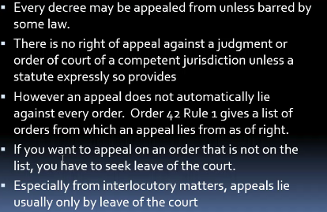

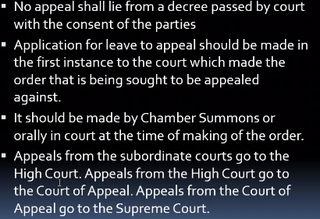

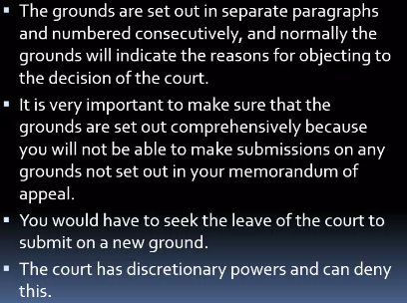

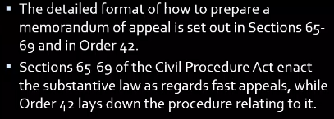

## Appelate courts

### Supreme court

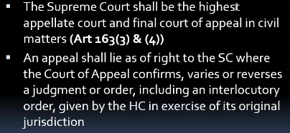

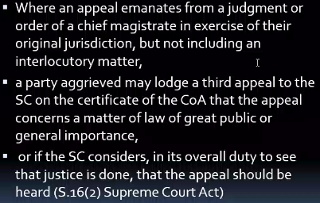

### Court of appeal

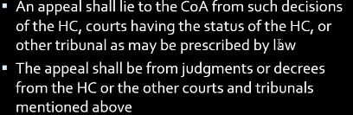

### High Court

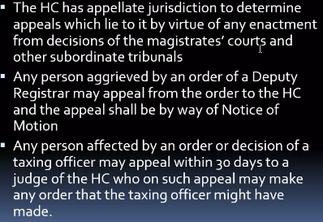

## Leave to appeal

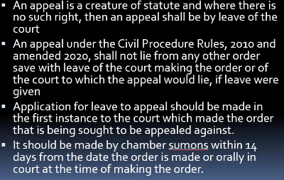

### Appealing against a refusal for leave

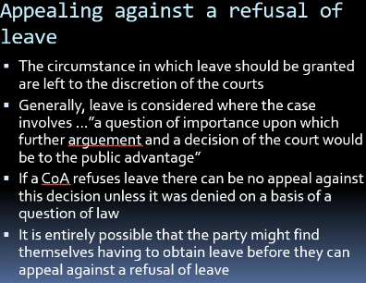

### Justification for leave requirement

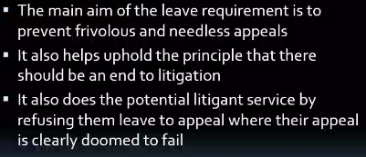

### Appeals on matters of judicial discretion

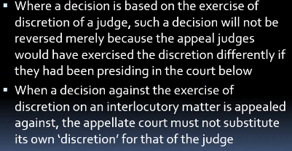

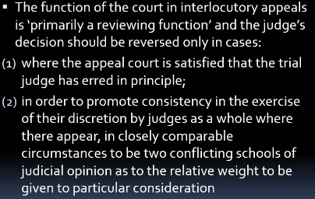

### Discretion in interlocutory matters

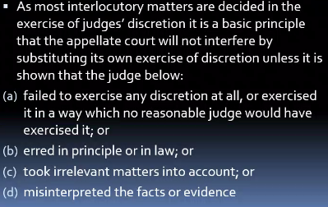

### Time limits & triggering effects

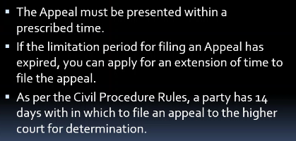

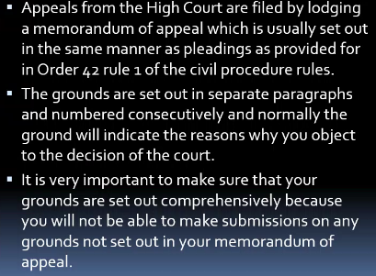

### Procedure for application of leave

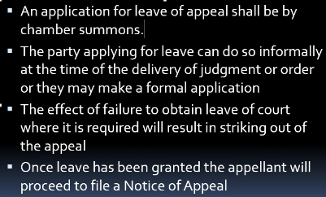

## Notice of appeal

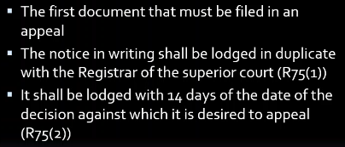

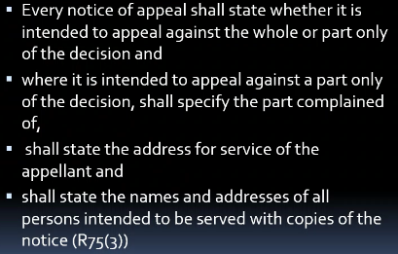

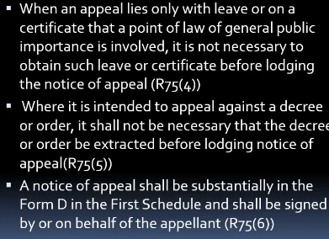

## Time for appealing

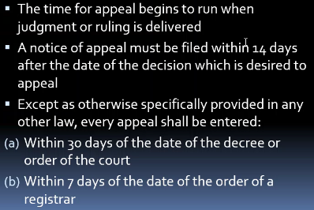

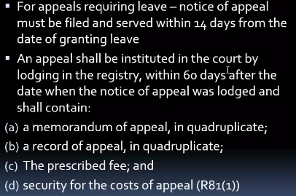

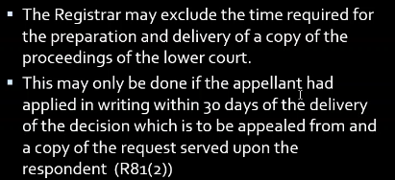

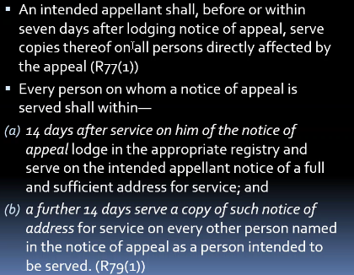

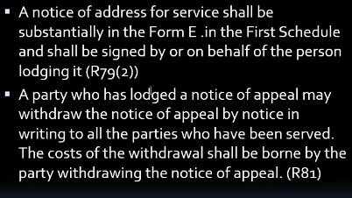

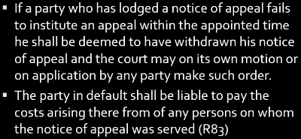

## Application to strike out notice of appeal/appeal

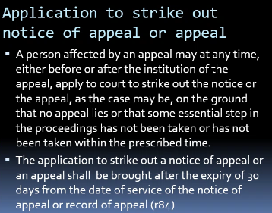

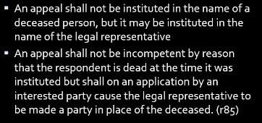

## Memo of appeal

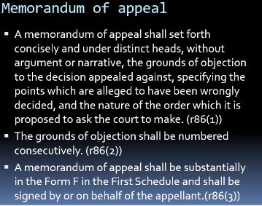

### How to prepare a memo of appeal

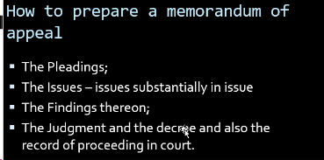

## Record of appeal

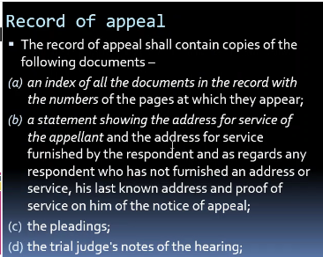

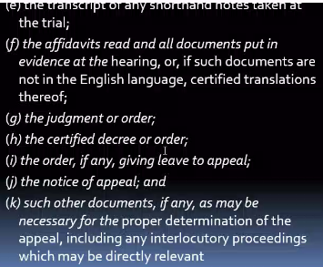

## Application for extension of time

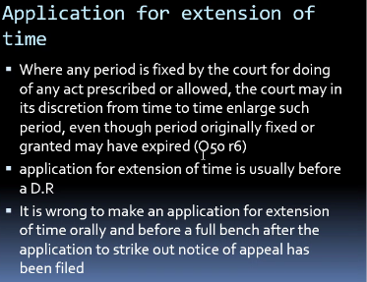

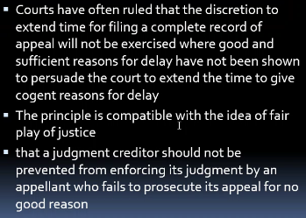

## Requirements for a valid appeal

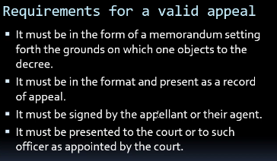

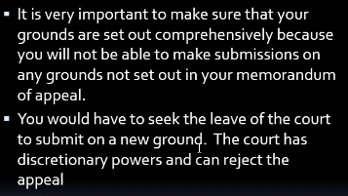

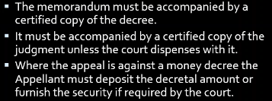

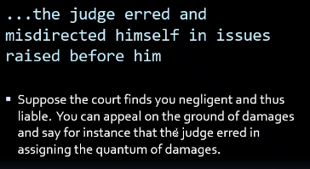

## Presentation of the appeal

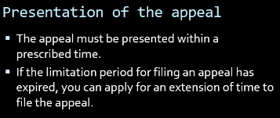

## Stay of execution

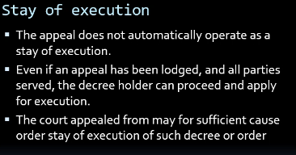

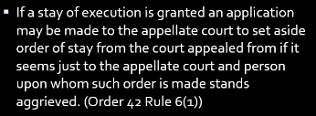

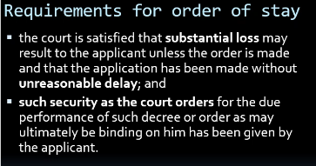

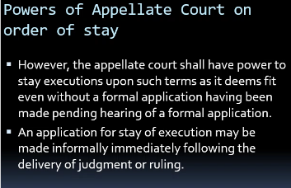

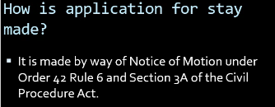

## Appeals are deemed to have been filed

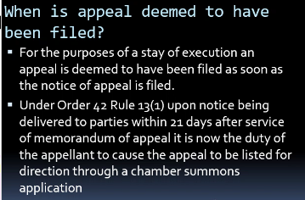

## Documents required

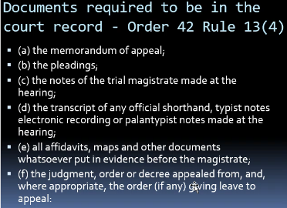

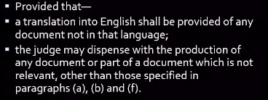



## How courts deal with appeals

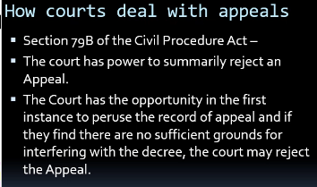

### The hearing

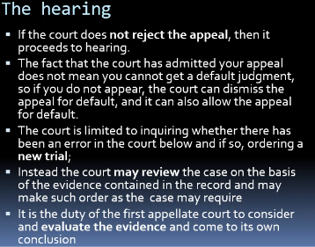

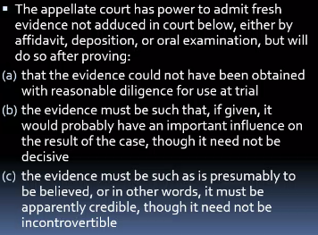

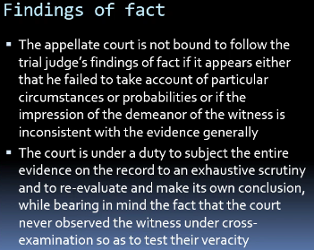

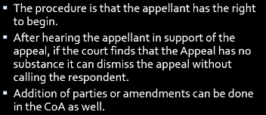

## Powers of appellate court

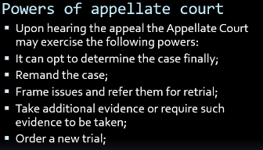

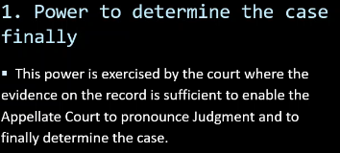

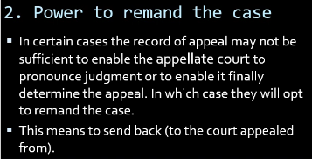

* + 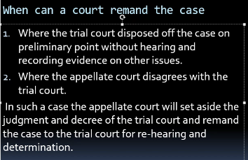
  + 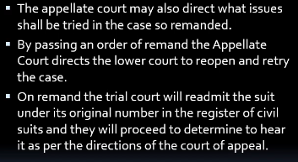

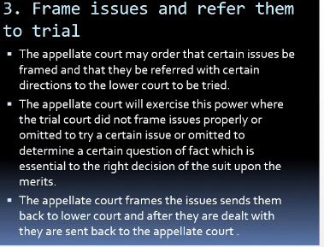

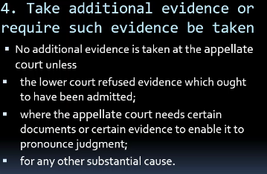

* + 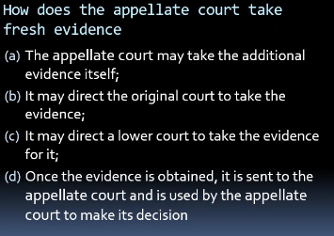

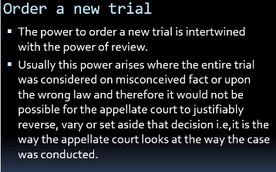

# Review

Where court making the decision revisits its own decision

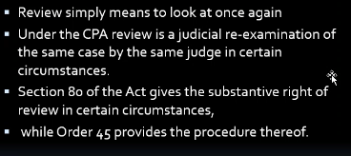

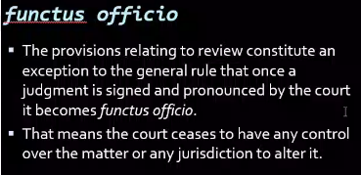

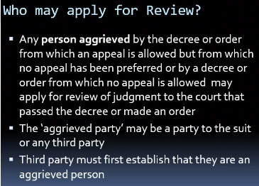

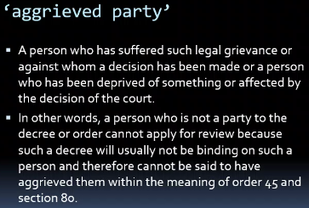

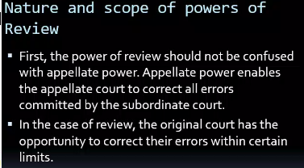

## Conditions foe review

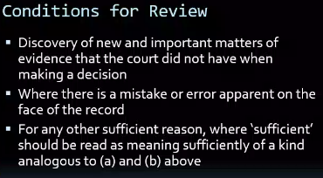



* + 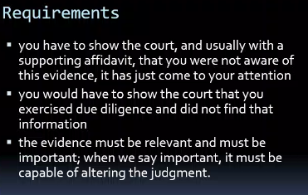

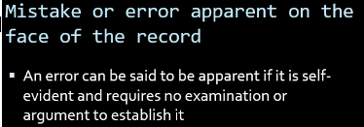

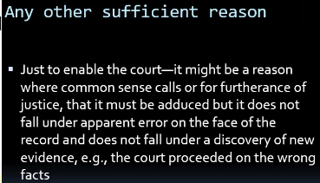

## Procedure

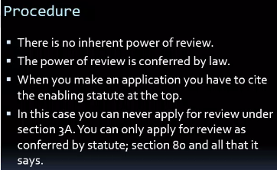

Not filed u/r sec 3A coz no inherent powers coz it’s a creatue of the law

* + Sec 80 & o45 r2
  + 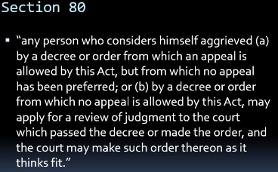

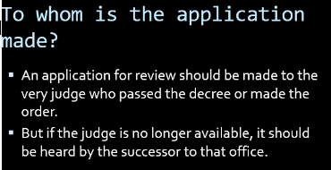

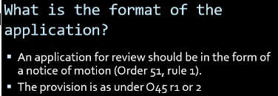

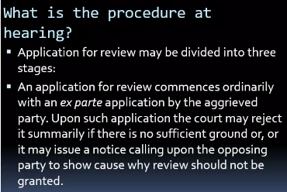

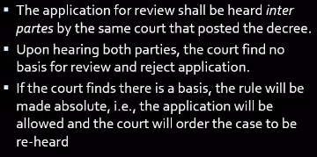

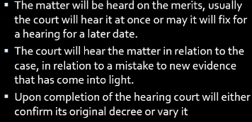



# Constitutional Litigation Procedures

# Costs

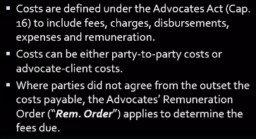

Fees – payment for services

Disbursements – expenses in court to be reimbursed,

* + things you pay for client to be reimbursed

Expenses - An expenditure of money, time, labor, or resources to accomplish a result;

Charges

Remuneration - Payment; compensation,

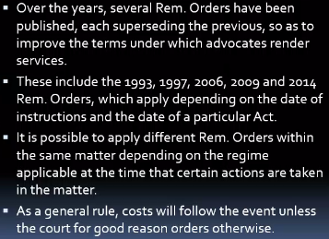

Costs belong to lawyer, even where he’s paid you.

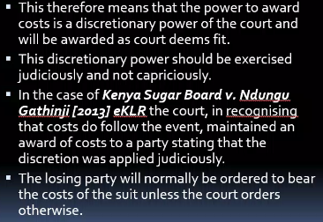

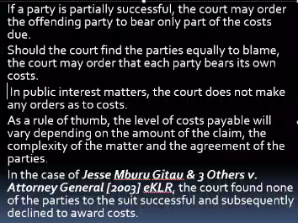

To know costs, consider

* + Agreement
  + Complexity of maters
  + Amount of claim

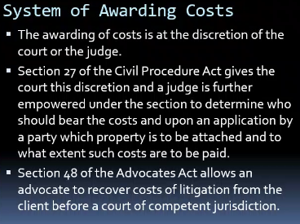

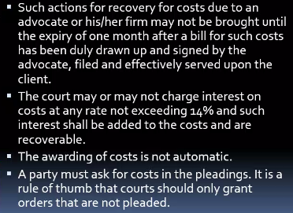

Can’t get costs if not pleaded

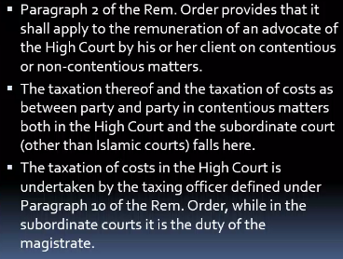

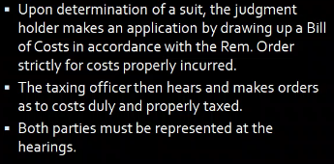

## Bill of costs

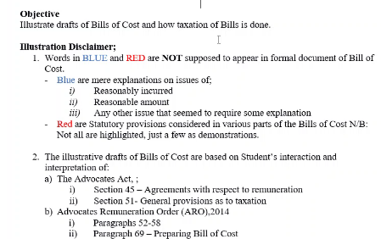

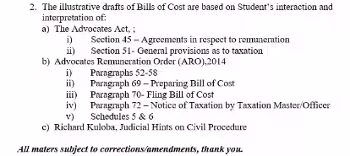

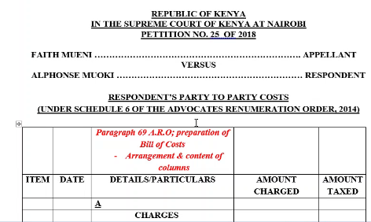

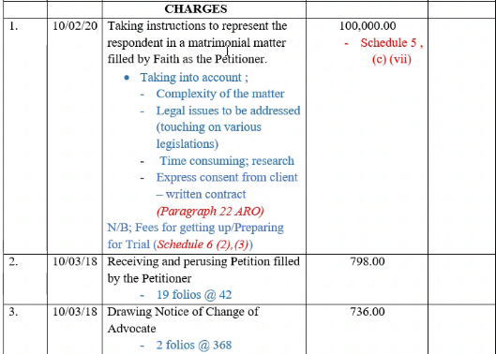



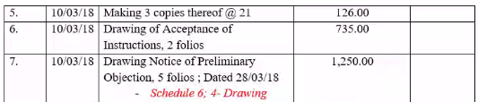

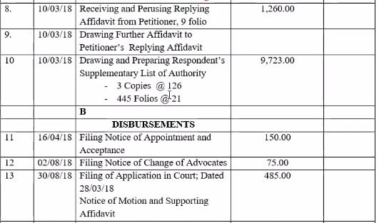

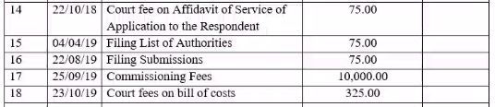

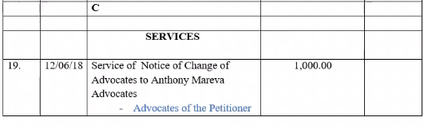

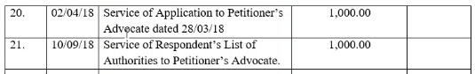

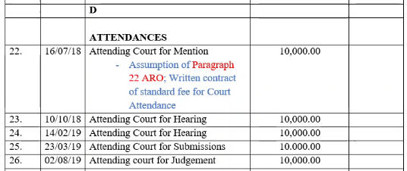

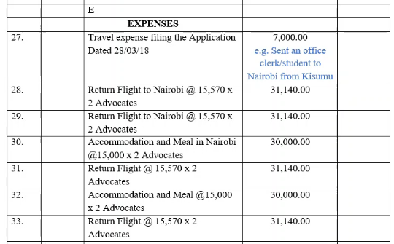

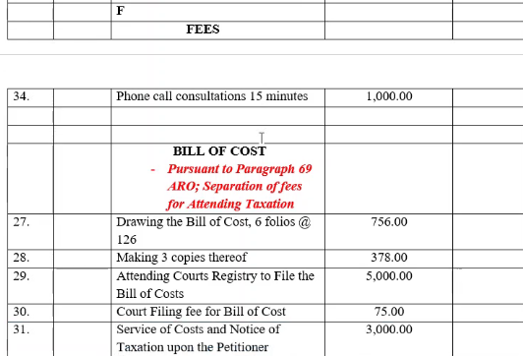



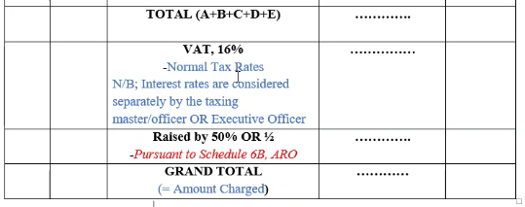

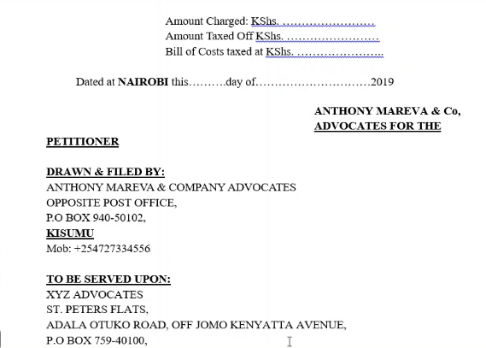

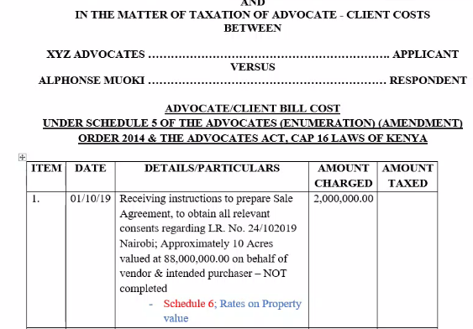

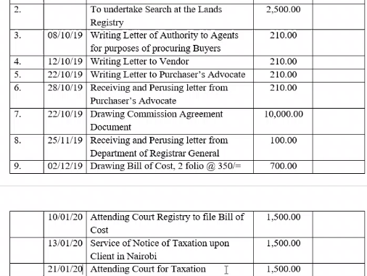

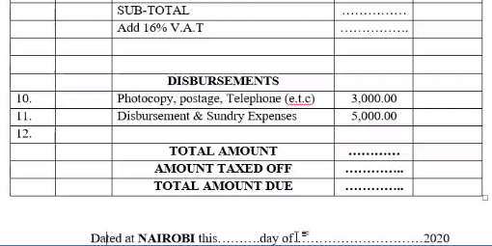

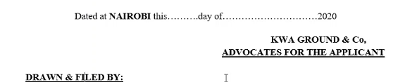

## Revision

* 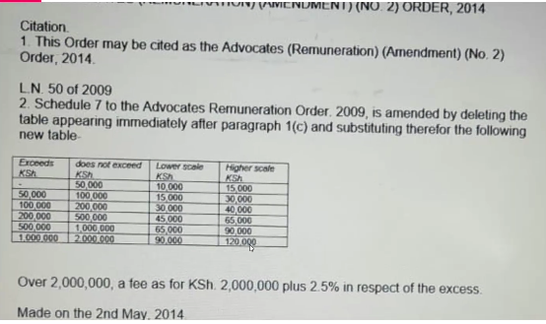
* Are discretionary
* Inter partes
  + Party & party
  + Advocate-Client
    - Come up with bill of costs
* Costs in interlocutory proceedings
  + Before cause is finalised
* Costs in cause
  + After finalised, winner is paid
  + Plaintiff/defendant cost in cause
  + Costs in any event
* Costs thrown away
  + Cost plaintiff incurred until whatever point during cause
* Costs reserved
* No order as to costs
  + No one will pay
* Counsel to pay costs
  + If mistake is by advocate, then advocate pays
* The Taxation Process
  + Advocate-client costs
  + Discretion of taxing master
  + Principles to be observed
  + Costs to more than one advocate
  + Change of advocates
  + Appeal on taxation by reference

# Procedures before Specialised Courts & Tribunals

* ELRC
* ELC
* Business Premises Rent Tribunal
* Rent Restriction Tribunal
* National Environmental Tribunal

# Revision

Done by higher court

* + Legality of the decision
  + Correctness of the decision
  + Propriety of the decision

## N/B

Vesting order – an aspect of transmission in conveyancing

* + Used to remove the name of a spouse in matrimonial property
  + Or even though one party doesn’t appear in the title, the court says will go to that party
  + Need for execution

Amendment

* + Can do once before close of pleadings
  + After pleadings close – use NOM & supporting affidavit to seek leave to amend
  + Use red pen to cancel out neatly then add what’s new
  + Where party has died, take out a grant ad litem b4 12 months end to prosecute the suit
  + Where defendant dies, suit doesn’t die
    - Plaintiff cites family to take out the letters of admin
      * Defence rep needs to respond within 15 days
    - Plaintiff can also file caveat
    - Plaintiff can also nominate one of the deceased’s dependants to take over the suit
      * Court can also nominate someone to rep the suit if the person that took out the letters of admin left the jurisdiction
    - Can O37 R1 – can bring out chamber summons against estate
    - Then sues the estate via the rep who took out the grant ad litem

## Ways to end a suit without going thru entire process CPR

O10 – Default judgment of Defence and Failure To Serve

O12 r2, 3&4 – dismissed non-appearance of plaintiff (& defendant)

O17 r3 – dismissed for want of prosecution

O24 – abatement – party has died

* + Situations of personal injury end – defamation & others subject to court’s interpretation
  + Criminal cases it ends
  + Civil cases you substitute – follow estate
  + Follow it as a creditor
  + Can do a caveat, the court will then inform you once the family makes an application
    - Esp when courts have awarded you.

O25 – settlement/consent – withdrawal

O36 – summary judgment & Judgment on admission

## CPR

O26 – security for costs (defendant thinks the plaintiff won’t be able to pay in case the suit fails)

* + O42 – security for costs

027 as read with o7 r2– defence of tender

O28 – an application for someone’s evidence to be taken b4 the case is heard maybe because the person

* + Is leaving jurisdiction
  + Is about to pass away
  + Court may take evidence outside the courtroom e.g. hospital

O29 as read with Gov’t Proceedings Act

* + Suing the gov’t
  + O29 r2 – some orders don’t apply against gov’t (are listed)
    - (2) No order against the Government may be made under—
    - (a) Order 14, rule 4 (Impounding of documents);
    - (b) Order 22 (Execution of decrees and orders);
    - (c) Order 23 (Attachment of debts);
    - (d) Order 40 (Injunctions);
    - (e) Order 41 (Appointment of receiver).

O32 – suits against children

* + All applications under this are under Chamber Summons
    - Chamber Summons are used
      * Applications under O1 r15
        + Substituting parties
        + 3rd party proceedings
      * Seeking leave for JR
      * When there’s a pending suit
        + Interpleader
        + Enforce a professional undertaking
      * When want to add or remove a party
      * O32 – minor has attained age of majority and wants to take over suit
      * Habeas corpus
      * O52 – disqualifying an advocate
      * Applications under o19

O36 – summary judgment specifically for liquidated claims

* + O36 r10 – setting aside summary judgment

O37 – OS

* + Adverse possession
  + Extension of time under statute of limitation
    - Doesn’t apply to all matters
      * E.g. Contract 6yrs done
      * Sale agreement problem
        + You use a plaint
      * If its about interpretation of a clause in the sale agreement
        + OS

O38 – selection of test suit

* + Mostly for tort to establish liability

O39 - Where defendant may be called upon to furnish security for appearance.

O40 – temporary & interlocutory injunctions

* + Interim injunction – for a period of time will expire
    - Before suit to preserve status quo
    - Last for about 14 days and can be extended by consent
    - Normally ex parte as you file suit
    - Until the court hears the application btn the parties
  + Interlocutory – applies until suit is determined
    - Until the main issues in the suit are heard & determined

O42 – appeals

* + For civil cases file memo of appeal within 30 days of decision esp if from subordinate court
  + File notice of appeal within 14 days in registry you’re coming from (superior court)
    - Rule says file memo in superior court within 60 days of filing the Notice
    - Usually takes longer to get docs from subordinate court so get a certificate of delay from high court to allow filing outside of time
      * Time stops running once court delays
        + Rule 75-83 CoA rules
      * Starts running once issued with the cert of delay
    - Record of appeal
      * HC requests the record & court prepares
    - Then matter is listed for direction, normally in chambers
    - Then proceed to hearing
      * Oral
      * Written submissions
  + O42 R6 – stay of execution pending appeal
    - Can seek stay pending appeal orally for 30 days
      * But formally, do CoU & NoM application
      * Attach draft memo of appeal
    - CPR only governs up to CoA and the CoA has its own rules
    - 4 Conditions - (2) No order for stay of execution shall be made under sub-rule (1) unless—
      * (a) the court is satisfied that substantial loss may result to the applicant unless the order is
      * made and that the application has been made without unreasonable delay; and
      * (b) Such security as the court orders for the due performance of such decree or order as May ultimately be binding on him has been given by the applicant.
      * (3) Notwithstanding anything contained in sub-rule (2), the court shall have power, without formal application made, to order upon such terms as it may deem fit a stay of execution pending the hearing of a formal application.
    - CoA Rules
      * In both criminal & civil when coming here must
        + File notice of appeal
        + Then memo of appeal 60 days after notice in Civil with

record of appeal in superior court

10th lining rule

Have to include title of lower court case

Start with record

Then index of appeal – all documents relied upon in lower court

Then statement of address of service

Then attach the documents listed in index

* + - * There are only 5 registries
        + Nairobi – main (others are sub-registries)
        + Mombasa
        + Eldoret
        + Kisumu
        + Nakuru
        + Nyeri
      * CoA can only
        + Confirm
        + Reverse
        + Vary
        + Remit back to superior court with orders
        + Order for a new trial
        + Make other incidental orders

Can seek leave if late but have to persuade judge

* + E.g. failing to receive instructions – act as soon as you get instructions

Can make an application for leave in CoA if denied in HC

* + Not normally done

Respondent files

* + Notice of address – where to get you
  + Response to appeal or
  + Cross-appeal – where also not satisfied